Consultation on:-
Proposal to dispose, by sale, of Grant Street workshop and yard, Grant Street, Fishertown, Nairn, IV12 4NN
What is proposed?
It is proposed to dispose, by sale, of the Grant Street workshop and yard at Grant Street, Fishertown, Nairn, IV12 4NN. This site is located on the corner opposite 2 Grant Street and adjoining numbers 4 and 4a Grant Street. The site measures 163.8m² or thereby. The location and current condition of the site are shown in the images below.

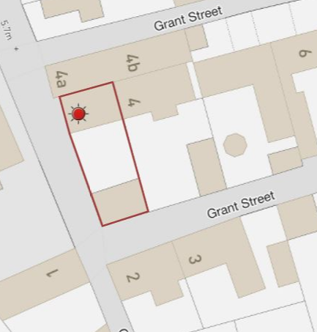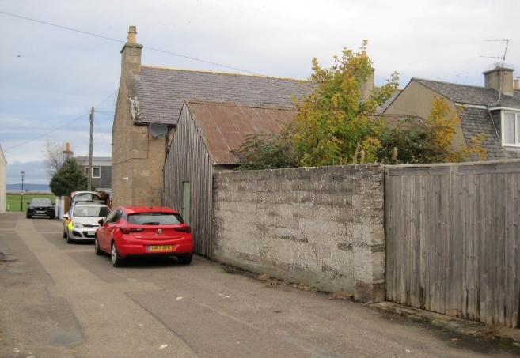

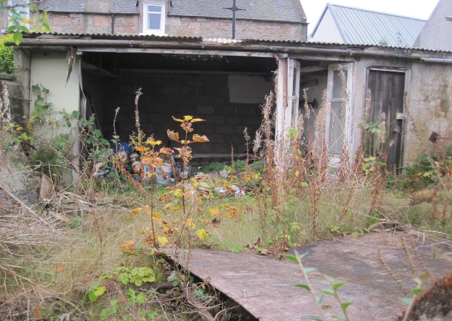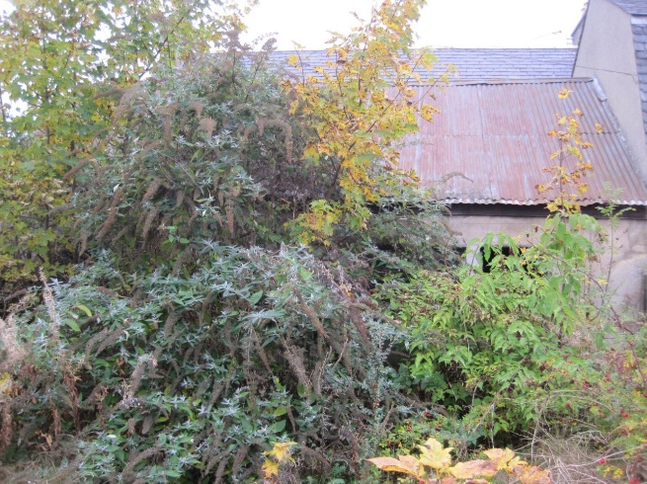
The workshop and yard has been vacant for a period of time in excess of 10 years with minimal interest being expressed by any person or organisation in connection with leasing the property.

The property has been assessed by the Council’s Nairn Area Surveyor who is of the opinion that leasing the premises in its current condition would not generate a significant rental income for Nairn Common Good. Similarly, undertaking works to demolish and/or restore the current buildings would incur costs for the Common Good Fund and would be unlikely to result in a proportionately higher rental income.

As part of their management responsibility for Nairn Common Good, local Members have considered the current condition of and possible options for the Grant Street workshop and yard. Taking all matters into consideration, Members were of the opinion that the proposal to dispose of the site in its current condition might be the best option for Nairn Common Good and approval to commence a public consultation seeking community views was confirmed at a Ward Business Meeting on 8 December 2021.

Consultation
Section 104 of the Community Empowerment (Scotland) Act 2015 requires the Council to consult local communities when considering disposing or changing the use of Common Good assets. In this case the consultation is seeking the views of the community in respect of the proposal to dispose by sale in order to inform the decision making process.

Key questions:
- What are your views on the proposed disposal of this common good asset?
- Do you have any views on potential benefits of the proposal?
- Do you have any issues or concerns arising from the proposal?
- Do you have any additional comments?

The Council will take all representations received into account in reaching a decision.

Depending on the representations received the possible outcomes are:
- The proposal goes ahead.
- The proposal is amended significantly, and a fresh consultation takes place.
- The proposal does not go ahead.

Representations
Consultation closing date – 10 March 2022

Please submit written representations to:-
Email: common.good@highland.gov.uk
Post: Sara Murdoch, Highland Council, Headquarters, Glenurquhart Road, Inverness, IV3 5NX.

Additional information
The Highland Council have a statutory obligation to seek court consent before disposing of Common Good land which may be ‘inalienable’.

In this context ‘inalienable’ refers to Common Good property that falls into at least one of the following categories: -

- The Title Deed of the property dedicates it to a public purpose, or
- The Council has dedicated it to a public purpose, or
- The property has been used for public purposes for many years (time immemorial) without interference by the Council

In respect of Grant Street workshop and yard, it is believed to be a remnant of Burgh land deriving title from the original Royal Charter. This was confirmed by expert title searchers in 2007. However, simply being Charter land does not automatically mean it will be considered to be inalienable. In this particular case, the use has always been of a private nature and, as such, it would not attract the classification on inalienability. Therefore, in the event that the outcome of the consultation is supportive of the proposal, it would be the Council’s opinion that an application to the Sheriff Court for approval would not be required.

Anticipated timescales
Once commenced, the consultation will be publicly available for 8 weeks. All representations will be analysed and a report on the outcome considered by the next scheduled Nairnshire Committee.

