THE LINKS KIOSK CONSULTATION on:-
- proposal to dispose, by lease, of 178m² of land at West Links incorporating the existing lease footprint of the Links Kiosk (137.5m²) together with an additional area (40.5m²) located on the West Links at Marine Road, Nairn.
- Proposal to change the use of 40.5m² (additional area) from public amenity land to land leased for kiosk seating.

What is proposed?

The Kiosk and an area of surrounding land is currently leased to James’s Limited (James Grigg) until 2029 at a passing rent of £2000 per annum for the purposes of a retail outlet selling ice cream, cakes, tray bakes, cold sandwiches and savoury slices, crisps and hot and cold drinks.

The tenant has approached the Council with a request to extend his lease to 30 years and also to acquire an additional area of land (40.5m²) to allow for an additional outside seating area. The tenant would wish to commit to a programme of investment in the site which may include the future possibility of replacement of the existing structure with a more modern building in keeping with the overall development proposals for the Links area and subject to any appropriate permissions and consents being obtained. A longer lease would allow him to see a return on such a level of investment.

The ongoing issues relating to Covid have caused the tenant to consider his current availability of outside seating. The extra area suggested would allow him to have additional outside seating facilities whilst adapting to whatever restrictions may be in place in response to the ongoing pandemic situation.

The proposal is that the passing rent would increase by £400 per annum for the additional area and be subject to the same rent review provisions as apply to the existing lease footprint.

The images below show:
- Image 1 - the existing area leased in red and the proposed new area to be included in blue (40.5m²)
- Image 2 – the original lease plan showing the current lease footprint (137.5m²)

Image 1

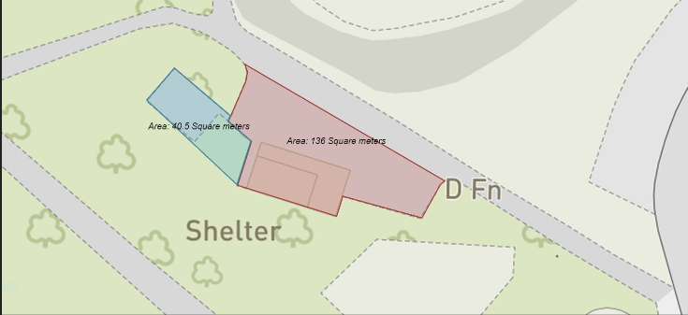

Image 2

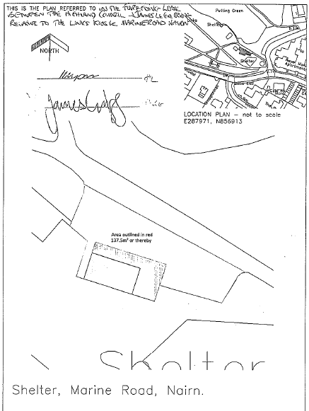

Consultation
Section 104 of the Community Empowerment (Scotland) Act 2015 requires the Council to consult local communities when considering disposing or changing the use of Common Good assets. This includes where the proposal is to grant a lease of over 10 years. The proposal in this consultation document relates to both a disposal and a change of use.

Please note that this consultation covers the proposal only and any planning or other permissions that may be appropriate are subject to separate procedures.

Key questions:
- What are your views on the proposed disposal, by lease, of the area of 178m² of land at West Links for 30 years incorporating the current leased area and the additional area of 40.5m² of land? What are your views on changing the use of the additional area of land from public amenity to Kiosk seating facilities?
- Do you have any views on potential benefits of the proposals?
- Do you have any issues or concerns arising from the proposals?
- Do you have any additional comments?

The Council will take all representations into account in reaching a decision.

Depending on the representations received the possible outcomes are:
- The proposal goes ahead subject to consent by the Sheriff Court.
- The proposal is amended significantly, and a fresh consultation takes place.
- The proposal does not go ahead.

Representations
Consultation closing date – 11 March 2022

Please submit written representations to:-
Email: common.good@highland.gov.uk
Post: Sara Murdoch, Highland Council, Headquarters, Glenurquhart Road, Inverness, IV3 5NX.

Additional information
The Highland Council have a statutory obligation to seek court consent before disposing of Common Good land which may be ‘inalienable’.

In this context ‘inalienable’ refers to Common Good property that falls into at least one of the following categories: -

- The Title Deed of the property dedicates it to a public purpose, or
- The Council has dedicated it to a public purpose, or
- The property has been used for public purposes for many years (time immemorial) without interference by the Council

In this case the property is located on the West Links at Nairn which derives its title from the Royal Charter of King James VI dated 15 October 1589 and, as such, it is considered that a question of alienability may arise. Therefore, the proposed disposal and change of use cannot be concluded until Sheriff Court consent has been obtained. If after this consultation, the proposal progresses to a court application the public will have a further opportunity to make representations within the Court process. A statutory advertisement will be placed in the Inverness Courier (Nairnshire Edition) to inform the local public that the court process has been commenced.

