CONSULTATION on:-
Proposal to dispose, by lease, of Bignold House located on Bignold Park, Wick to Wick Academy Football Club
What is proposed?
A disposal, by lease, of Bignold House which is located on Bignold Park, South Road, Wick to Wick Academy Football Club. Bignold Park has been identified as Common Good property of the former Burgh of Wick. Bignold House derives its Common Good title from the title of Bignold Park. The location of Bignold House is shown in the plans and images below together with a picture of the property.

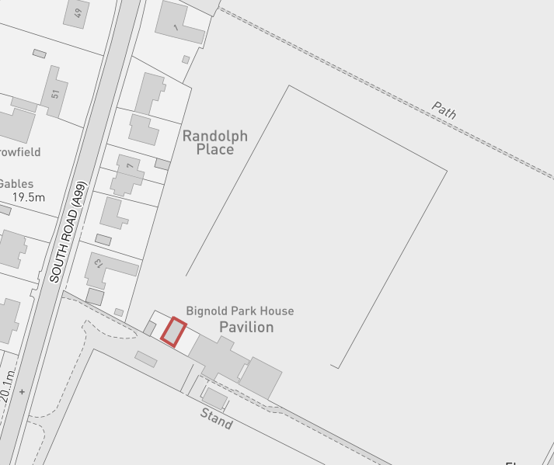

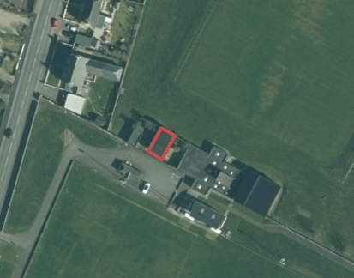
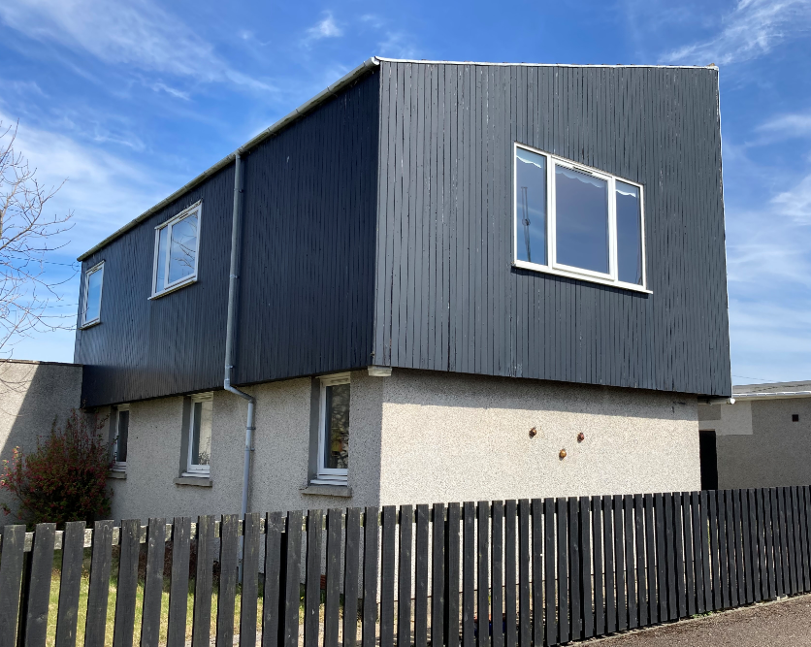

Background to the proposal
Bignold House had previously been occupied by a member of Highlife Highland staff. When it became vacant Wick Academy Football Club who lease the surrounding land for their football pitch made enquiries into the building. It would be their wish to use the building as a new tea facility, office space and to provide new toilets on the upper floor as well as disabled facilities on the ground floor. player and for meetings. In addition they would plan to use the lounge for hospitality for sponsors and guests as well as letting it out to local community groups for meetings.

Wick is a recently reactivated Common Good fund and the proposed lease of Bignold House would benefit the fund as not only would it be generating a regular income but would also see the asset continue to be used, maintained and kept in repair by the tenant.

Negotiations have taken place and proposed terms agreed subject to the outcome of this public consultation as follows:-
- 50 year lease term with break option every 15 years subject to 3 months’ notice
- Full repair, maintenance and insurance (on building as it currently is)
- Any alterations subject to landlord consent and appropriate planning and any other permissions
- Rent - £1000 per annum, rent review every 5 years in line with RPI
- 12 months’ rent free period
- All consultation (including court) costs and legal costs associated with the proposal and lease (if approved) to be paid by Wick Academy Football Club.

Consultation
Section 104 of the Community Empowerment (Scotland) Act 2015 requires the Council to consult local communities when considering disposing or changing the use of Common Good assets. This includes where the proposal is to grant a lease of over 10 years.
Therefore, before taking any decision, and to inform the decision making process, we are keen to hear the views of the community, in particular:

- What are your views on the proposed disposal, by lease, of the Common Good property known as Bignold House?
- Do you have any views on potential benefits of the proposal?
- Do you have any issues or concerns arising from the proposal?
- Do you have any additional comments?

The Council will take all representations into account in reaching a decision.

Depending on the representations received the possible outcomes are:
- The proposal goes ahead subject to consent being given by the Sheriff Court
- The proposal is amended significantly, and a fresh consultation takes place
- The proposal does not go ahead

Representations
Consultation closing date – 21 March 2022

Please submit written representations to:-
Email: common.good@highland.gov.uk
Post: Sara Murdoch, Highland Council, Headquarters, Glenurquhart Road, Inverness, IV3 5NX.

Additional information
The Highland Council have a statutory obligation to seek court consent before disposing of Common Good land which may be ‘inalienable’.

In this context ‘inalienable’ refers to Common Good property that falls into at least one of the following categories: -
- The Title Deed of the property dedicates it to a public purpose, or
- The Council has dedicated it to a public purpose, or
- The property has been used for public purposes for many years (time immemorial) without interference by the Council.

Bignold Park was gifted by Arthur Bignold to the Provost, Magistrates & Councillors of the Burgh of Wick in 1903. Arthur Bignold had acquired the ground with a view “to its being utilised as a public park and recreation ground for the inhabitants of Wick and Pultneytown”. He gifted it to the Royal Burgh of Wick “for the use and enjoyment of the inhabitants thereof heritable and irredeemably”.
Bignold House is located within the boundary of the land known as Bignold Park and derived its Common Good title and status from that land and it is therefore considered that a question as to its alienability arises. As a result, the proposed lease cannot be concluded until Sheriff Court consent has been obtained.

If after this consultation, the proposal progresses to a court application the public will have a further opportunity to make representations within that process. A statutory advertisement will be placed in the John O’Groat Journal to inform the local public that the court process has been commenced.

