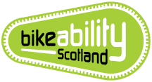
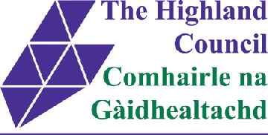

Checklist for Primary Schools undertaking Bikeability
www.highland.gov.uk/bikeability

- Notify the Bikeability Scotland Co-ordinator (BSC) of your intention to carry out Bikeability
- Recruit staff/volunteers, process PVG’s & send on Bikeability Scotland Instructor (BSI) training
  - Volunteer recruitment leaflets and resources are available from the BSC
  - BSI courses are listed on the HC Bikeability webpage, along with a request form for additional courses
- Complete a Risk Assessment (playground = HT/BSI, on road = BSI/BSC). Templates are available from the HC Bikeability webpage. Add to Evolve.
- Request resources via Survey Monkey from BSC in December or June
  - Resources can be requested out with these times but may take longer to arrive
- Set a date for delivery of sessions and certificate award ceremony
- Organise a Dr Bike* or bike check session, the BSC can assist with this
- Send out consent letters, include:
  - Parent’s Guide (pdf available)
  - Consent to take part
  - Consent to bring in own bike
  - Consent to share bikes with pupils who do not have one to use
  - Clothing advice
  - Date of award ceremony if parents invited to attend
- Give out certificates and badges at the award ceremony
- Respond to Survey Monkey Data Return from BSC (also on the HC Bikeability webpage) in December and June
- Start planning for the next set of sessions

Have you considered:
- Joining up with another school to deliver. This could be helpful if you have small numbers or are low on volunteers.
- Remote/rural location? Ask the Bikeability Co-ordinator about a Rural Cluster Delivery Programme.
- Do you have adequate cycle storage? The Road Safety Team could assist your school with supplying cycle storage (road.safety@highland.gov.uk)
- Cycle Friendly School Award (https://www.cycling.scot/what-we-do/cycling-friendly/primary-school)

* Dr Bike – external bike mechanic will come and assess bikes, giving them an MOT style report, bike checks can be performed by the BSI.

Emma Garden – Bikeability Scotland Co-ordinator
emma.garden@highland.gov.uk
01463 702039 / 07884 752563
Road Safety Team, Infrastructure & Environment, Glenurquhart Road, Inverness, IV3 5NX

