CONSULTATION on:-
- proposal to dispose, by sale, of approximately 56m² of land at Tigh Ruaraidh, 8 Well Street, Dornoch, IV25 3LU
What is proposed?
It is proposed to dispose, by sale, of 56m² or thereby of land which will enable the completion of the title for the property, as shown on the images below.

Image 1
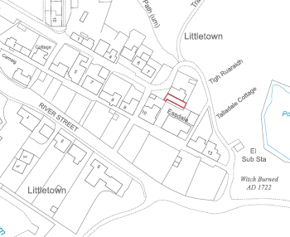

Image 2
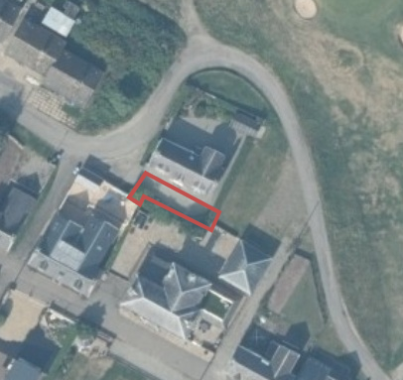
Whilst the area of land in question has never formed part of the title, it does provide access to the front of the house in an analogous manner to how a road/pavement would provide access. However, notwithstanding this, past owners have fenced off the land and used it as garden ground and for parking. In or about 2009, the Council was approached, by previous owners, about acquiring the area of land in question, specifically at the time for the purposes of constructing a sun lounge.

Extensive negotiations took place with the property owner in 2009 and a subsequent purchaser however, in 2015, the owner at the time decided not to proceed further with the transaction. The Council voluntarily registered the ownership of the area of land in question in 2016.

The Council has now been approached with a new request to consider the sale of the land to the current owner to allow her to acquire a complete title to the land including that area used but not owned. Negotiations have taken place and a proposed purchase price of £8000 has been agreed. This price reflects the fact that the land has development value in addition to use as a garden and for access, although there are no current plans for development.

The property is located in the Littletown area of Dornoch. The current owner of the property believes that there is a title discrepancy as a result of the re-routing of Well Street from the front to around the rear of the property possibly in 1950/60’s. However, no confirmation of whether this is the case is to hand. Scrutiny of old maps from prior to that period would appear to show Well Street running up to a point to the west of the property then a narrower accessway running in front of the property. Whilst a road has been run around the back of the property, this has been referred to in previous negotiations as a track. In any event, irrespective of whether the road was rerouted or not the access to the property remained unaffected and no new rights were inferred in favour of the property.

The Littletown area of Dornoch is considered to derive its title from the original Royal Charter of 14 July 1628 and, as former Burgh land, is therefore, now assessed to be Common Good land.

The area of land in question measures 56m² or thereby and a proposed purchase price has been agreed of £8000. Any sums received from the sale of this piece of land, if approved, would be paid into Dornoch Common Good Fund.

Consultation
When the Common Good Asset Register was consulted upon and published in February 2020, this piece of land was overlooked and not raised in consultation enquiries. However, it has now been confirmed as Common Good and, notwithstanding the fact it is not on the Asset Register, section 104 of the Community Empowerment (Scotland) Act 2015 still applies. As a result the Council is required to consult local communities when considering disposing (or changing the use) of Common Good assets. Therefore, the consultation is seeking the views of the community in respect of the proposal to dispose, by sale, in order to inform the decision making process in this case.

Key questions:
- What are your views on the proposed disposal by sale of the area at Tigh Ruaraidh, 8 Well Street, Dornoch?
- Do you have any views on potential benefits of the proposals?
- Do you have any issues or concerns arising from the proposals?
- Do you have any additional comments?

The Council will take all representations into account in reaching a decision.

Depending on the representations received the possible outcomes are:
- The proposal goes ahead.
- The proposal is amended significantly, and a fresh consultation takes place.
- The proposal does not go ahead.

Representations
Consultation closing date – 28 July 2022

Please submit written representations to:-
Email: common.good@highland.gov.uk
Post: Sara Murdoch, Highland Council, Headquarters, Glenurquhart Road, Inverness, IV3 5NX.

Additional information

The Highland Council have a statutory obligation to seek court consent before disposing of Common Good land which may be ‘inalienable’.

In this context ‘inalienable’ refers to Common Good property that falls into at least one of the following categories: -

- The Title Deed of the property dedicates it to a public purpose, or
- The Council has dedicated it to a public purpose, or
- The property has been used for public purposes for many years (time immemorial) without interference by the Council

In this case, the use of the area of land in question has been for private rather than public use. The Council does not consider that a question of alienability is raised in this case. As a result, in the event that the outcome of the consultation is to support disposal, the Council does not consider it will be necessary to also seek Sheriff Court approval.

