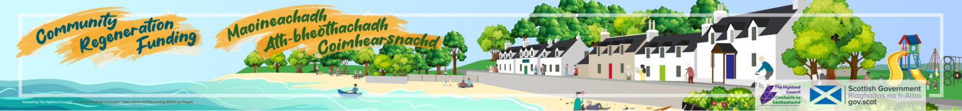
Expression of interest
(August 2023)
Applicant organisation:
Project title:
Project location (inc. postcode):
Contact name:
Email address:
Contact telephone:

Which one of the following strategic objectives does your project relate to:
- Increasing community resilience ☐
- Tackling poverty and inequality ☐
- Addressing causes of rural depopulation ☐
- Helping economic recovery and sustaining growth ☐
- Tacking the climate emergency and working towards net zero ☐

Total cost of project: | £
Community Regeneration Funding request: | £
Start date of project:

End date of project:

* Projects must start from early 2024 and be concluded and claimed by 1st March 2025.
Match funding: - please give details of match funding:
Name of funder | Amount (£) | Applied (date) | Confirmed (date)
Total match funding | £
Total CRF | £
Total project | £

If you are applying for 100% funding from CRF, please state reasons why. Applicants are required to source match funding and only under exceptional circumstances 100% CRF will be considered:

Budget - Please list main items of expenditure and if they are capital or revenue:
Budget heading | Capital or revenue costs? | Amount (£)
Total capital expenditure |  | £
Total revenue expenditure |  | £
Total project: |  | £

Does your project require statutory consents such as planning permission, building warrant or utility consents? Please give details and timescales if they have been granted, pending decision, not applied.
Type | Granted/applied/not applied (inc date)

Do you own the asset, or will you require a lease or asset transfer? Please give details and timescales if they have been applied or pending decision.
Type | Granted/applied/not applied (inc date)

Fair Work First - all applicants must comply with the Scottish Government’s Fair Work First policy. It is a policy for driving high quality and fair work across all sectors of the labour market. This is being implemented to grants and contracts awarded across the public sector. You will be required to provide a signed statement at full application on how your organisation/group is committed to advancing the ‘Real Living Wage’ and ‘Effective Voice’ criteria. Organisations will not be eligible for funding if they do not meet this policy.

Please confirm if your organisation is:

Aware of the Fair Work First policy | Yes/no
Draft policy in place/currently implementing | Yes/no
Signed statement in place | Yes/no

Project summary – provide a brief outline of your project and what the funding will specifically deliver. Please be concise and summarise key information how the project will benefit/bring change to the community. Do not use more than one side of this form.

Please confirm you have read and understood the Privacy Notice: Yes ☐ No ☐

Completed forms should be emailed no later than 12pm Friday 8th September to: communityregenerationfund@highland.gov.uk

