Consultation number 2 on:-
Proposal to:
- dispose, by sale, of Grant Street workshop and yard, Grant Street, Fishertown, Nairn, IV12 4NN
- dispose, by demolition, of all buildings on site if appropriate as part of marketing process

What is proposed?
It is proposed to dispose, by sale, of the Grant Street workshop and yard at Grant Street, Fishertown, Nairn, IV12 4NN. This site is located on the corner opposite 2 Grant Street and adjoining numbers 4 and 4a Grant Street. The site measures 163.8m² or thereby. The location and images of the site are shown below. The consultation also includes a proposal to demolish all buildings on site, if necessary, for reasons outlined below.

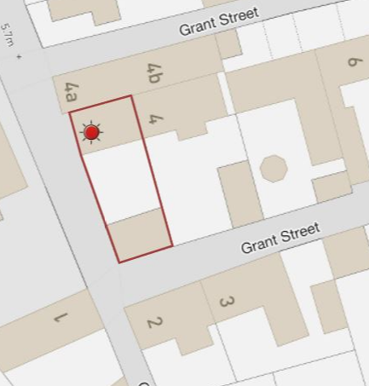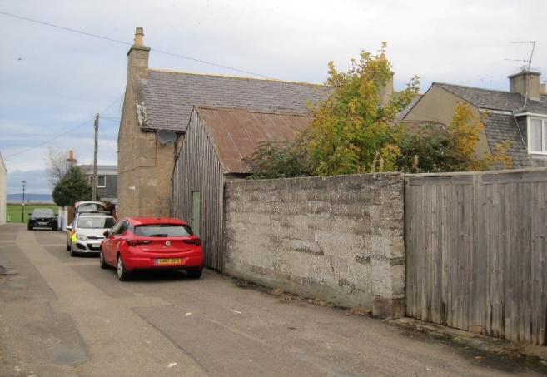

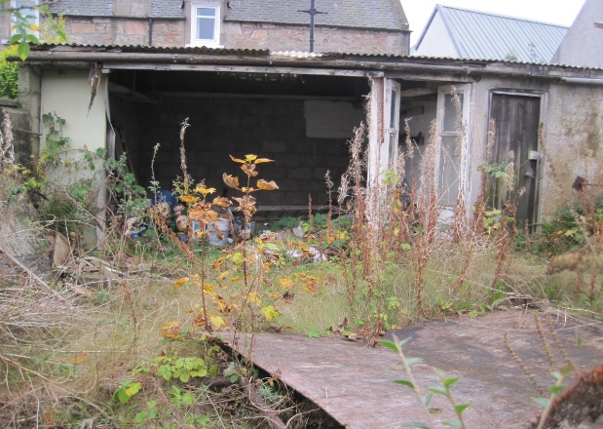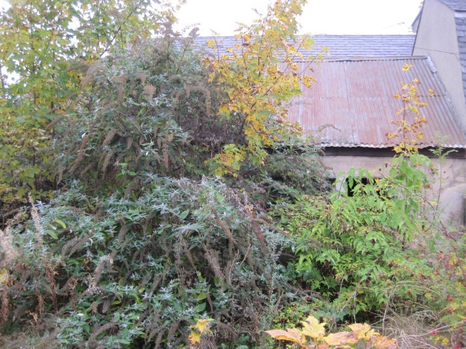

Background
Proposals for options for Grant Street Workshop and Yard were considered by Nairn Area Members in late 2021. Noting advice from the Council’s Nairn Area Surveyor that leasing the premises in either its current or cleared condition would not generate a significant rental income for Nairn Common Good, Members were of the opinion that a proposal to dispose by sale in its current condition might be the best option for Nairn Common Good.

The public consultation under section 104 Community Empowerment (Scotland) Act 2015 in respect of the proposal to sell Grant Street Workshop and Yard ran from 11 January 2022 until 10 March 2022 with 9 responses being received. 2 responses were supportive, 1 was a simple rejection but the others raised the issue that leasing should be considered as well as or instead of sale.

On 8 August 2022 Members at the Nairnshire Area Committee considered the outcome of the consultation taking into account all representations received and amended the proposal in the consultation document to reflect Members decision that the property should be marketed for lease only and not sale. Therefore, the property was marketed on this basis only.

Current position
Following an initial marketing period, a number of those viewing the property raised concerns in respect of the buildings on the site. In response, professional advice was obtained that highlighted the buildings are in a particularly poor and dilapidated condition and at present, pose a major risk to health and safety:
- With regard to the timber building, many of the load bearing studs have rotted away at ground floor level, leaving the building very unstable.
- The first floor (roof void effectively) is not part of the original structure and much of the cladding is also rotten and allowing weather to penetrate the building.
- Internally, scaffolding has been erected underneath to help with support of the roof and in places, is most likely preventing the building collapsing entirely.
- Rolled steel joists have also been positioned in the centre of the building and are again, considered to be propping up the roof.
Given the health and safety implications, demolition of this building is believed to be the only viable option.

The other buildings on site are made up of concrete blockwork with suspected corrugated asbestos sheet roofing. These too are dilapidated and, although not in immediate danger of collapsing, the site would benefit from these also being demolished.

Marketing has been suspended in the circumstances and the updated information was advised to Members at a Ward Business Meeting on 20 October 2022 and options reconsidered as follows:
- Continuing with plan to lease the site will require the buildings to be demolished. This will incur costs to the Common Good fund – a general estimate is in the region of £15k (more precise figures cannot be given at this stage but this may increase in the event of the presence of asbestos)
- Continuing with plan to lease but try to include a condition that any prospective tenant demolish and rebuild.

- Revert to previous proposal to sell the site in its current condition with a capital receipt estimated to be in the region of £50k, based on a slightly larger plot being marketed in close proximity to the subjects (more precise figure will be dependent on market demand).

Taking all available information into account, Members considered that the most beneficial option for Nairn Common Good fund was to revert to the original proposal to dispose of Grant Street Workshop and Yard by sale. Therefore, they requested that a fresh public consultation be initiated in respect of the proposal.

To ensure that the maximum opportunities remain open to Nairn Common Good in respect of this consultation, the proposal also includes disposal by demolition if so indicated by the marketing process. The only viable situation being considered being a request for a long development lease with demolition undertaken by the tenant. Given the size of the site, such a request is unlikely but the option to consider should remain available.

Consultation
Section 104 of the Community Empowerment (Scotland) Act 2015 requires the Council to consult local communities when considering disposing or changing the use of Common Good assets. In this case the consultation is seeking the views of the community in respect of the proposal to dispose by sale in order to inform the decision making process.

Key questions:
- What are your views on the proposed disposal of this common good asset?
- Do you have any views on potential benefits of the proposal?
- Do you have any issues or concerns arising from the proposal?
- Do you have any additional comments?

The Council will take all representations received into account in reaching a decision.

Depending on the representations received the possible outcomes are:
- The proposal goes ahead.
- The proposal is amended significantly, and a fresh consultation takes place.
- The proposal does not go ahead.

Representations
Consultation closing date – 17 March 2023

Please submit written representations to:-
Email: common.good@highland.gov.uk
Post: Sara Murdoch, Highland Council, Headquarters, Glenurquhart Road, Inverness, IV3 5NX.

Additional information
The Highland Council have a statutory obligation to seek court consent before disposing of Common Good land which may be ‘inalienable’.

In this context ‘inalienable’ refers to Common Good property that falls into at least one of the following categories: -

- The Title Deed of the property dedicates it to a public purpose, or
- The Council has dedicated it to a public purpose, or
- The property has been used for public purposes for many years (time immemorial) without interference by the Council

In respect of Grant Street workshop and yard, it is believed to be a remnant of Burgh land deriving title from the original Royal Charter. This was confirmed by expert title searchers in 2007. However, simply being Charter land does not automatically mean it will be considered to be inalienable. In this particular case, the use has always been of a private nature and, as such, it would not attract the classification on inalienability. Therefore, in the event that the outcome of the consultation is supportive of the proposal, it would be the Council’s opinion that an application to the Sheriff Court for approval would not be required.

Anticipated timescales
Once commenced, the consultation will be publicly available for 8 weeks. All representations will be analysed and a report on the outcome considered by the next scheduled Nairnshire Committee.

