CONSULTATION on:-
- proposal to dispose of 51.8m² or thereby of land at Harbour Street, Nairn adjacent to the Seamans Hall.
What is proposed?
It is proposed to dispose of 51.8m² or thereby of land, for nil consideration, to Green Hive as shown outlined in green on the image below.

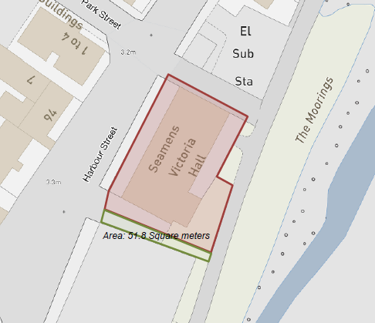

Green Hive is a charity based in Nairn building capacity by engaging the community in environmental projects and activities. Towards the end of 2022, the group acquired the ownership of the Seamans Hall from the then Trustees. Plans have been developed for the renovation of the property to enable it to continue to be used for the benefit of the community of Nairn.

Part of these plans propose the installation of a new entrance to the building, dually accessed from the riverside and Harbour Street which would require a narrow extension along the southern gable. As a result, Green Hive has approached the Council with a request to consider a disposal of the small strip of the land as shown in the image above.

Title investigations have confirmed that the strip of land is not contained within either the Seamens Hall title or the former gas works title. Historically, the land in and around that area formed part of the Royal Charter land of Nairn and, a result, any land not contained within any title is most likely to be a remnant of Charter land and therefore, be assessed as Common Good. There have been other small “pockets” of land identified as such in and around the Harbour Road area.

It is acknowledged that this small piece of land is not specifically identified and recorded on the currently published Common Good Asset Register for Nairn. This is because it would have been too time consuming and cost prohibitive to have conducted such wide spread investigations in the absence of some evidence as to the possible location of these small remnants of land. An entry has been included on the Register to note that it is known these parcels of land are likely to exist and will be investigated and assessed as they become known. This is what has occurred following receipt of this request and, as a result of being categorised as Common Good property, the requirement to conduct a public consultation has been triggered.

Assessment of the nature of the proposal
The strip of land does not constitute a public throughway and effectively, only provides access to the rear of the building. In reality, it is only likely to be of interest to the adjoining occupiers rather than any wider general market.

In assessing whether the disposal should be by way of lease or sale, the proposed use for the land must be considered as well as any potential value. Green Hive’s preferred option would be to acquire this strip of land and incorporate it into their title for the Hall.

Members sought the advice of the Council’s Area Surveyor in assessing the options to enable this proposal to be prepared for consultation.

The small strip of land is considered to have a negligible rental value and given the proposed use of the land in connection with an extension, this option is considered to have little merit.

In considering the proposal for a permanent disposal, value must be balanced against the possible market for the land and the use for which its acquisition is being sought. Any land can be attributed a value and it is reasonable to consider this strip of land being valued on the basis of “garden ground” rates as evidenced elsewhere in Nairn. That stated and as stated above, there is unlikely to be any general market interest in such a strip of land.

It is worth noting that Green Hive have acquired the Seamens Hall for £1.00 from the former Trustees with the intention of restoring and renovating it for use as a community hub and to secure its ongoing use for the Nairn community. It would seem inequitable to assign the area of land in question a value higher than that paid for the Hall in the circumstances.

Following full consideration of all the options and in recognition of the proposed community use plans for the Seamens Hall, Members confirmed at a Ward Business Meeting on 1 March 2023 that a public consultation should be commenced on a proposal to dispose of this strip of land for nil consideration to Green Hive.

Consultation
Section 104 of the Community Empowerment (Scotland) Act 2015 requires the Council to consult local communities when considering disposing (or changing the use) of Common Good assets. Therefore, the consultation is seeking the views of the community in respect of the proposal to dispose of the strip of land between the Seamens Hall and former gas works in order to inform the decision making process in this case.

Key questions:
- What are your views on the proposed disposal of the area of 51.8m² or thereby of land at Harbour Street, Nairn adjacent to the Seamans Hall for nil consideration?
- Do you have any views on potential benefits of the proposals?
- Do you have any issues or concerns arising from the proposals?
- Do you have any additional comments?

The Council will take all representations into account in reaching a decision.

Depending on the representations received the possible outcomes are:
- The proposal goes ahead.
- The proposal is amended significantly, and a fresh consultation takes place.
- The proposal does not go ahead.

Representations
Consultation closing date – 10 May 2023

Please submit written representations to:-
Email: common.good@highland.gov.uk
Post: Sara Murdoch, Highland Council, Headquarters, Glenurquhart Road, Inverness, IV3 5NX.

Additional information
The Highland Council have a statutory obligation to seek court consent before disposing of Common Good land which may be ‘inalienable’.

In this context ‘inalienable’ refers to Common Good property that falls into at least one of the following categories: -

- The Title Deed of the property dedicates it to a public purpose, or
- The Council has dedicated it to a public purpose, or
- The property has been used for public purposes for many years (time immemorial) without interference by the Council

In this case, the use of the area of land in question has been for private rather than public use, namely access to the rear of the property. The Council does not consider that a question of alienability is raised in this case. As a result, in the event that the outcome of the consultation is to support disposal, the Council does not consider it will be necessary to also seek Sheriff Court approval.

