CONSULTATION on:-
- Proposal to dispose, by lease, of 2145m² or thereby of undeveloped land incorporating it into the existing ground lease of the adjacent land at 17 Longman Drive, Inverness
- Proposal to change the use of the land referred to above from undeveloped land to land used in connection with the commercial business of Brandon Landscaping Ltd, 17 Longman Drive, Inverness

What is proposed?
The property at 17 Longman Drive, Inverness is let on a long ground lease to Brandon Landscaping Limited until 2118. There is an adjacent area of vacant undeveloped land, and the tenant of 17 Longman Drive has approached the Council with a request to lease this additional area of 2145m² and to incorporate it into the existing lease footprint for use in connection with their business such as– storage of plant, equipment, vehicles and materials.

The terms of the proposal would see the additional area of land being valued at market value rental resulting in an increase of rent to the Common Good fund of £10,600 per annum. The additional area be subject to the same rent review provisions as apply to the existing lease footprint namely to review to open market value every 5 years. In considering the proposal, it was noted that the subject area of land does not have vehicular access and only restricted pedestrian access to Longman Drive. As a result it is considered to be of limited interest to other potential tenants.

Images below show the existing lease footprint outlined in blue and the proposed additional area to be leased outlined in red.

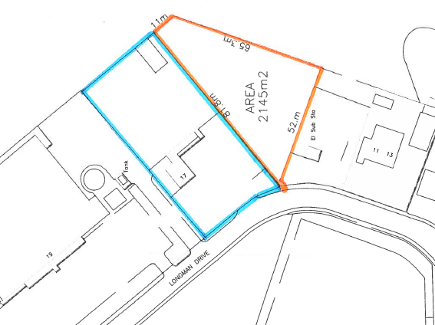

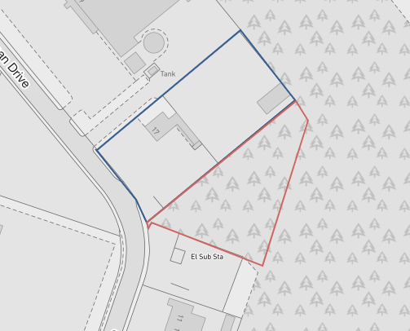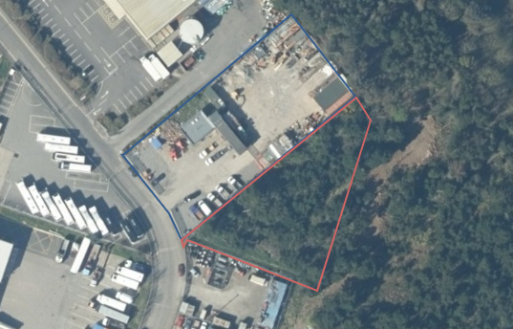

A significant part of Longman North which includes Longman Drive forms part of the Common Good of Inverness by virtue of the Charter of King James VI dated 1 January 1591 – see image below of a plan of this part of Longman North showing the area in question shaded in green representing Common Good land.

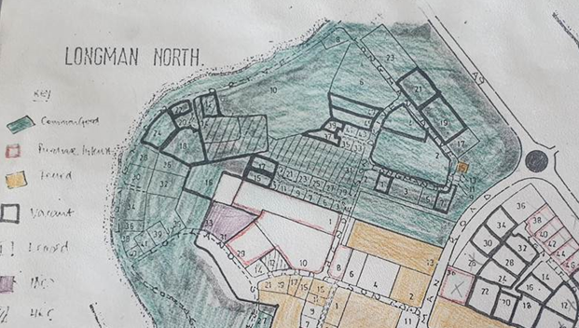

The proposal contained within this consultation document would allow a previously unusable parcel of Inverness Common Good land to be utilised and to become income generating to the wider benefit of the Inverness Common Good Fund.

Consultation
Section 104 of the Community Empowerment (Scotland) Act 2015 requires the Council to consult local communities when considering disposing or changing the use of Common Good assets. This includes where the proposal is to grant a lease of over 10 years. The proposal in this consultation document relates to both a disposal and a change of use.

Please note that this consultation covers the proposal only and any planning or other permissions that may be appropriate are subject to separate procedures.

Key questions:
- What are your views on the proposed disposal, by lease of the area of 2145m² and incorporating it into the existing lease of 17 Longman Drive, Inverness?
- What are your views on the proposed change of use of the land from vacant, undeveloped land to land used in connection with the commercial business of Brandon Landscaping Limited?
- Do you have any views on potential benefits of the proposals?
- Do you have any issues or concerns arising from the proposals?
- Do you have any additional comments?

The Council will take all representations into account in reaching a decision.

Depending on the representations received the possible outcomes are:
- The proposal goes ahead.
- The proposal is amended significantly, and a fresh consultation takes place.
- The proposal does not go ahead.

Representations
Consultation closing date – 23 June 2023

Please submit written representations to:-
Email: common.good@highland.gov.uk
Post: Sara Murdoch, Highland Council, Headquarters, Glenurquhart Road, Inverness, IV3 5NX.

Additional information
The Highland Council has a statutory obligation to seek court consent before disposing of Common Good land which may be ‘inalienable’.

In this context ‘inalienable’ refers to Common Good property that falls into at least one of the following categories: -

- The Title Deed of the property dedicates it to a public purpose, or
- The Council has dedicated it to a public purpose, or
- The property has been used for public purposes for many years (time immemorial) without interference by the Council

In this case, the use of the area of land in question has been for private rather than public. This is because access for the public is very restricted and does not lead anywhere useful. In addition, there is a proper footpath/cycle path further up Longman Drive which links to Kessock Bridge footpath/cycle path. This land has remained vacant, undeveloped and unused whilst the adjacent area has been developed into the industrial estate. Therefore, the Council does not consider that a question of alienability is raised in this case. As a result in the event that the outcome of the consultation is to support disposal, the Council does not consider it will be necessary to also seek Sheriff Court approval.

