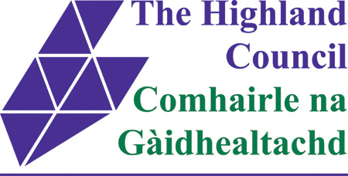

ASSET TRANSFER UNDER THE COMMUNITY EMPOWERMENT ACT

NOTICE OF ASSET TRANSFER REQUEST

Invergordon Town Hall
High Street, Invergordon, IV18 0AA

An asset transfer request has been made to Highland Council under Part 5 of the Community Empowerment (Scotland) Act 2015.
The request has been made by Invergordon Naval Museum & Heritage Centre
The request is for ownership of the Invergordon Town Hall to:
- Provide access to improved leisure & cultural facilities, enhance the High Street and make Invergordon a better place to live and work;
- To provide a destination for visitors and workers in Invergordon and create jobs;
- To tackle loneliness in the community and
- Ensure the Town Hall is restored, used and kept as something that will benefit the whole community.
Documents relating to this request can be viewed online at: www.highland.gov.uk/cat
Anyone may make representations about this request to Highland Council. Representations must be in writing and include the name and address of the person making the representation. A copy of the representation will be given to the organisation making the request, with personal information redacted, and will also be posted online as above also with personal information redacted.
Representations must be made by 25th August 2023
They should be sent to Helen Ross, Senior Ward Manager, Caithness, Sutherland & Easter Ross, The Highland Council, Drummuie, Golspie, KT10 6TA , or emailed to helen.ross@highland.gov.uk
General information about the asset transfer scheme is available at www.gov.scot/policies/community-empowerment/asset-transfer
and at www.highland.gov.uk/cat

