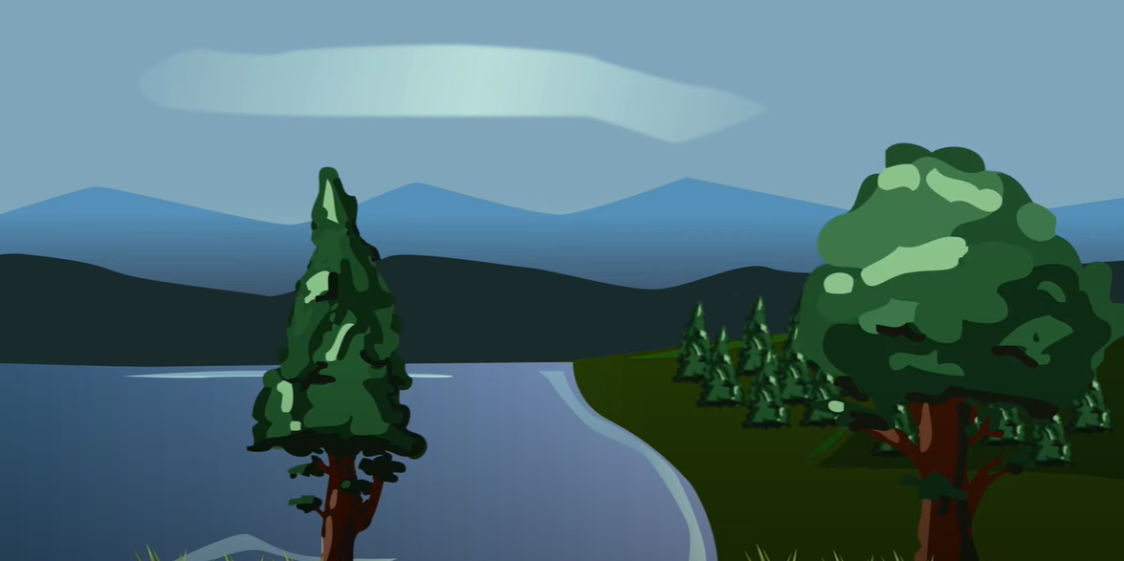
Nature Restoration Fund
Maoin Ath-shlànachadh Nàdair

Expression of Interest
Cur an cèill ùidh

This fund is for capital projects only.
Please refer to the ‘Guidance Notes’ and Fair Work First Summary Guidance when completing the application form.
A recent bank statement and a signed Fair Work First policy statement must be submitted with the application. Failure to provide these will delay the application being considered.
Projects must not start or commit expenditure before receiving and accepting the offer of grant letter if awarded funding.
All projects should be completed and claimed by 30 June 2024.

Application Form

SECTION 1: PROJECT SUMMARY
1.1 | Project reference number | Office use only
1.2 | Organisation name
1.3 | Project title
1.4 | Project costs | Total cost of project |  | £
 |  | Match funding |  | £
 |  | Grant requested |  | £
1.5 | Start date
1.6 | End date

1.7 Which ONE of the following strategic themes will the project meet?

- Habitat restoration – management for enhancement and connectivity  - Freshwater restoration, including hydrological change  - Eradication of invasive non-native species impacting on nature  - Coastal and marine management to promote restoration and resilience  - Urban - enhancing and connecting nature across, and between, towns and cities. | Yes / No  Yes / No  Yes / No  Yes / No  Yes / No
SECTION 2: CONTACT DETAILS

2.1 | Main contact name
 | Contact number
2.2 | Position
2.3 | Address  Postcode
2.4 | Email address
2.5 | Website address

SECTION 3: ORGANISATION DETAILS

3.1 | Organisation Status | Please indicate (x) | Organisation number
 | Company limited by guarantee
 | Constituted group
 | Public body
 | Charity
 | SCIO
 | Private
 | Other (please specify)

3.2 | Are you applying on behalf of a partnership and is your organisation the lead applicant? If yes, please provide partnership agreement with the application. | Yes / No

3.3 | Is the organisation VAT registered?  By ticking this, you are declaring the organisation VAT status as per HMRC. If this changes at any time during the project, you must notify the NRF Team as this may affect the offer of grant. | Yes / No
3.4 | If the organisation is VAT registered, please quote number.
3.5 | Is the VAT related to the project being reclaimed from HMRC? Provide relevant details in the box below, i.e. details of exemptions | Whole | Partial | None
Notes:

3.6 Privacy Notice
Please confirm you have read and understood the NRF Privacy Notice: Yes / No https://www.highland.gov.uk/privacynoticenrf

SECTION 4: PROJECT DETAILS

4.1 | Project location - include postcode Please also confirm whether the project location is within a designated area i.e SSSI, SAC, LNR and provide details of advice sought in 4.3.
4.2 Do you own the land/is there a lease agreement in place or do you have landowner
consents? Please provide evidence - this must be in place before you start the project.

4.3 | Does the project require planning permission or statutory regulatory consents? | Yes / No
If YES, please detail below – consents must be in place before you start the project. Please provide evidence.
Type |  | Date granted

4.4 Have you had support/advice from other organisations in developing the project?

For example: | Please indicate (x) | Details
NatureScot
Highland Council
Cairngorms National Park
Other (please detail)

4.5 | The project
- Please summarise the project, explaining how it will achieve the funds’ strategic themes as noted in 1.7, and list which outcomes it hopes to achieve.

- Please explain how the project benefits biodiversity specifically in the location stated in 4.1. How will this improve, enhance and deliver positive effects for local ecosystems in this area?

- List the main activities to deliver the project including timescales – this will be the project delivery plan. Projects must be completed no later than 30 June 2024.

Activity name | Achieve by (date)

- In developing the project, please detail how you have considered the following:

Environmental impact – describe how the project specifically addresses/supports climate change/net zero ambitions and how it mitigates any negative impacts through nature-based solutions/enhancements.

Equalities impact – explain how the project ensures that no one is excluded or disadvantaged from benefitting from the project?

Fair Work First (refer to the guidance note) – all applicants are required to provide a signed statement how your organisation is committed to advancing the Fair Work First Policy including the ‘Real Living Wage’ and ‘Effective Voice’ criteria. The statement should be agreed jointly by the employer and an appropriate workplace representative. This representative should be from the relevant trade union(s) where one or more is recognised. Alternatively, where there is no union representation, it should be another appropriate workers’ representative. Please provide this statement on a separate form. In addition, can you also confirm if you have the Living Wage Accreditation and/or planning to be certified.

- How will the project be supported or maintained after NRF funding and what will be the legacy/lasting benefits?

(f) Please outline how the project fits with the
Highland Nature: Biodiversity Action Plan (BAP) 2021 – 2026

SECTION 5: BUDGET
Delete the example below before completing this section. If the NRF project is part of a bigger project, list what the funding specifically will be spent on.

5.1 Main project expenditure

Budget Heading | Details/items | Amount
Equipment | Shovels | £50
 | Tools | £200
Materials | Tree saplings | £1000
 | Wildflower seed | £1500
Contractor costs for labour | Landscaping and tree planting | £500
 | Digger hire | £2000
TOTAL PROJECT COST |  | £
Is VAT included in these costs? |  | Yes / No

5.2 | Reasonableness of costs – please explain how you have obtained these costs whilst developing the project?

SECTION 6 – MATCH FUNDING

6.1 |  | Please give details of confirmed match funding:  Match funding must be confirmed before you start the project and evidence provided.
Name of funder |  |  | Date awarded | Amount £
Total match funding |  |  |  | £
NRF requested |  |  |  | £
Total project cost |  |  |  | £
6.2 Will the project involve “in kind” support?
This should not form part of the overall cost of the project.
Yes / No
If yes, please detail:

6.3 Please explain why public funding is required to deliver the project.

SECTION 7 – SIGNATURE
I declare that the information contained in this application is correct to the best of my knowledge. I have read the guidance notes and understand and accept the terms and conditions noted within them.
The data you have provided in the application (and claim) forms are subject to the provisions of the Freedom of Information (Scotland) Act 2002, the Data Protection Act 1998 and the Environmental Information (Scotland) Regulations 2004.

7.1 | Main applicant, chairperson or equivalent – the person signing this application has the authority within the organisation to apply for grant funding
 | Signature: | Print: | Date:

7.2 Supporting documents checklist.
You must enclose the following documents with the application.

1 | Bank statement – latest statement
2 | Financial accounts – latest available accounts
3 | Fair Work First – signed policy statement
Please declare what the remaining balances are for in you bank account:

If your project is approved funding, we require the following additional documentation (where applicable) before you start:

- Constitution or articles of memorandum
- Committee members or directors list (unless stated in the annual accounts)
- Permissions – planning, consents, licences
- Policies – such as health and safety, environmental policy, equal opportunity
- Confirmation of match funding
- Copy of valid insurance policy
- Evidence of land ownership, lease, or consents
- Partnership agreement

For assistance completing this form please contact: NRF@highland.gov.uk
For further information, please visit https://www.highland.gov.uk/naturerestorationfund

