CONSULTATION on:-
Proposal to dispose, by way of “ribbon” lease, small portions of common good land located at Riverside Park (south of the River Wick) to wind farm developers to facilitate the oversail of turbines and equipment necessary for the installation, maintenance and decommissioning of such wind farms.
What is proposed?

The Council has recently been approached by a wind farm company seeking an option to lease an area of land in Wick to oversail with turbines as part of a wind farm development. Investigations have confirmed that the area of land to be subject of the oversail forms part of Wick Common Good having been acquired by the Town Council of Wick in 1900. This area of land is shaded pink on the plan below and forms part of Riverside Park (south of the river).

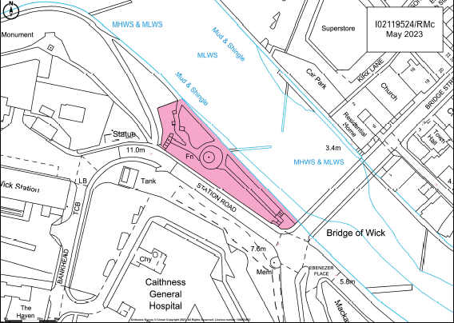

When a wind farm developer is transporting turbines and equipment required for the construction and installation of the wind farm, it will use the existing road infrastructure. In doing so, the turbines and equipment being transported may be required to temporarily over hang areas of land outwith the adopted road. This is known as an “oversail”.

In order for a developer to obtain funding, a real right in land (i.e. ownership or a registerable lease) is required by their lender. Often several developers need to oversail the same area of land at different times so leasing the actual land being oversailed to one developer is not a workable solution. This would preclude the ability of other developers to oversail without the tenant developer’s consent. Therefore, in order for several developers to secure funding, a practise has arisen of granting a “ribbon” lease as it is, in effect, a lease of a small token strip of land adjacent to the area being oversailed. The rights to oversail are set out as ancillary rights in that lease. This arrangement allows for different wind farm developers to obtain leases of different “ribbons” allowing them all to oversail a broadly similar area of land. The length of these leases is often in excess of 30 years to cover the expected life of the wind farm.

Wick Common Good fund was reactivated following investigations leading to the publication of the Wick Common Good asset register in May 2021. During the investigations Common Good property assets were identified, but no cash assets. As a result, the fund has limited revenue assets. The manner of rent arrangement for the oversail leases can vary from company to company both in nature of payment and value of payment. Therefore the securing such leases for would provide significant income generation opportunities for Wick Common Good fund.
As stated above, the development of wind farms are usually funding dependant which can make assessing timescales difficult to predict and as a result these can be subject to change. The current request is an example of that, as the timescales for having agreements in place have reduced making the required Community Empowerment consultation and subsequent Sheriff Court approval impossible. As a one off arrangement, a proposal has been made to allow a lease of non-Common Good land but with attendant rights permitting the oversail to ensure that the main benefit still accrues to Wick Common Good.
This is not an ongoing solution and, as a result, the Council is consulting on the proposal to allow general permission to negotiate and grant these “ribbon” leases without requiring separate consultations in each case. This will ensure the correct permissions are in place and allow the Council on behalf of Wick Common Good to act within any changing timescales resulting from funding constraints or varying wind farm company requirements. Allowing this general approval for such disposals will ensure Wick Common Good fund can continue to benefit from such opportunities as they arise.
The granting of such “ribbon” leases will not impact the use of the subjects as a public park and no physical occupation of the ground will take place. The land will be oversailed during the development, maintenance and decommissioning of the wind farms as when may be required.

Consultation
Section 104 of the Community Empowerment (Scotland) Act 2015 requires the Council to consult local communities when considering disposing or changing the use of Common Good assets. This includes where the proposal is to grant a lease of over 10 years.
Therefore, before taking any decision, and to inform the decision making process, we are keen to hear the views of the community, in particular:

- What are your views on the proposed disposal, by “ribbon” lease, of portions of common good land located at Riverside Park (south of the River Wick) to wind farm developers to facilitate the oversail of turbines and equipment necessary for the installation, maintenance and decommissioning of such wind farms.

- Do you have any views on the proposal that a single permission be granted to cover all future such lease arrangements?

- Do you have any views on potential benefits of the proposal?

- Do you have any issues or concerns arising from the proposal?
- Do you have any additional comments?

The Council will take all representations into account in reaching a decision.

Depending on the representations received the possible outcomes are:
- The proposal goes ahead subject to consent being given by the Sheriff Court.
- The proposal is amended significantly, and a fresh consultation takes place.
- The proposal does not go ahead.

Representations
Consultation closing date – 5 January 2024

Please submit written representations to:-
Email: common.good@highland.gov.uk
Post: Sara Murdoch, Highland Council, Headquarters, Glenurquhart Road, Inverness, IV3 5NX.

Additional information
The Highland Council have a statutory obligation to seek court consent before disposing of Common Good land which may be ‘inalienable’.

In this context ‘inalienable’ refers to Common Good property that falls into at least one of the following categories: -
- The Title Deed of the property dedicates it to a public purpose, or
- The Council has dedicated it to a public purpose, or
- The property has been used for public purposes for many years (time immemorial) without interference by the Council.

This particular portion of Riverside Park (south of River Wick) was acquired in a disposition by the Trustees of James Louttit to the Town Council of Wick registered 12 July 1900. The title deed recites that the area of land was acquired for “behoof of the whole body and community thereof (Wick) and also for behoof of the community of the Burgh of Pultneytown, to be held in all time coming primarily for recreation purposes heritably and irredeemably”. As a result it has been dedicated to a public purpose and is inalienable.
If after this consultation, the proposal progresses to a court application the public will have a further opportunity to make representations within that process. A statutory advertisement will be placed in the John O’Groat Journal to inform the local public that the court process has been commenced.

