I,E&E  The Highland Council  Site Supervision Team | OUTAGE 2  WEEKLY PROGRESS REPORT

Project: | Uig Harbour Redevelopment | Project No: | YEHAH0001
Contractor: | RJ McLeod (Contractors) Ltd

Week No: | 1 of 6 |  | Week Ending: |  | 03/11/2023
Contract Period: | Outage 2 |  | Planned Completion Date: |  | 11/12/2023
For information |  | Weather: |  | No weather delays experienced
 |  | Progress v Programme: |  | Planned Completion of the outage is on target
Activities
- Arrival of ‘Lara 1’ crane barge on site ahead of schedule. First lift to take place on Monday next week.
- Decommission and prepare linkspan for lifting, hang linkspan on pad eyes
- Horizontal cut to existing linkspan lifting dolphins
- Delivery of linkspan components by lorry
- Installation of steel reinforcement to outer roundhead
- Installation of steel reinforcement to linkspan bankseat
- Concrete poured to linkspan bankseat
- Cut chains and extract existing inner dolphin fenders

Photographs:
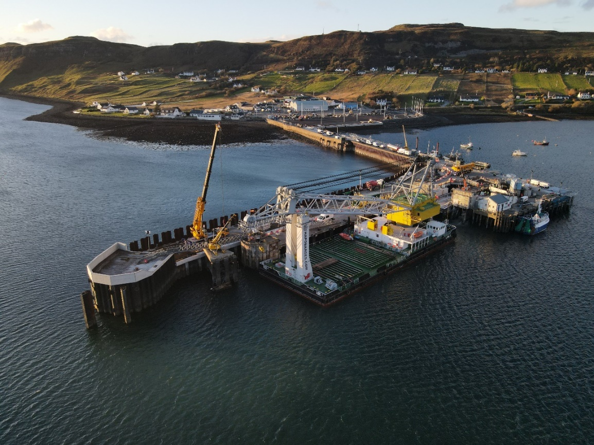
‘Lara 1’ Crane Ship on Site
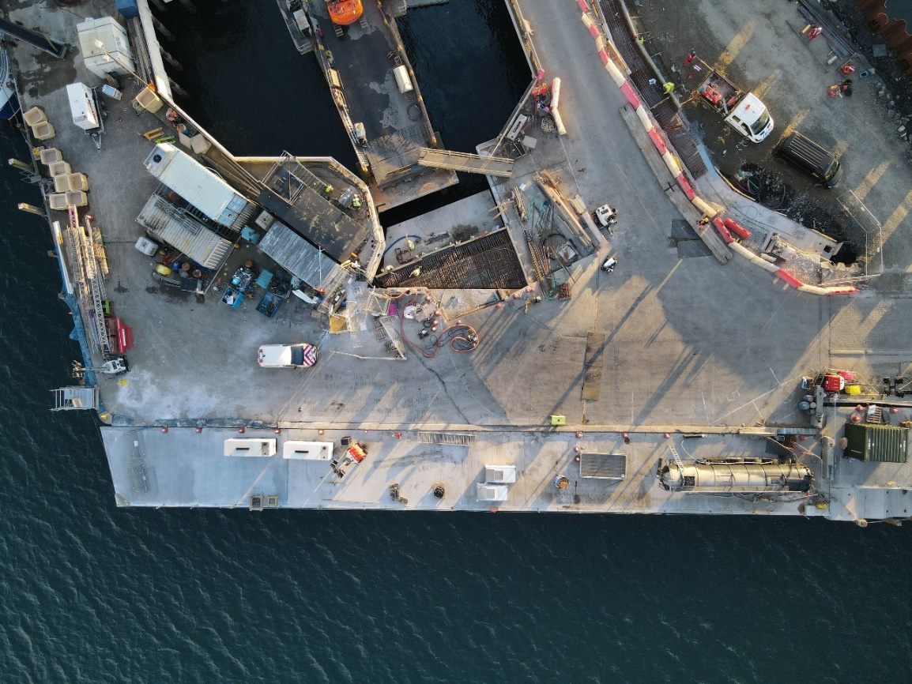
Linkspan Bankseat Works

Copied to: | The Highland Council Website

