I,E&E  The Highland Council  Site Supervision Team | OUTAGE 2  WEEKLY PROGRESS REPORT

Project: | Uig Harbour Redevelopment | Project No: | YEHAH0001
Contractor: | RJ McLeod (Contractors) Ltd

Week No: | 3 of 6 |  | Week Ending: |  | 17/11/2023
Contract Period: | Outage 2 |  | Planned Completion Date: |  | 11/12/2023
For information |  | Weather: |  | 1.5 days lost to high winds
 |  | Progress v Programme: |  | 2 day delay experienced, remain on programme for reopening on the 11th of December
Activities
- Remove lower level concrete blocks from existing linkspan lifting dolphins, all of the superstructure has now been removed and is being broken up on site for recycling and removal from site
- Cut and extract bankseat piles, this work is now complete
- Cut and extract linkspan lifting dolphin piles, - this work is ongoing and when sufficient piles are removed the linkspan can be lifted into position. It is programmed to lift the linkspan into its final position on Friday 17th / Saturday 18th of November. (Prior to the outage this operation was programmed for the 25th of November – Work therefore remains on schedule for opening on the 11th of December)
- Install fender brackets to inner dolphin - the fender work has been delayed due to the weather conditions and is currently behind programme. Work will be targeted on the critical fenders to allow opening on schedule
- Linkspan mechanical and electrical installation – work is progressing well and the pipework is 70% complete, the control cabinet and linkspan control room are in place and the fit out is also progressing well
- Installation of linkspan scheduled for Friday 17th / Saturday 18th subject to removal of the dolphin piles and weather conditions
- Installation of steel reinforcement to roundhead - concrete pour for this area is scheduled for Monday 20th

Photographs:
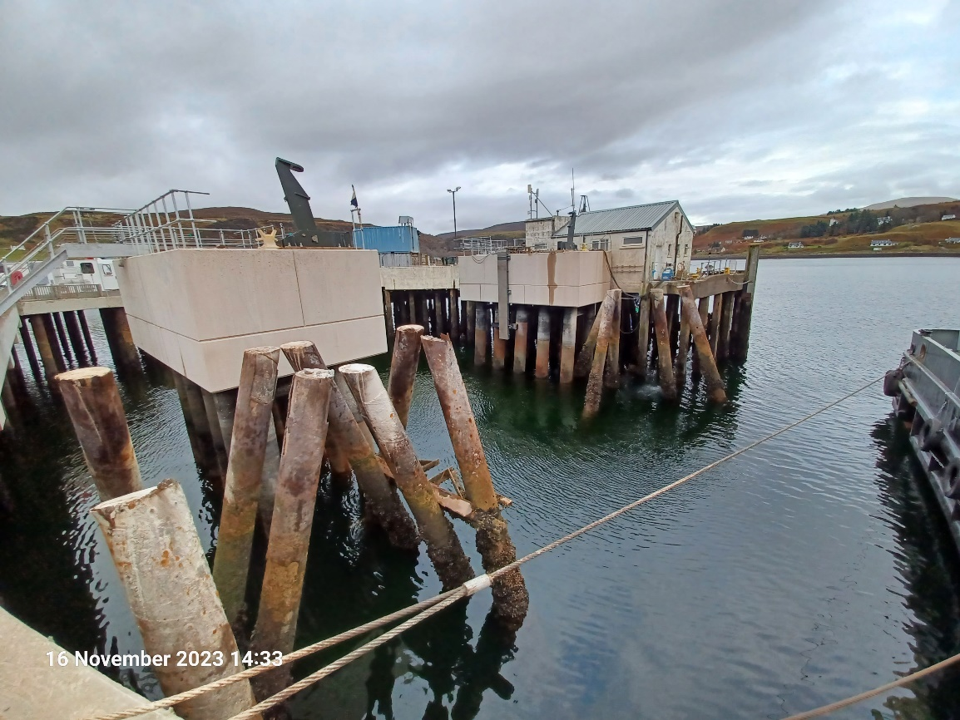
Extraction of Linkspan Lifting Dolphin Piles
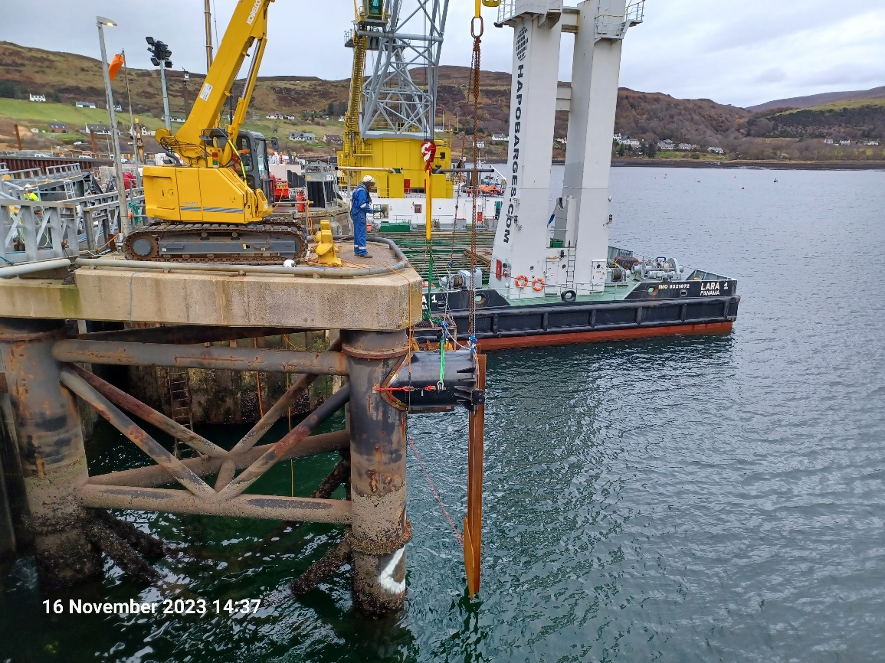
Installation of Fender Brackets to Inner Dolphin
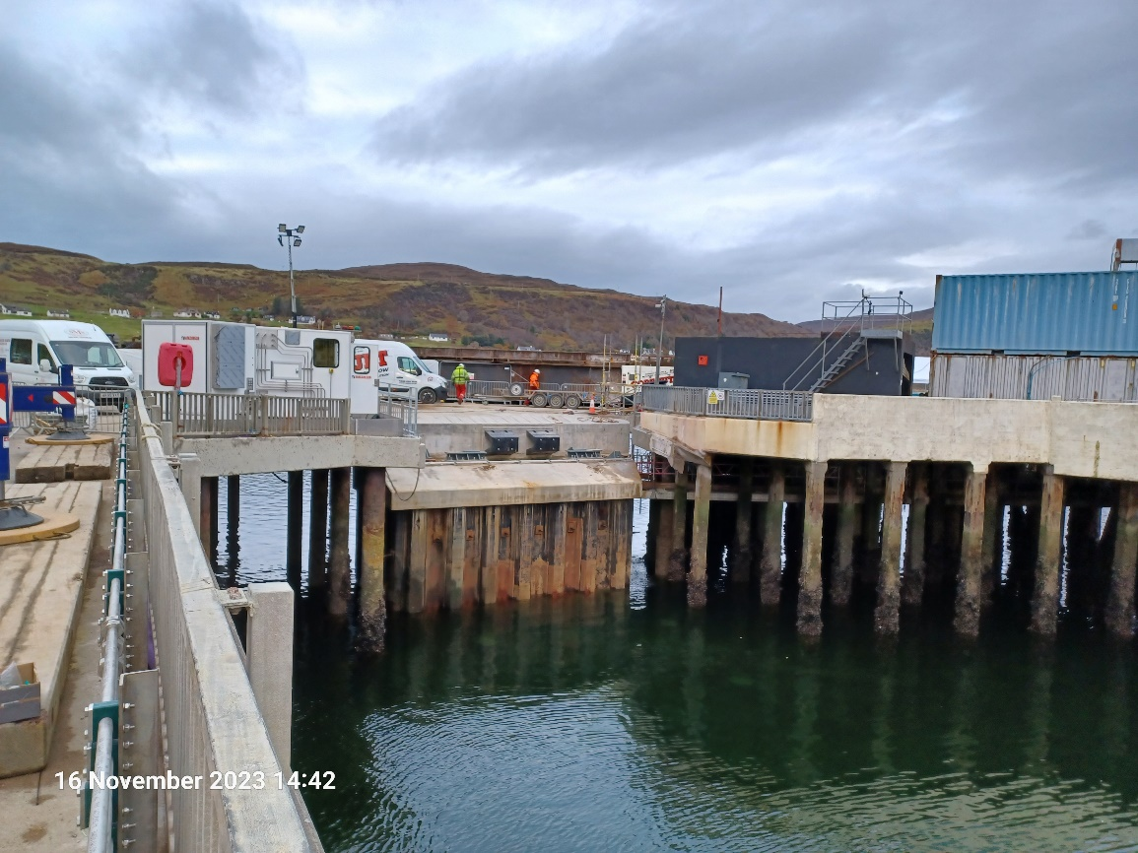
Linkspan Mechanical and Electrical Installation - Control Cabinet and Linkspan Control Room
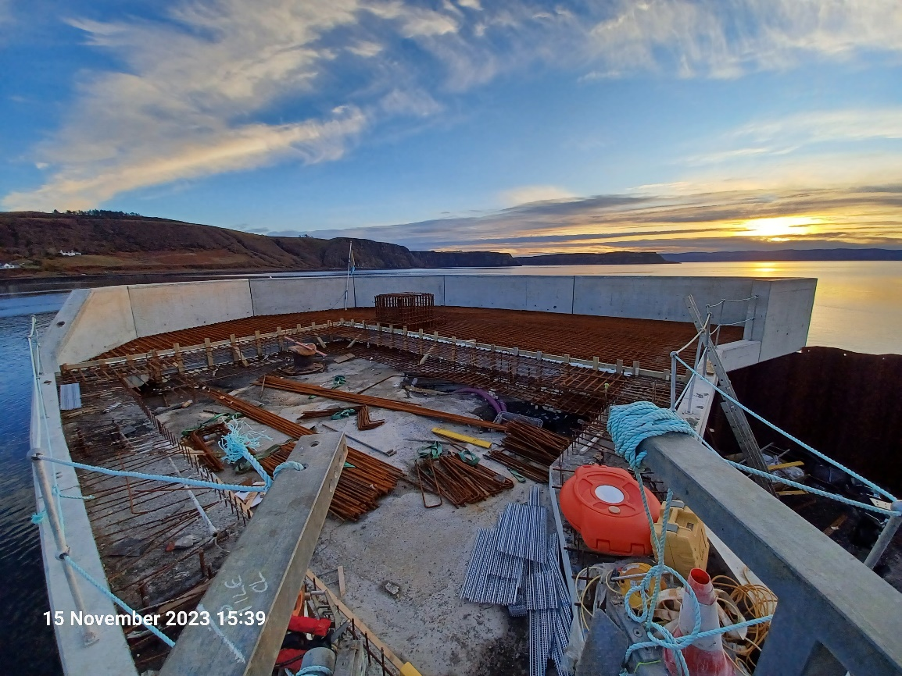
Installation of Steel Reinforcement to Roundhead

Copied to: | The Highland Council Website

