I,E&E  The Highland Council  Site Supervision Team | OUTAGE 2  WEEKLY PROGRESS REPORT

Project: | Uig Harbour Redevelopment | Project No: | YEHAH0001
Contractor: | RJ McLeod (Contractors) Ltd

Week No: | 4 of 6 |  | Week Ending: |  | 24/11/2023
Contract Period: | Outage 2 |  | Planned Completion Date: |  | 11/12/2023
For information |  | Weather: |  | 3 days lost to high winds
 |  | Progress v Programme: |  | 5 day delay experienced, remain on programme for reopening on the 11th of December
Activities
- Cut and extract linkspan lifting dolphin piles, 2no. remaining
- Install fender brackets to inner dolphin, works require use of crane and have therefore been impacted by high winds on Wednesday and Thursday
- Linkspan mechanical and electrical installation, pressure testing and flushing of hydraulic pipework commenced on Thursday ahead of programme
- Concrete pour to roundhead deck unit scheduled for Friday
- Commence extraction of existing berthing line fenders, 8no. total to remove, works require use of crane and have therefore been impacted by high winds on Wednesday and Thursday
- Installation of berthing line fender piles due to commence following removal of existing fenders, 7no. to install, works require use of crane and have therefore been impacted by high winds on Wednesday and Thursday

Our contractor RJ McLeod commented (Thursday 23rd November) ‘With additional resources and working longer hours we are still focussed on the 11th December but it is very tight and if there are any further weather delays or other issues with the piles or fenders there will be an overrun’

The HC will provide a further update on progress over the weekend to the communities during the planned Uig resilience meeting Monday 27th.

Photographs:
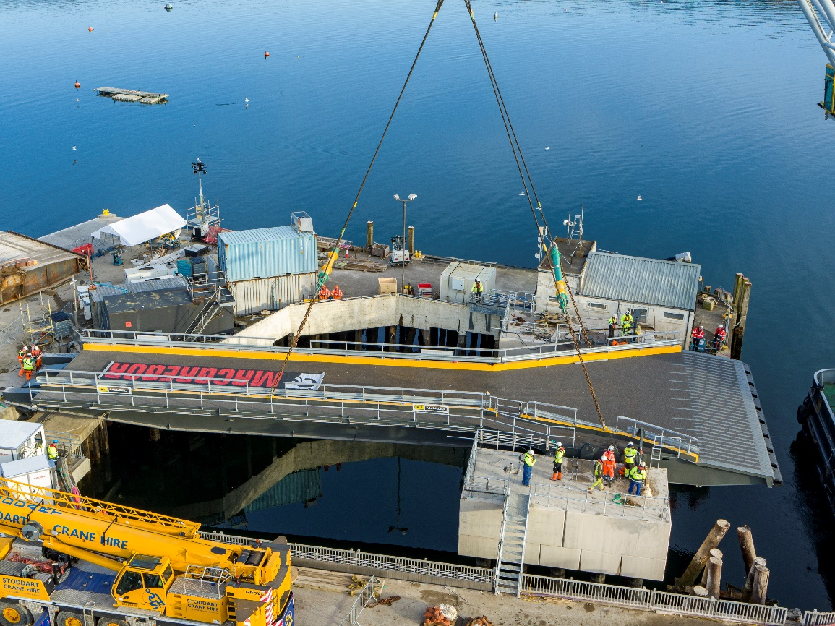
Installation of Linkspan Last Friday 17/11/23
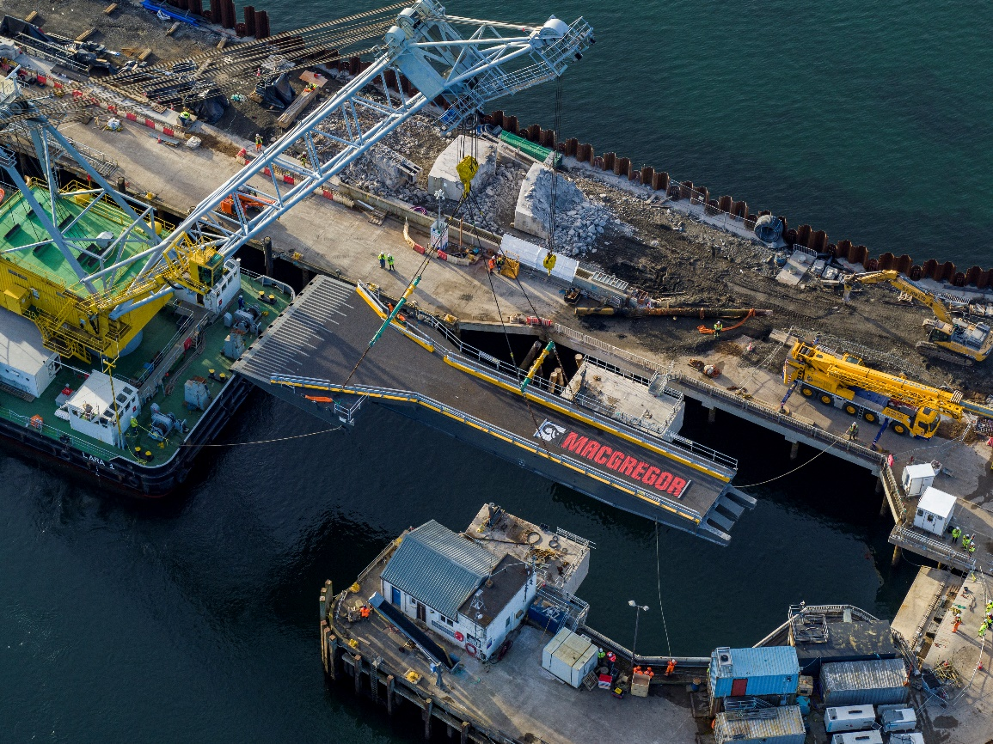
Installation of Linkspan Last Friday 17/11/23
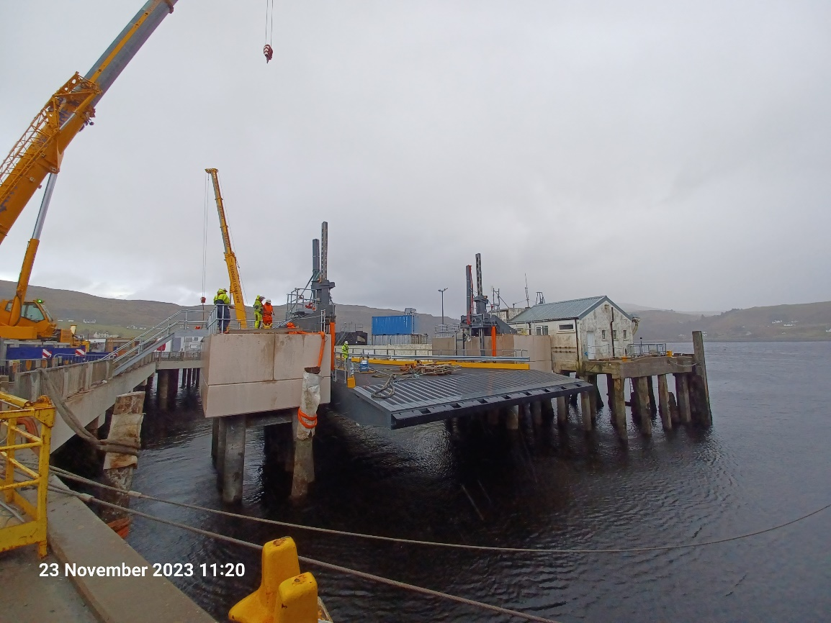
Linkspan Mechanical and Electrical Installation and Extraction of Linkspan Lifting Dolphin Piles
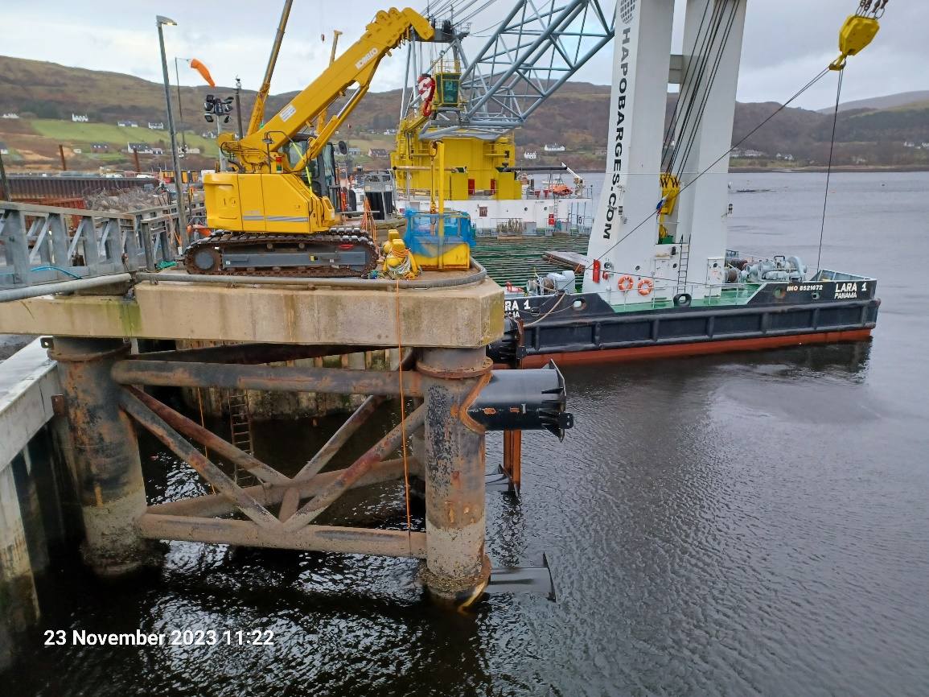
Installation of Fender Brackets to Inner Dolphin

Copied to: | The Highland Council Website

