I,E&E  The Highland Council  Site Supervision Team | OUTAGE 2  WEEKLY PROGRESS REPORT

Project: | Uig Harbour Redevelopment | Project No: | YEHAH0001
Contractor: | RJ McLeod (Contractors) Ltd

Week No: | 5 of 6 |  | Week Ending: |  | 01/12/2023
Contract Period: | Outage 2 |  | Planned Completion Date: |  | 16/12/2023
For information |  | Weather: |  | 3.5 days lost to high winds
 |  | Progress v Programme: |  | 7 day delay experienced, scheduled reopening programmed for Saturday 16th December, on programme to achieve this rescheduled date
Activities
- Cut and extract all remaining linkspan lifting dolphin piles.
- Cut and extract existing berthing line fenders, 8no. total. All piles have now been removed.
- Installation of 7no. berthing line fenders with concrete plug and welded cap. Installation of fender sleeves with panels to follow.
- Install fender brackets to inner dolphin.
- Complete linkspan mechanical and electrical installation, commissioning works due to commence on Friday, load test programmed for 4th of December.
- Installation of steel reinforcement to outer roundhead, concrete poured to bollard plinth on Thursday, final concrete pour to deck scheduled for Monday 4th of December. Installation of mooring bollards to follow.

Note:
The berthing trials for ferry operations to resume on the 16th of December are scheduled to take place on the evening of the 14th of December provided no further weather delays are encountered. The Highland Council will provide updates on progress as the installation and commissioning progresses.

Photographs:
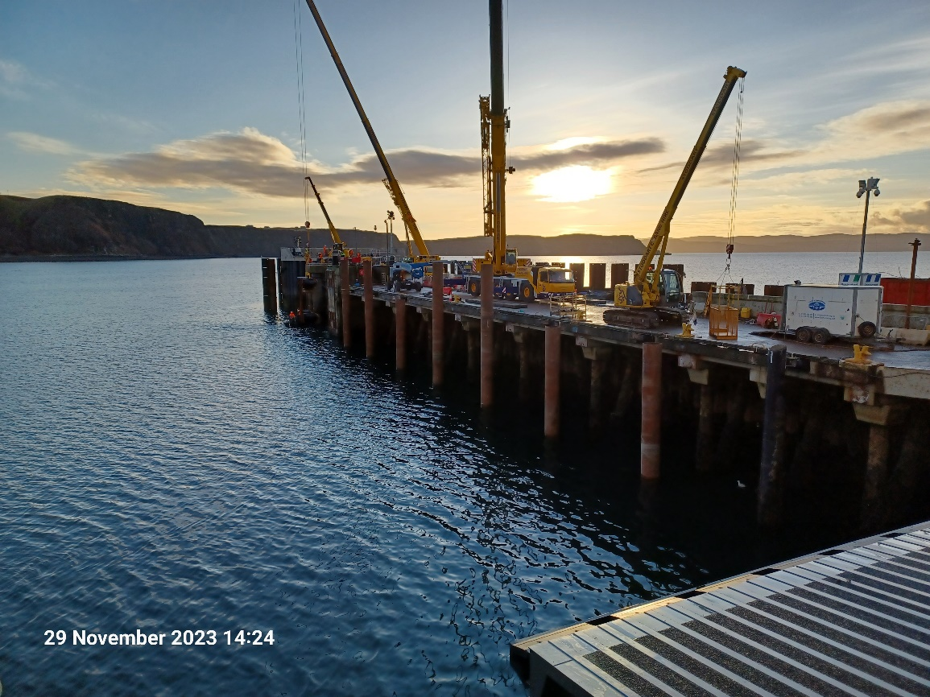
Installation of Berthing Line Fenders
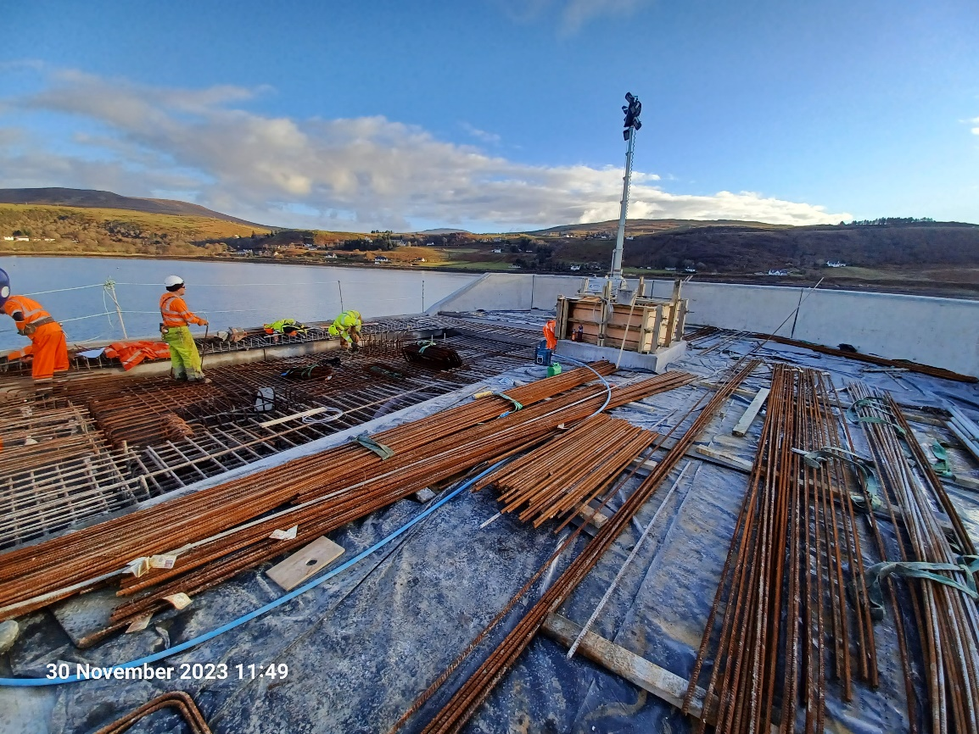
Installation of Steel Reinforcement to Outer Roundhead
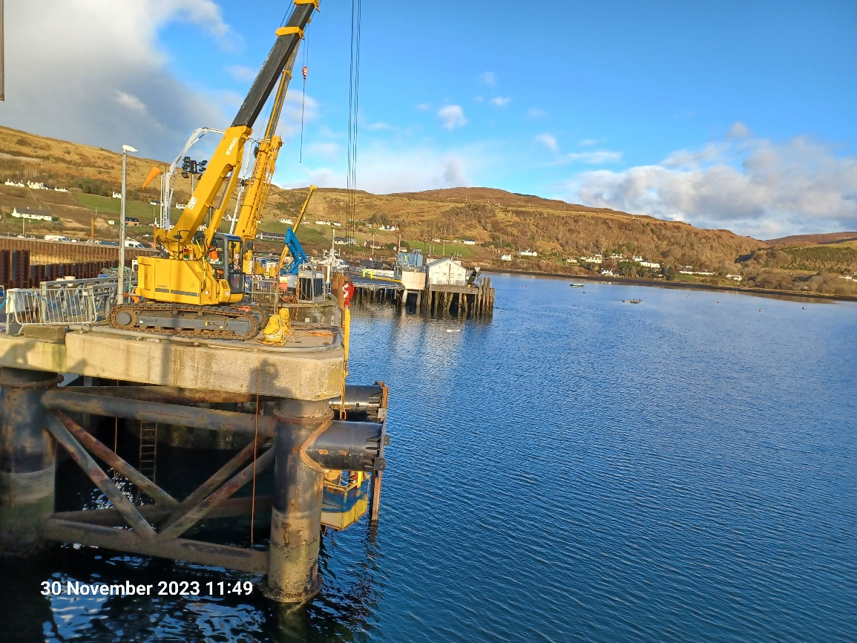
Installation of Fender Brackets to Inner Dolphin
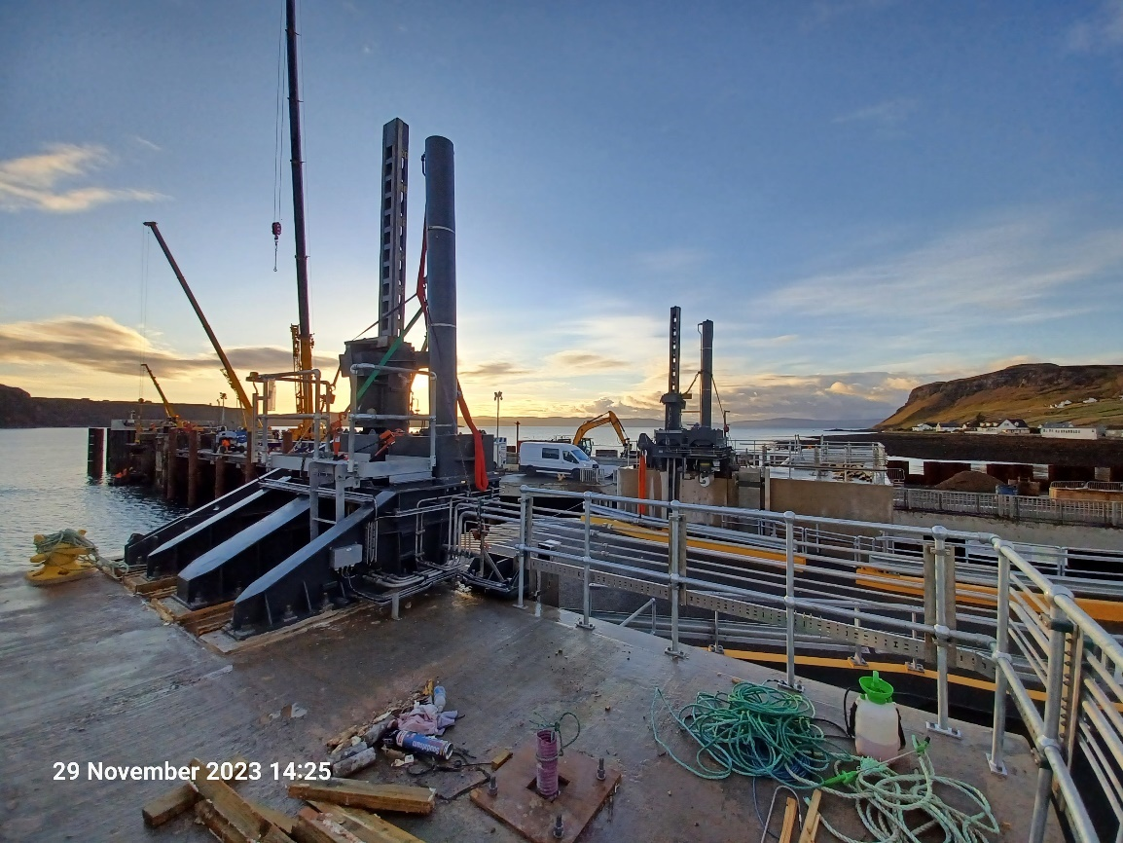
Linkspan Mechanical and Electrical Installation

Copied to: | The Highland Council Website

