I,E&E  The Highland Council  Site Supervision Team | OUTAGE 2  WEEKLY PROGRESS REPORT

Project: | Uig Harbour Redevelopment | Project No: | YEHAH0001
Contractor: | RJ McLeod (Contractors) Ltd

Week No: | 6 of 7 |  | Week Ending: |  | 08/12/2023
Contract Period: | Outage 2 |  | Planned Completion Date: |  | 16/12/2023
For information |  | Weather: |  | 3.5 days lost to high winds
 |  | Progress v Programme: |  | 7 day delay experienced, scheduled reopening programmed for Saturday 16th December, on programme to achieve this rescheduled date
Activities
- Cut and extract existing berthing line fenders, 8no. total
- Installation of fender sleeves and panels with grout infill to anulus. Installation of chains also ongoing
- Install fender brackets to inner dolphin, installation of fenders to follow
- Linkspan commissioning and testing works completed on Tuesday. Operator training and berthing trials to take place on Thursday 14th December in advance of programmed reopening on Saturday 16 December 2023
- Installation of steel reinforcement to outer roundhead, final concrete pour to deck carried out on Thursday 7th December. 100t mooring bollard installed

The Highland Council will provide a further update on progress to the communities during the planned Uig resilience meeting Monday 11 December 2023.

Note that when ferry services resume the vehicle marshalling for ferry traffic shall be in its ‘normal’ space. The new marshalling area is now due to open under a revised traffic management plan following the Christmas break.

Photographs:
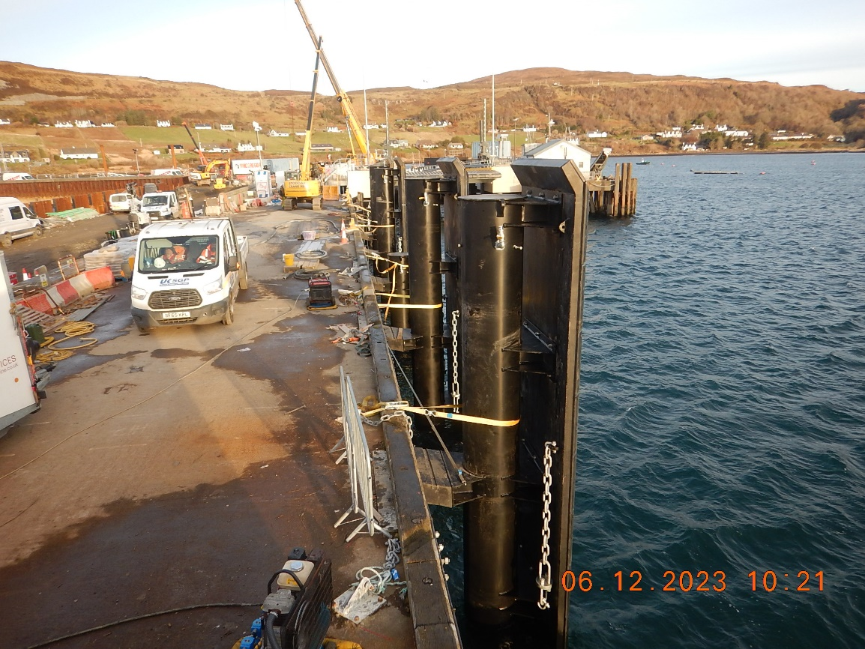
Installation of Berthing Line Fenders
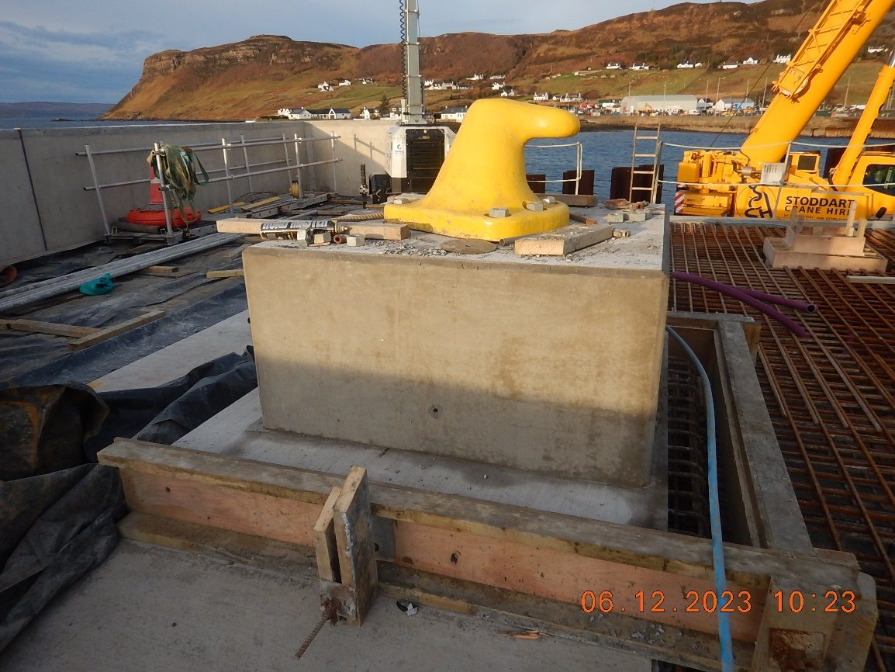
Installation of Bollard to Roundhead
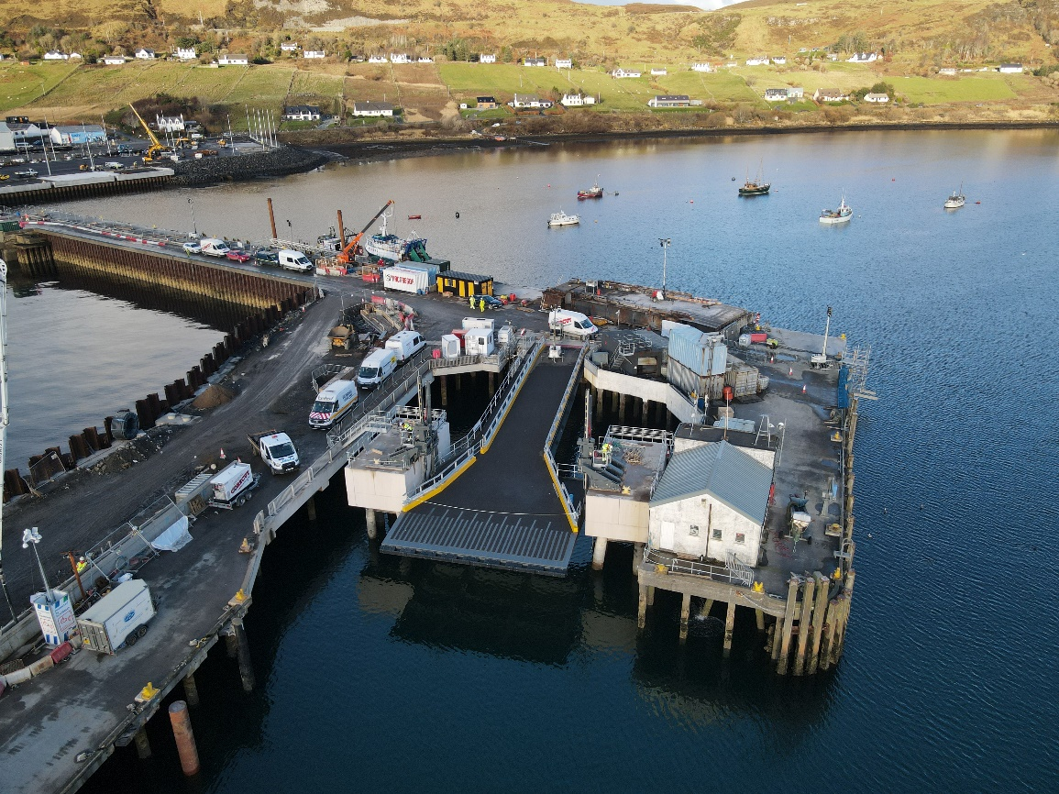
Linkspan Commissioning and Testing
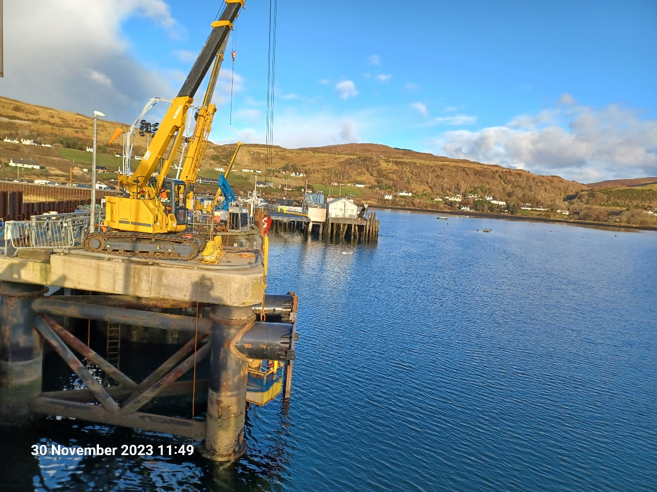
Installation of Fender Brackets to Inner Dolphin

Copied to: | The Highland Council Website

