I,E&E  The Highland Council  Site Supervision Team | OUTAGE 2  WEEKLY PROGRESS REPORT

Project: | Uig Harbour Redevelopment | Project No: | YEHAH0001
Contractor: | RJ McLeod (Contractors) Ltd

Week No: | 7 of 7 |  | Week Ending: |  | 16/12/2023
Contract Period: | Outage 2 |  | Planned Completion Date: |  | 16/12/2023
For information |  | Weather: |  | 3.5 days lost to high winds
 |  | Progress v Programme: |  | 7 day delay experienced
Activities
- Installation of fenders to inner dolphins completed on Tuesday
- Dive survey carried out to check seabed for debris, no reported obstructions
- Tidying and road sweeping works prior to return of ferry operations
- Linkspan operator training carried out on Thursday 14th December
- All planned outage works complete
- Berthing trials with MV Hebrides carried out on the evening of Thursday 14th December
The planned opening of Uig Harbour which was due to take place on the 16 December will regrettably be delayed. The berthing trial of the MV Hebrides, on the 14 December, highlighted an issue where new restraint bollards, designed to aid the manoeuvring of the vessel during bad weather, did not function as planned. The Highland Council, RJ McLeod’s, our partners Caledonian Maritime Assets Limited (CMAL), Transport Scotland and CalMac are working on a solution to install an additional bollard to ensure safe operations to resume ferry services.

Other aspects of the trial were successful such as the linkspan, fendering and vehicle swept path tests were completed.

To avoid unnecessary uncertainty, the Highland Council has taken the decision, in consultation with our contractor RJ McLeod, our partners Caledonian Maritime Assets Limited (CMAL), Transport Scotland and CalMac, to delay the re-scheduled opening of Uig harbour until after the completion of revisions to the restraint bollards and a re-scheduled vessel berthing trial to be conducted on 21 December 2023. Following a successful berthing trial services would be expected to resume on Friday 22 December
The Highland Council apologises for any inconvenience caused and will seek to minimise the delay to re-opening services.
Alternative Ferry operations will continue as scheduled
Photographs:
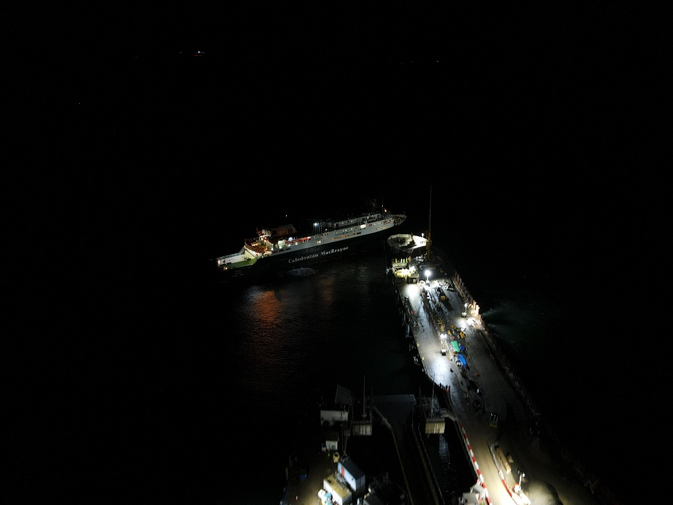
MV Hebrides Berthing Trials
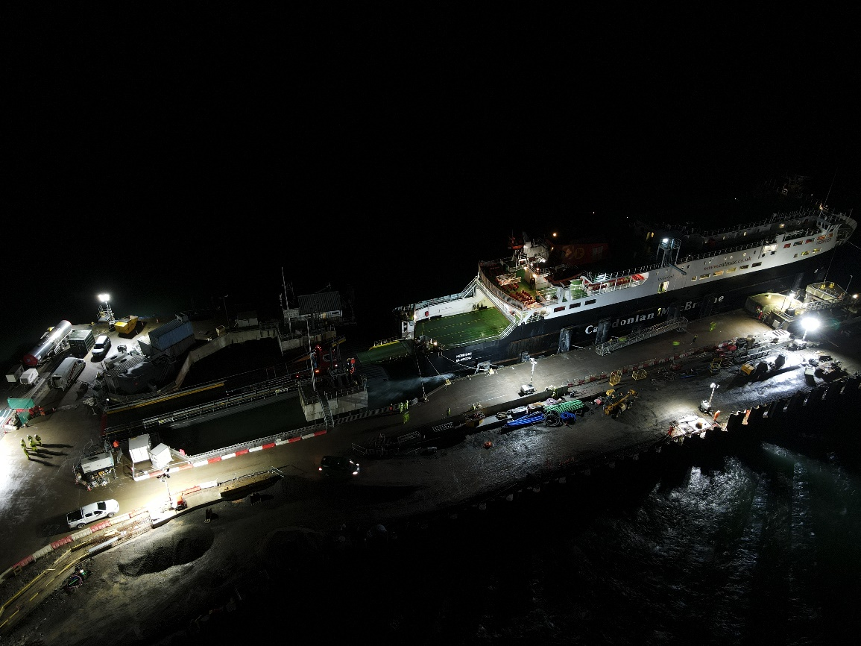
MV Hebrides Berthing Trials

Copied to: | The Highland Council Website

