I,E&E  The Highland Council  Site Supervision Team | OUTAGE 2  WEEKLY PROGRESS REPORT

Project: | Uig Harbour Redevelopment | Project No: | YEHAH0001
Contractor: | RJ McLeod (Contractors) Ltd

Week No: | 8 of 8 | Week Ending: | 22/12/2023
Contract Period: | Outage 2 | Planned Completion Date: | 20/12/2023
- Installation of additional bollard to roundhead and berthing structure following issues raised during previous berthing trial
NOTE: Berthing trial carried out successfully on Wednesday 20th December following installation of additional bollards. CALMAC have confirmed that ferry services will resume at Uig from Friday 22nd December. No further outage progress reports will be issued.

Photographs:
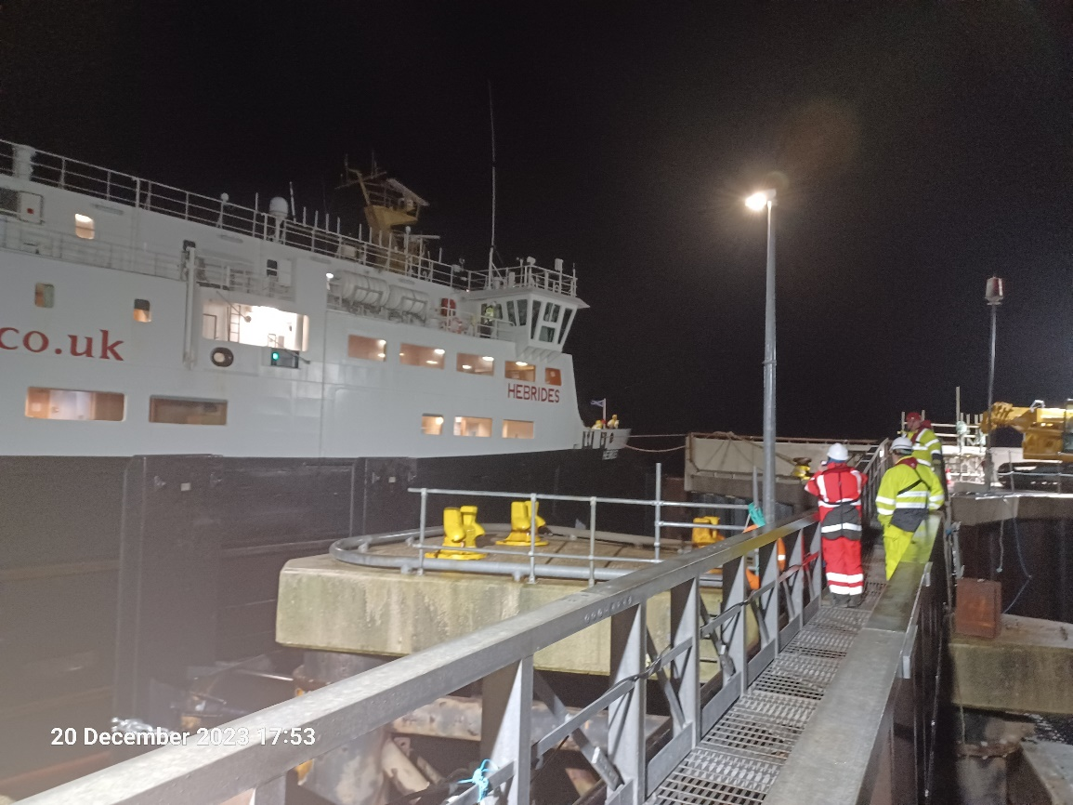
MV Hebrides Berthing Trials
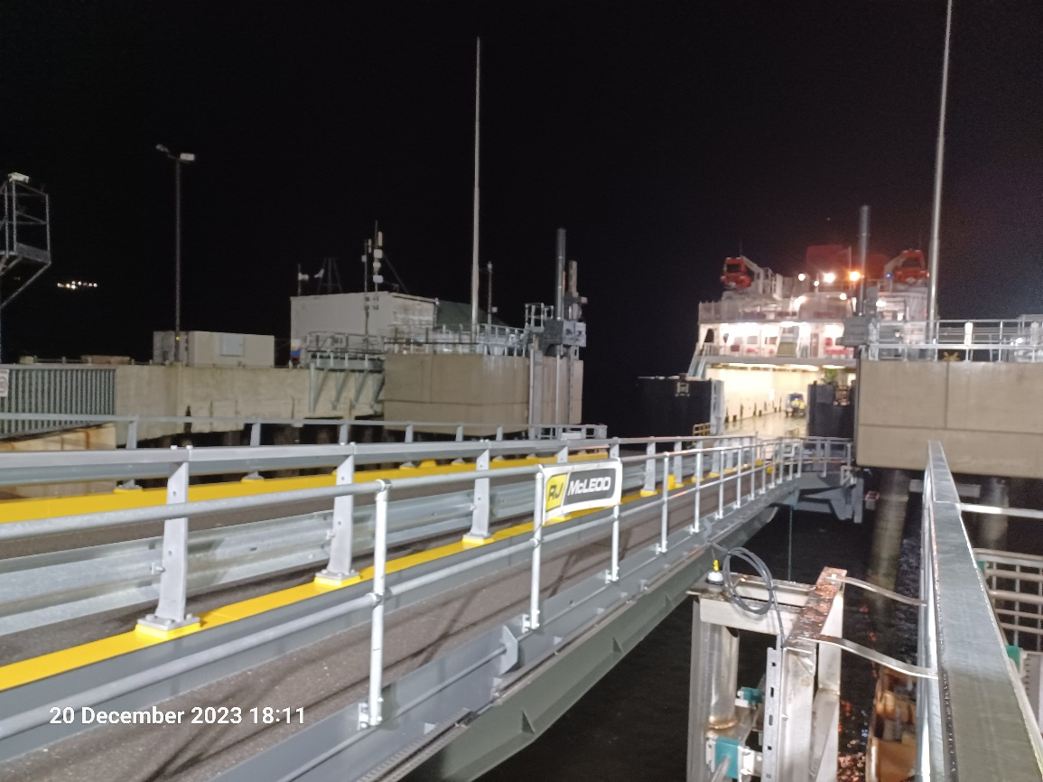
MV Hebrides Berthing Trials

Copied to: | The Highland Council Website

