CONSULTATION on:-
Proposal to dispose, by sale, of the bust of Sir John Gordon by Edmé Bouchardon; an asset of Invergordon Common Good fund.

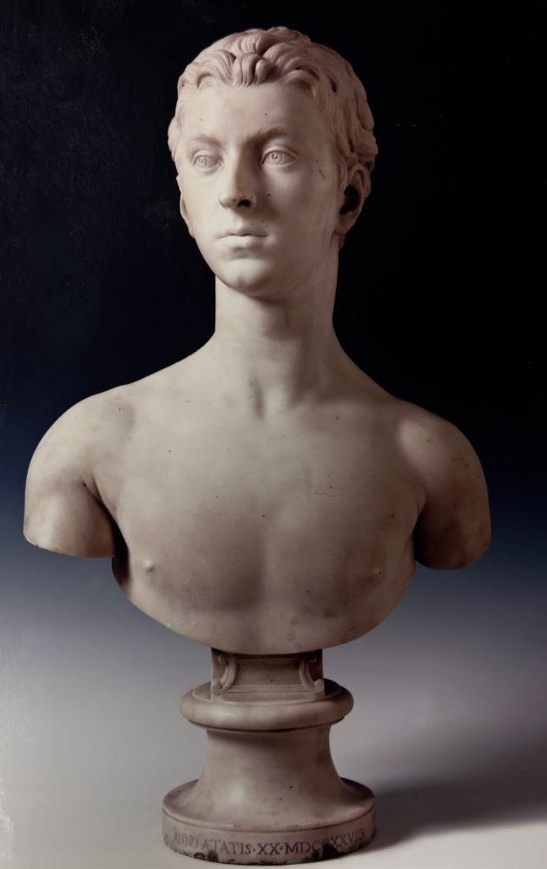

What is proposed?
The Council wishes to consider whether the bust of Sir John Gordon sculpted by Edmé Bouchardon should be sold. The bust is an asset of Invergordon Common Good fund.

The aim of this consultation
Section 104 of the Community Empowerment (Scotland) Act 2015 requires the Council to consult local communities when considering the disposal of Common Good assets. This is the first step in a lengthy process. Before taking any decision, and to inform the decision making process, we are keen to hear the views of the community on potential sale. The Council will take all representations into account in reaching a decision. If the Council chooses to dispose, this will then need to be considered and decided upon by a court because the Bust is considered an inalienable asset.¹

The full background to this proposal can be viewed online via the following reports to the Easter Ross Area Committee, namely:
- Easter Ross Area Committee 17 February 2022 when a decision was made that officers should undertake work on an options appraisal and outline business case for the use of any capital receipt in the event that a proposal to sell was approved. The February 2022 report can be read in full at item 11 from this link Easter Ross Area Committee | The Highland Council
with the decision recorded on the minute at this link Easter Ross Area Committee | The Highland Council

- In August 2023, Sotheby’s Auctioneers received an unsolicited offer to purchase the bust. Details about this offer and the issues that require to be considered can be read in full in the Easter Ross Area Committee report in October 2023 which can be accessed from this link at item 10 - Easter Ross Area Committee | The Highland Council . This Committee report should be read alongside the consultation document. Following full consideration of the contents of the report, Members agreed to commence a Community Empowerment consultation to inform the decision making in respect of a proposal to sell the Bouchardon bust.

What is the Bouchardon bust and why is it regarded as Common Good property?
The bust of Sir John Gordon was sculpted by Edmé Bouchardon in the early 18th century. It has been described by experts at Sotheby’s as being “ brilliant in execution” and in a style not to be more widely seen until later in the 18th century.

Sir John Gordon is believed to have been the founder of Invergordon and the original reason for the purchase was for public display because of who the subject was namely, Sir John Gordon, not because of who the sculptor was. The fact that it was acquired for this reason and with clear intent that it should be on public display in the Town Hall means it is assessed as being a Common Good asset.

Where is the bust now?
The Bouchardon Bust is in secure, approved storage in Inverness. Because of the value of the Bust, and security concerns, it has not been possible to put it on public display locally.

Things to consider
- Title - Once title had been evidenced, consideration was given to whether the bust was a Common Good or General Fund asset of the Council. The bust was purchased by the Town (or Burgh) Council of Invergordon. There is case law that states that any property acquired by a burgh not for statutory purposes or held on special trusts is Common Good.

- Ability to display - With the exception of two occasions when the bust was loaned to the Getty Museum and the Louvre under special arrangements, the high value and associated security issues have prevented it from being on public display locally. The bust is currently held within secure, approved storage in Inverness.

- Expert advice from Sotheby’s - chosen for their long involvement with the Council both in respect of specific projects and general advice for insurance purposes. They have advised on current market value, estimated to be in excess of £2.5m.

- Where would the money go if the Bust was sold? – the bust is a Common Good asset and therefore the proceeds from any sale would be a capital receipt belonging to the Invergordon Common Good Fund. Sale proceeds would require to be dealt with in accordance with Council policy and Scottish Government guidance. The current Common Good Policy (see link Common Good Fund Policy | (highland.gov.uk) ) follows the Government guidance with both stating any capital receipts can only be used to fund new capital expenditure. This would offer the potential for investment that would generate an ongoing income for Invergordon Common Good fund which, in turn, would be used for the benefit of the Invergordon community. Any financial considerations can only be in broad terms at this stage.

- Is it ethical to sell? – Ethical sale issues are of most relevance when an item is accessioned² into a museum collection and there is a set Code of Ethics for such circumstances including a clear process around deaccessioning³. This is not the case with the Bouchardon bust as it is not accessioned. However, it would remain advisable to consider these criteria and the Code of Ethics as the basis for any sale, if approved. Expert advice from Sotheby’s confirmed they were not aware of any examples of loss of access to heritage funding resulting from the sale of a non-accessioned item and, if handled appropriately, any sale of the bust would not have any wider adverse effects to the Council.

- Waverley criteria - It should also be noted that if a proposal to sell is approved (by Council and Court) it would be referred to the UK Reviewing Committee on the Export of Works of Art and Objects of Cultural Interest, known as the Waverley Committee, who, if they regard it as meeting the ‘Waverley Criteria,’ would defer any sale for a period to allow any UK museum to express a serious intention to purchase. If such intention is expressed, a further period of deferral would be allowed for funds to be raised. If no interest is expressed, sale would proceed as originally proposed. The three Waverley Criteria are:

- Is it closely connected with our history and national life?
- Is it of outstanding aesthetic importance?
- Is it of outstanding significance for the study of some particular branch of art, learning or history?

- Replica for local display – it is proposed that if a decision was taken to sell the bust, a high-quality replica could be commissioned which would allow for local public display. This would fulfil the original intention of the purchase.

Recent offer
In August 2023 Sotheby’s received an unsolicited offer from a private buyer expressing interest in purchasing the Bouchardon bust if it were to be considered for sale. As work on the options appraisal and business case was ongoing, discussions took place between Council officers and Sotheby’s representatives. Following negotiations, Sotheby’s have secured confirmation of a best and final offer in excess of £2.5m. In addition, if accepted the interested party would pay for the provision of a museum quality replica which could then be displayed within the local area without the current restrictions.

It is the considered opinion of the experts at Sotheby’s that the current offer received is at the top level of the market and represents peak value for the Bouchardon bust. They have compared it to other works by Bouchardon as well as other artists. The current auction record for Bouchardon was achieved in 2012 in France for a sterling equivalent of £2.4m. The offer now received by Sotheby’s is close to the price achieved for the last major work sold by Canova which was £2.9m in 2023. This comparison is significant as Canova is an iconic 18/19 century sculptor whose works command a premium over other 18th century sculptor including Bouchardon.

If the decision is taken to dispose of the bust following the outcome of the public consultation, consideration will be required about whether private sale or public auction presents the best opportunity to maximise the capital receipt for the Invergordon Common Good and specialist advice will be sought.

Key questions

- Do you support the proposal to sell the Bouchardon bust?

- If yes, do you have any further comments?

- If no, please give reasons and comment what you think should be done with the bust instead.

- Do you have any other relevant comments not covered by the above questions?

Potential outcomes
Depending on the representations received the possible outcomes are:
- The proposal goes ahead subject to consent being given by the Sheriff Court.
- The proposal is amended significantly, and a fresh consultation takes place.
- The proposal does not go ahead.

Representations (Personal information provided in any responses will be treated confidentially in accordance with the Council’s Data Protection Policy)

Consultation closing date – 15 March 2024

Please submit written representations to:-
Email: common.good@highland.gov.uk
Post: Sara Murdoch, Highland Council, Headquarters, Glenurquhart Road, Inverness, IV3 5NX.
Microsoft form: complete the online form available from this link

https://forms.office.com/e/7p7PdjpUd4

Glossary of Terms
- Inalienable – property that is subject to some kind of prohibition or restriction on alienation (disposal or change of use) as a result of being part of the Common Good – usually stated public purpose, subsequent public use dedication or uninterrupted public use for time immemorial.
- Accessioning – formal process by which an item is accepted by a library, museum or gallery creating ethical responsibilities to preserve the item over the long term.

- Deaccessioning – formal process for permanently removing an item from a library, museum or gallery collection to sell or otherwise dispose of it.

