Notice of Application
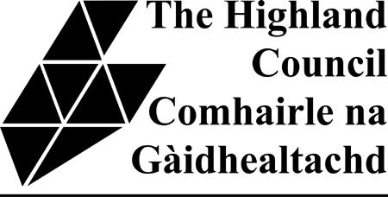

HOUSING (SCOTLAND) ACT 2006
PUBLIC NOTICE
HOUSE IN MULTIPLE OCCUPATION LICENCE
NOTICE IS HEREBY GIVEN that application has been made on the ....……... day of ........…….........20….
to The Highland Council for a LICENCE FOR A HOUSE IN MULTIPLE OCCUPATION in respect of premises at: ..............................................................................................................................…………….
by: Name ....................................................................…
Address ...................................................................….

....................................................................…

Day to day Manager(s)......................................... ....................................................

Address(es) ................................................... .....................................................

................................................... .....................................................

Any objections and/or representations in relation to the application may be made to the Licensing Office in the relevant area. Please find address details below.

Objections and representations should be made in accordance with the following provisions, namely:

1. Any objection or representation relating to an application for the grant or renewal of a licence shall be entertained by the licensing authority if, but only if, the objection or representation:
(a) is in writing;
(b) specifies the grounds of the objection or, as the case may be, the nature of the representation;
(c) specifies the name and address of the person making it;
(d) is signed by him or on his behalf;
(e) was made to them within 21 days or whichever is the later or, as the case may be, latest of the following dates:
(i) where public notice of the application was given in a newspaper, the date when it was first so given;
(ii) where the Council have required the applicant to display the Notice again from a specified date; that date;
(iii) in any other case, the date when the application was made to them.

2. Notwithstanding (1)(e) above, it shall be competent for a licensing authority to entertain an objection or representation received by them before they take a final decision upon the application to which it relates if they are satisfied that there is sufficient reason why it was not made in the time required.

3. An objection or representation shall be made for the purposes of (1) above if it is delivered by hand within the time there specified to the licensing authority or posted (by registered or recorded post) so that in the normal course of post it might be expected to be delivered to them within that time.

Caithness, Sutherland & Easter Ross Highland Council, Caithness House, Market Place, Wick, KW1 4AB. | Ross area  Highland Council, High Street, Dingwall,  IV15 9QN | Skye area  Highland Council, Tigh Na Sgire, Park Lane, Portree,  IV51 9GP | Lochaber area  Highland Council,  Charles Kennedy Building,  Achintore Road,  Fort William,  PH33 7RQ. | Inverness, Nairn and Badenoch & Strathspey area  Highland Council, Council HQ, Glenurquhart Road, Inverness,  IV3 5NX.

