Our Ref: | PCS108617/scr/SH
SG Ref: | SEA00522

Simon Hindson  The Highland Council  Council Offices  Glenurquhart Road  Inverness  IV3 5NX  By email: sea.gateway@scotland.gsi.gov.uk | 2 August 2010

Dear Mr Hindson,

Environmental Assessment (Scotland) Act 2005
Planning Constraints on Development: Supplementary Guidance - Screening Report

Thank you for consulting SEPA on the above Guidance submitted on 12 July 2010 via the Scottish Government SEA Gateway.

In accordance with Section 9(3) of the Environmental Assessment (Scotland) Act, 2005, we have considered your screening report using the criteria set out in Schedule 2 for determining the likely significance of effects on the environment.

We understand that the Guidance only provides advice on data that will be taken into consideration in determining applications and that it is considered that any strategic issues will be addressed by the assessment of the Policy which the Guidance supports. We consider this approach reasonable if the revised ER for the Plan robustly assesses the policy, preferably including the hierarchical approach it will take. On this basis we consider that in respect of our main areas of interest (air, water, soil, human health and climatic factors) the Guidance is not likely to have significant strategic environmental effects. Although we are of the view that significant environmental effects are not likely, it is for the Highland Council as Responsible Authority to make a formal determination taking into account the consultation responses received.

Please note that although we do not consider that the Guidance will have significant strategic effects on the environment we would wish to provide comment on it. We would therefore welcome consultation on the draft proposals - which should be directed to SEPA's local Planning Service at planning.dingwall@sepa.org.uk.

If it is formally determined that SEA is required, you will be aware that the next stage requires the Responsible Authority to consult the Consultation Authorities on the proposed scope and level of detail to be included within the Environmental Report. The Consultation Authorities typically expect to receive a concise Scoping Report at this stage. Further information about this stage and what should be included in a Scoping Report can be found in Chapter 5 of the Scottish SEA Tool Kit available from www.scotland.gov.uk/Publications/2006/09/13104943/45. We would encourage you to use the Scoping Report to focus the assessment on those SEA topics upon which there are likely to be significant environmental effects.

Should you wish to discuss this consultation, please do not hesitate to contact me on 01349 860359 or planning.dingwall@sepa.org.uk.

Yours sincerely,
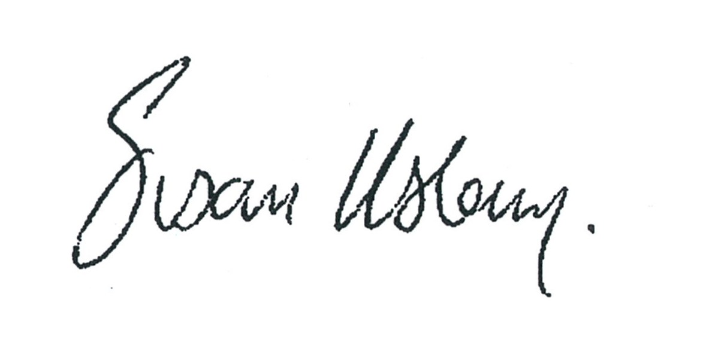

Susan Haslam
Senior Planning Officer
Planning Service

