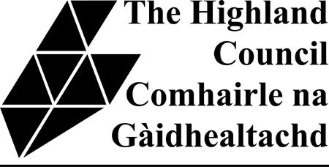

Application for assistance under the

Garden Aid Scheme

Please note that the Garden Aid Scheme for 2016 is currently fully subscribed. New applicants should make their own arrangements to have their grass cut in 2016. New applicants will be added to a waiting list for consideration in the future.
Name

Address
Date of birth

Telephone number

PLEASE ANSWER THE FOLLOWING QUESTIONS WHICH WILL HELP US DECIDE IF YOU ARE ELIGIBLE FOR ASSISTANCE UNDER THE GARDEN AID SCHEME. THE COUNCIL WILL CHECK THE INFORMATION YOU PROVIDE.

I confirm that:

I am a Council Tenant YES

and
I am 60 years of age or older YES
or
I am in receipt of Personal Independence Payment (if so
please enclose a copy of your confirmation of award letter) YES

and
I am in receipt of Housing Benefit YES

and
There is no one living in my household or nearby who
can cut my grass. YES

I confirm that the information I have given above is true and correct to the best of my knowledge.
I understand that The Highland Council will undertake checks of records held for the purposes of administering council tax and benefits in order to verify the information I have provided.

I confirm that I will inform the Council of any change to my circumstances.

Signed: _________________________________Date:________________

Please return this form to HQ Business Support (Community Services), Highland Council, Glenurquhart Road, Inverness, IV3 5NX

