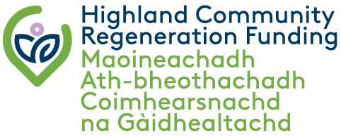
Highland Reuse & Repair Fund
(R&R Fund)
Maoin Ath-chleachdaidh & Càraidh na Gàidhealtachd

Expression of Interest
Cur an cèill ùidh

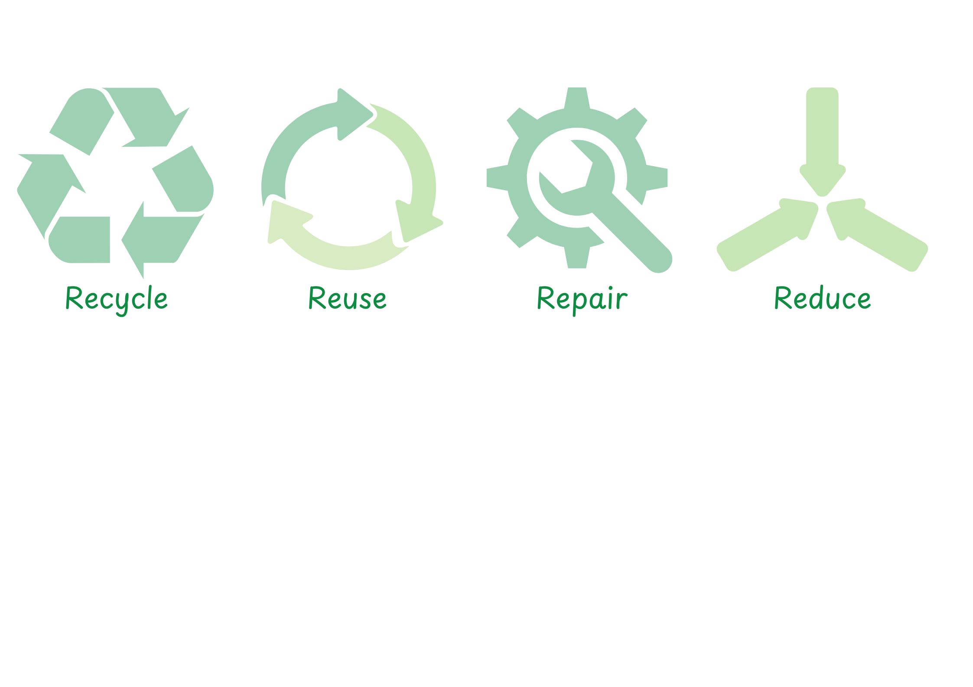

Please refer to the Guidance Notes and Fair Work First Summary Guidance when completing this application form.
Application Form

SECTION 1: PROJECT SUMMARY
1.1 | Project reference number | Office use only
1.2 | Organisation name
1.3 | Project title
1.4 | Project costs | Total cost of project | £
1.4 | Project costs | Match funding | £
1.4 | Project costs | Grant requested | £
1.5 | Start date
1.6 | End date

1.7 Which of the following priority themes will the project meet?

- Community-led Waste Reduction  Empowering communities to extend the life of materials through reuse, repair, and upcycling | Yes / No
- Skills for Sustainable Living  Supporting workshops and initiatives that teach repair, mending, and creative reuse skills - building local capacity and reducing household costs. | Yes / No

SECTION 2: CONTACT DETAILS

2.1 | Main contact name
 | Contact number
2.2 | Position
2.3 | Address  Postcode
2.4 | Email address
2.5 | Website address

SECTION 3: ORGANISATION DETAILS

3.1 | Organisation Status | Please indicate (x) | Organisation number
 | Company limited by guarantee
 | Constituted group
 | Public body
 | Charity
 | SCIO
 | Private
 | Other (please specify)

3.2 | Are you applying on behalf of a partnership and is your organisation the lead applicant? If yes, please provide partnership agreement with the application. | Yes / No

3.3 | Is the organisation VAT registered? You are declaring the organisation’s VAT status with HMRC. If this changes at any time during the project, you must notify the R&R Fund Officer as this may affect the grant. | Yes / No
3.4 | If the organisation is VAT registered, please quote number.
3.5 | Will the VAT related to the project be reclaimed from HMRC? Provide relevant details in the box below, i.e. details of exemptions | Whole | Partial | None
Notes:

3.6 Privacy Notice
Please confirm you have read and understood the R&RF Privacy Notice: Yes / No https://www.highland.gov.uk/privacynoticerrf

3.7 Artificial Intelligence Assistance Declaration
Have you used any form of AI assistance in the preparation of this application: Yes / No
For guidance on the appropriate use of AI in funding applications, please refer to Use of AI in Funding Applications Guidance https://www.highland.gov.uk/AIguidance

SECTION 4: PROJECT DETAILS

4.1 | Project location - include postcode

4.2 | Do you have ownership or lease the land or building? If ownership or lease agreements are not in place, please provide details of the arrangements to obtain these and by when.

4.3 | Does the project require planning permission or statutory regulatory consents? | Yes / No
If yes, please detail below – consents must be in place before you start the project. Please provide evidence.
Type |  | Date granted

4.4 Have you had support/advice from other organisations in developing the project?

For example: | Please indicate (x) | Details
Highland Council
Highlands & Islands Climate Hub
Highland Community Waste Partnership
Other (please detail)

4.5 | The project
- Please summarise the project, in no more than 700 words, explaining how it meets at least one of the funds’ priority themes as noted in 1.7.

- How will your project measure its waste reduction impact? Clearly state what your project aims to achieve in terms of waste reduction and how you will track progress.

- List the main activities the project will undertake, including timescales – this will be the project delivery plan. Please note, projects must be completed in 12 months from the date of the Offer of Grant Letter.

Activity name | Achieve by (date)

- In developing the project, please detail how you have considered the equalities impact: Explain how the project ensures that no one is disadvantaged or excluded from benefitting from the project?

- Do you have a Fair Work First Policy Statement. Yes / No All applicants are required to provide a signed statement detailing how your organisation is committed to advancing the Fair Work First Policy including the ‘Real Living Wage’ and ‘Effective Voice’ criteria (see guidance note).
- Do you have Living Wage Accreditation and/or are planning to be certified? Please give details.

- How will the project be supported or maintained after the end of the R&RF grant period and what will the legacy/lasting benefits be?

SECTION 5: BUDGET Delete the example below before completing this section. If the project is part of a bigger project, list what specifically the funding will be spent on.

5.1 Main project expenditure

Budget Heading | Details/items | Amount
Equipment | Sewing machines | £100
 | Repair Kits | £200
Tools | Upcycling tools (drills, sanders etc) | £500
Materials | Paints for upcycling | £1500
 | Compost bins | £500
Community Workshops | Workshop facilitation | £1000
 | Venue hire | £400
TOTAL PROJECT COST |  | £
Is VAT included in these costs? |  | Yes / No

5.2 | Reasonableness of costs – please explain how you have obtained these costs whilst developing the project?

SECTION 6 – MATCH FUNDING

6.1 | Please give details of confirmed match funding:  Match funding must be confirmed before you start the project and evidence provided.
Name of funder |  | Date awarded | Amount £
Total match funding |  |  | £
RRF requested |  |  | £
Total project cost |  |  | £

6.2 Will the project involve “in kind” support?
This should not form part of the overall cost of the project.
Yes / No If yes, please provide details:

6.3 Please explain why public funding is required to deliver the project.

SECTION 7 – SIGNATURE

I declare that the information contained in this application is correct to the best of my knowledge. I have read the guidance notes and understand and accept the terms and conditions noted within them.
The data you have provided in the application (and claim) forms are subject to the provisions of the Freedom of Information (Scotland) Act 2002, the Data Protection Act 1998 and the Environmental Information (Scotland) Regulations 2004.

7.1 | Main applicant, chairperson or equivalent – the person signing this application has the authority within the organisation to apply for grant funding
 | Signature: | Print: | Date:

7.2 Supporting documents checklist.
You must enclose the following documents with the application.
1 | Bank statement – latest statement
2 | Financial accounts – latest available accounts
3 | Fair Work First – signed policy statement
Please declare what the remaining balances are for in your bank account:

If your project is approved funding, we require the following additional documentation (where applicable) before you start:

- Constitution or articles of memorandum
- Committee members or directors list (unless stated in the annual accounts)
- Permissions – planning, consents, licences
- Policies – such as health and safety, environmental policy, equal opportunity
- Confirmation of match funding
- Copy of valid insurance policy
- Evidence of land ownership, lease, or consents
- Partnership agreement

Projects must not start or commit expenditure before receiving and accepting the Offer of Grant Letter. All projects should be completed and claims submitted within 12 months of receiving the Offer of Grant Letter.

For assistance completing this form please contact: rrf@highland.gov.uk
For further information, please visit: https://www.highland.gov.uk/reuserepairfund

