Appendix 2B Written Responses and Pupil Views

Name of consultation: St Clements School, Dingwall
Your comments: This is a fantastic idea as it will provide the opportunity for children to have contact with their peers at Dingwall Primary School.
Any positive step can only improve facilities for both schools.
I am commenting as: Former parent
I am commenting on behalf of: Myself

Name of consultation: Proposal to Relocate St. Clement's Special School, Dingwall
Your comments: Marybank, Scatwell & Strathconon Community Council agrees to the proposal.
I am commenting as: Local councillor
I am commenting on behalf of: Community Council

Name of consultation: St Clement’s Movement of school
Your comments: I am a parent of two boys who attend this school currently. I feel the school does definitely need a new building but would much prefer it was a stand alone school so that bullying etc by mainstream children will not take place for our kids at St Clements who are extremely vulnerable .
I am commenting as: Parent

Name of consultation: St. Clement’s School

Your comments:
Over the years St. Clement’s has worked hard to develop strong links with the community and this gives the children a real sense of moral purpose. This is especially apparent through the various extra curricular learning opportunities they gain in their locality and the overwhelming amount of support the community provides. This is a vital resource for the pupils and St. Clement’s strives to continue to develop solid community relations to increase their sense of pride and identity.

For a new build it is vitally important that St. Clement’s School retains its own unique identity, is a separate school in its own building and has its own protected staff/management structure. Designated indoor/outdoor spaces for exercise, dining, specially adapted general classrooms, subject classroom and a medical room and for all of these spaces to have specifications suited to the pupils requirements.

The whole ethos of St. Clement’s is based on inspiring ambition and nurturing happiness and these kids deserve a new school that can meet their needs. For me, these needs have to be individualised and at the very core of any planning process. Every child is an individual and the educational opportunities delivered can shape their future. This is especially important for children who have additional learning needs and this has to be a priority. To ‘think outside the box’ and consider the pastoral, social, environmental and vocational factors to help improve the access to lifelong learning for optimum health and wellbeing in a new school environment is crucial.

Pupils at St. Clement’s are encouraged to learn in a way that is adapted to suit their capabilities. The school staff are to be commended for their amazing dedication and professionalism in how they achieve this. However, at the age of 18 their options for any further education are very limited and they deserve to be afforded more rights and access to higher education. A visionary model that at the very least considers future proofing and helping these children from the age of 18 plus is the dream!

To conclude, capacity is also a concern as we live in an ever expanding community and the pupil roll will only increase with this.

I am commenting as: Parent
I am commenting on behalf of: Parent Council
Name of Parent Council: St Clement’s School Parent Council

Name of consultation: Review of Proposal to relocate St Clement’s Special School, Dingwall to a new site north of Ross Avenue, Dingwall

Your comments: Consultation Feedback – Review of Proposal to relocate St Clement’s Special School, Dingwall to a new site north of Ross Avenue, Dingwall.
The Future Capacity and Vision for St. Clement’s School in support of building at Docharty Brae
Dear Highland Council Education Service,
I am writing as a parent of a child participating in the consultation for the new St. Clement’s School. Please find attached my full submission, which expands on the key points outlined below.
1. Specialist Provision is Essential
Children with Additional Support Needs (ASN) require tailored teaching, small class sizes, one-to-one or small group support, and sensory-friendly environments. On-site therapies and specialist spaces are critical to their wellbeing, learning, and progress.
2. Preferred Site – Docharty Brae
I support Docharty Brae as the permanent site. It offers a standalone identity for the school, fewer traffic and congestion concerns, community familiarity, and the potential for long-term expansion to meet future needs.
3. Capacity and Flexibility
Classroom numbers and layouts must reflect the individual needs of pupils, not standard ratios. Dedicated spaces for music, PE, art, science, cooking, and sensory wellbeing, along with ample outdoor areas, are essential. Flexible design ensures the school can accommodate both current and future demand.
4. Preserving School Identity and Ethos
St. Clement’s must remain an independent specialist school to maintain the culture, ethos, and specialist approach that families rely upon.
5. Early Years and Lifelong Pathways
On-site nursery provision is vital for early intervention. The school should also provide clear pathways into further education, vocational training, apprenticeships, and structured social opportunities, ensuring children have support beyond statutory school age.
6. Social Inclusion and Extended Opportunities
Children and young people with ASN must have access to structured social and recreational activities beyond school to prevent isolation and promote inclusion, ensuring equity with mainstream peers.
7. Future-Proofing and Expansion
Docharty Brae offers the ability to integrate specialist healthcare services, additional classrooms, vocational spaces, and potential supported housing. This flexibility ensures sustainable, high-quality ASN provision for the future.
8. Key Consideration
The new St. Clement’s must be ambitious, flexible, and designed around the real needs of ASN learners. Every child requiring ASN support should have timely access to appropriate education, care, and lifelong opportunities.
This brief summary highlights the key points of my full submission (attached), which provides detailed points I would like to see considered to ensure the new school is fit for purpose today and in the years to come.

To: Highland Council Education Service Email: Education.Consultations@highland.gov.uk

Subject: The Future Capacity and Vision for St. Clement’s School

Dear Council Members,
I am writing to you as a parent to share my perspective on the future of St. Clement’s School and the importance of ensuring that the new school is not only fit for purpose today, but also for the generations of children who will need it in years to come.
St. Clement’s is more than a school to me and my family. It represents a lifeline of specialist education and care for children with Additional Support Needs (ASN). However, the current building is outdated and does not reflect the scale of need across Dingwall and the wider Highlands. Every year, there are children who require ASN placements who cannot be accommodated, leaving families in a state of uncertainty and children without the right support at the right time.
Key Benefits of Dochcarty Brae Site

Approved by the Highland Council in 2022 following a full statutory consultation process. This site does not require a further consultation to proceed with the new St. Clement’s School. Families have already been waiting for the promised investment and the detailed work with architects to ensure that both the building and outdoor spaces are suitable and focused on delivering the best possible educational journey our young people deserve.
The site offers a clean-slate, purpose-built opportunity designed specifically around the needs of pupils at St. Clement’s.
It allows the new building to be a standalone school, retaining the unique identity of St. Clement’s, reinforcing its specialist role, and protecting its ethos.
The location presents fewer traffic and congestion issues compared to the POD site.
Developing at Dochcarty Brae enables a simpler building process without the complications of shared infrastructure.
Dochcarty Brae is already well known to and supported by parents, staff, and the wider local community.
Constructing the school on this site avoids the disruption of live school construction or the challenges of coordinating with other educational developments.
The new school must be designed with capacity at its heart. It must be large enough to meet existing demand and flexible enough to grow with future needs. This is not simply about avoiding shortfalls — it is about making sure that every child who requires an ASN placement has a place, without delay or compromise.

Classroom Numbers and Framework Concerns
A key issue that must be addressed is how the Highland Council will calculate the number of classrooms required for the new ASN school. If the framework is based simply on school roll numbers, in the same way it is for mainstream schools, the results will not reflect the reality of ASN provision.

Classroom Capacity and Individual Pupil Needs

A critical concern in planning the new St. Clement’s School is how classroom numbers are calculated. If the Council uses standard ASN ratios for primary and secondary settings without factoring in the individual requirements of pupils, the resulting provision may be inadequate. Many children with ASN require one-toone or small group settings, sensory-friendly environments, or low-stimulation spaces.

For example, a pupil with severe communication needs may only be able to access learning in a one-to-one setting, while another may thrive in a small group classroom with highly tailored teaching strategies. Standard ratio calculations — such as assuming 10 pupils per classroom — fail to capture these variations. The consequence is a mismatch between classroom size and actual needs, which can hinder learning, increase stress, and limit progress.

Furthermore, current evidence from the Joint Additional Needs Group (JAG) meetings indicates that there are children requiring ASN placements who cannot currently access St. Clement’s due to limited capacity. This unmet demand is likely to grow as awareness of services increases and as more children are assessed. If the new school is not designed with flexibility for these additional pupils, it will replicate the same capacity issues, leaving children without timely access to specialist education.

To genuinely meet the needs of all learners, the new school must account for both the total number of pupils and the complexity of their individual support requirements. Classrooms should be designed to allow small group learning, one-to-one support, and quiet, low-stimulation spaces. Only by doing this can the school ensure a positive educational experience, enable meaningful progress for every pupil, and accommodate both current and future demand.
In addition to standard classrooms, the school must include dedicated learning spaces for specific activities, including but not limited to cooking, music, physical education, art, science, and sensory wellbeing spaces. These specialised areas are essential for providing a full curriculum, supporting skill development, and promoting emotional regulation and creativity for pupils with ASN.
Furthermore, outdoor spaces must be plentiful, private and allow all pupils to maintain their dignity in a safe and welcoming setting. Children at St. Clement’s have long been limited in access to outdoor learning and recreational activities. The new school must provide sufficient playgrounds, sensory gardens, and outdoor activity areas to allow children to develop physical skills, social interaction, and wellbeing — experiences that are critical to their holistic development.
If the Council’s framework does not account for these variations and dedicated spaces, there is a real risk that the new school will be under-built from the start. The result would be classrooms and facilities that are too large, too busy, or too inflexible for the pupils who need them most. This would fail to provide the supportive environment that is essential to their progress.
For an ASN school to succeed, its design must go beyond numbers on a page. It must reflect the individual requirements of pupils, recognising that smaller class sizes, breakout areas, sensory spaces, outdoor activity zones, and specialised learning environments are not luxuries — they are necessities for many children to feel safe, regulated, and able to learn.

Retaining the Unique Identity of St. Clement’s
It is equally important that St. Clement’s retains its unique identity in the move to a new building. The school must remain independent as a standalone facility, with its own dedicated teaching and management structure. This ensures that the ethos, culture, and specialist approach developed over decades is preserved. The children, families, and wider community rely on St. Clement’s distinctiveness to deliver the tailored support that mainstream settings cannot provide.

Early Years, Lifelong Pathways, and Transition
This vision must also include a pre-school nursery provision on-site. Early intervention is critical for children with ASN, and starting support as soon as possible gives them the best chance of thriving.
It is equally vital to think beyond the school years. A vision for the near future would be a wellplanned ASN campus that would link directly into further education, training, and apprenticeships. Many young people need clear, supported pathways into adulthood, where they can learn vocational skills, develop independence, and access real opportunities for employment. Without this, too many pupils finish school with no secure next step.

The Importance of Social Opportunities Beyond Education (Appendix A)
For many children with ASN, further education may not be a realistic or appropriate pathway. Yet, these young people still deserve access to opportunities for social interaction, structured activities, and meaningful engagement after the school leaving age and into their mid-twenties.
At present, there is no clear provision for continued social or educational opportunities once ASN pupils finish school, whereas their mainstream peers are supported by a wide array of options — whether through college, apprenticeships, clubs, or community groups. This imbalance leaves ASN young people, and their families isolated, with very few routes to maintain social connections or participate in age-appropriate opportunities.
It is ultimately a matter of fairness and rights. Every young person should have access to structured opportunities that support their wellbeing, social development, and inclusion within the wider community. Where further education is not an option, there must be alternative provision to ensure that no child is left behind. The Dochcarty Brae site presents a real opportunity to plan for this future — with the potential to expand onto adjacent land and develop a wider ASN campus. At this stage, it is vital that the Highland Council considers how investment in this site could provide the space and infrastructure needed for extended social programmes, supported community activities, and long-term partnerships that continue well beyond statutory school age.

Dochcarty Brae: A Site with Capacity for Expansion and Future Investment
The Dochcarty Brae site offers unique opportunities for the long-term development of St. Clement’s School into a comprehensive ASN campus. Recently, it was established that adjacent land to the Dochcarty Brae site was offered to the Highland Council for social housing, which could be adapted to provide sheltered accommodation for pupils with ASN, supporting independence and transition into adulthood.
Beyond housing, this additional land creates the potential to develop a wider campus around the school, enabling:
- Expansion of educational facilities to accommodate rising demand for ASN placements, including pre-school, school-age, and post-16 learners.
- Creation of social, recreational, and vocational spaces for pupils who require continued engagement beyond statutory schooling.
- Integration of specialist healthcare services — such as occupational therapy, speech and language therapy, and mental health support — into a single, co-located delivery model that reduces travel, improves coordination, and provides consistent, accessible support for pupils.
This flexibility for future growth and investment is crucial for planning a sustainable, high-quality ASN provision in the Highlands. In comparison, the single POD site next to Dingwall Primary offers no realistic opportunity for expansion, limiting the long-term vision for St. Clement’s and constraining the capacity to accommodate all children who will require ASN support in the years to come.
Selecting Dochcarty Brae as the permanent site ensures that the school can grow to meet the needs of every child, now and in the future, while creating a truly integrated campus that delivers education, care, and wellbeing in one cohesive setting.

Why Specialist ASN Provision Matters
Evidence shows that for most children with significant and complex needs, attending a specialist ASN school provides better educational, social, and emotional outcomes than placement in mainstream schools. The Scottish Government (2019) highlighted that specialist schools deliver tailored teaching, smaller class sizes, higher staff-to-pupil ratios, and on-site therapies — support that mainstream settings cannot replicate consistently. The Equality and Human Rights Commission also notes that children with complex ASN are less likely to thrive in mainstream schools, where larger classes and overstimulation can create barriers to learning and wellbeing.
Families repeatedly confirm that ASN schools provide the sense of safety, belonging, and progress their children need. These schools are not “alternatives” — they are essential.

My Closing Thoughts
The size and scale of the new St. Clement’s must therefore reflect not only the current unmet demand but also the true reality of ASN education. If the framework used to plan classrooms and capacity does not account for the diverse and individual needs of pupils, the new school will fall short of its purpose before it even opens.
I urge the Council to ensure that the new St. Clement’s is ambitious, future-proof, and designed to meet the real needs of ASN learners — from nursery, through school, and into further education, employment, and fair alternatives for those who need lifelong support. Only then can we say we have built a school worthy of the children it serves.
Yours sincerely,

Appendix A
Briefing Note: Social Opportunities Gap for ASN Young People

Briefing Note: Social Opportunities Gap for ASN Young People

Context
- Many children with Additional Support Needs (ASN) will not progress to further education or traditional vocational pathways.
- Unlike mainstream pupils, there is currently no structured provision for continued social or educational engagement after school leaving age.
- ASN young people are at risk of social isolation, lack of meaningful activity, and missed opportunities to develop independence.

Current Inequality
- Mainstream students have access to college courses, apprenticeships, clubs, and community programmes from school leaving age into their mid-twenties.
- ASN students often have no equivalent local provision, resulting in a gap in rights and opportunities.
Why It Matters • Social engagement is critical for emotional wellbeing, confidence, and life skills.
- Without structured activities, young people with ASN face increased isolation and reduced independence.
- Families bear additional burden when provision is lacking, often providing support themselves at great personal cost.

Opportunity to Develop an ASN Campus on the Dochcarty Brae Site
- The opportunity to develop an ASN campus on the Dochcarty Brae site could provide:
  - Extended social programmes and clubs beyond school hours.
  - Structured opportunities for young people aged 16–25 who are not in further education.
  - Partnerships with community organisations, employers, and training providers.
- This ensures a fair and inclusive pathway to adulthood, complementing educational provision.

Call to Action
- The new St. Clement’s School should be designed to provide both educational and social pathways for all ASN learners.
- Councillors and decision-makers should recognise that social provision is as essential as classroom provision for wellbeing, inclusion, and equality.

Pupil Views- St Clement’s
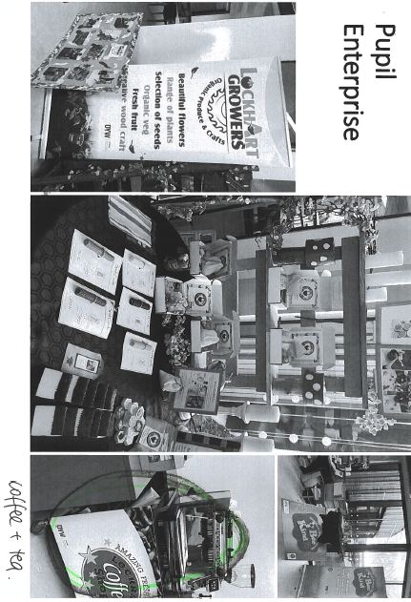
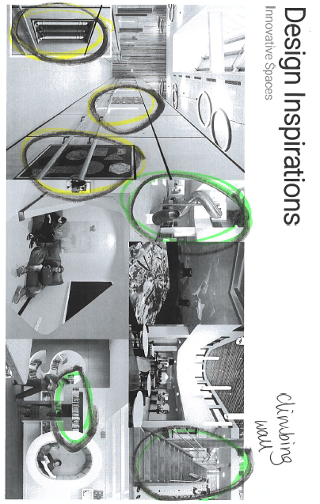

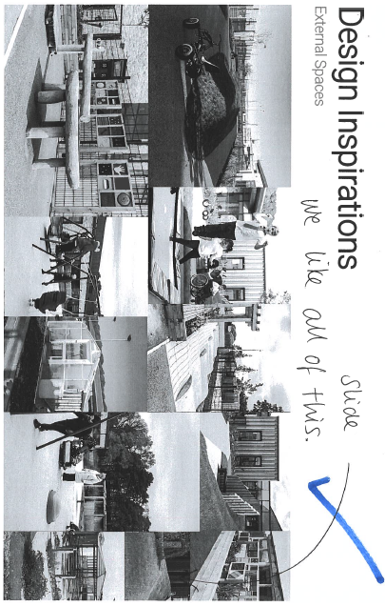
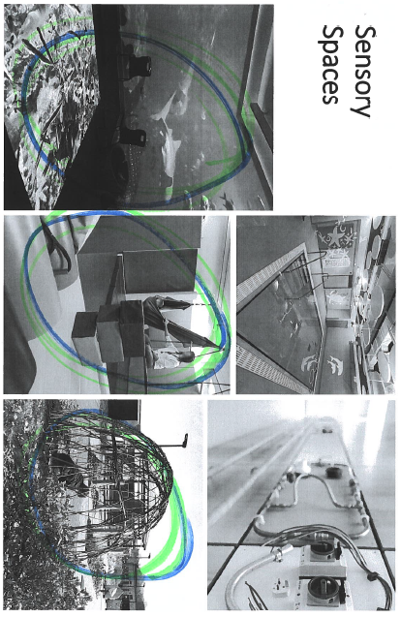

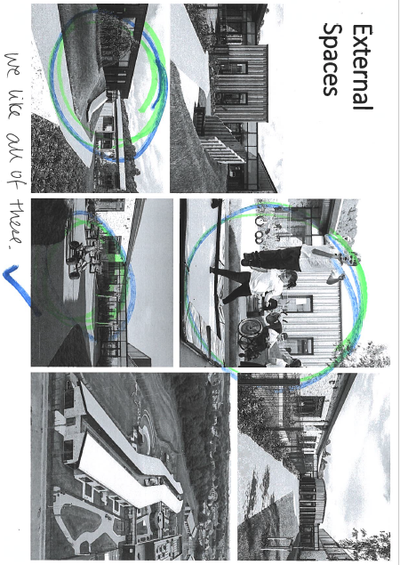
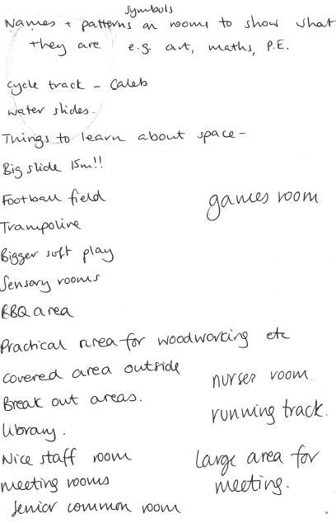
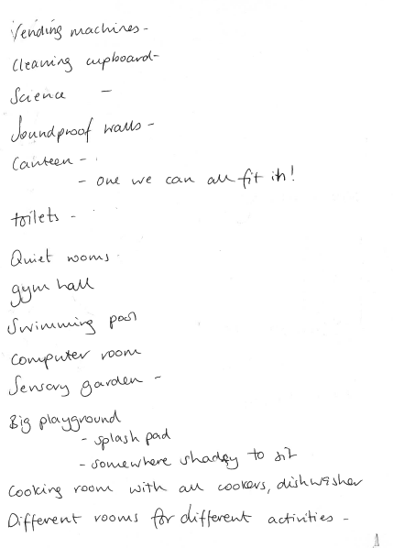

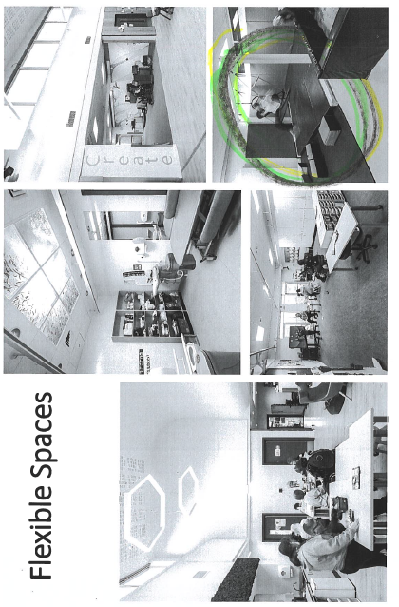
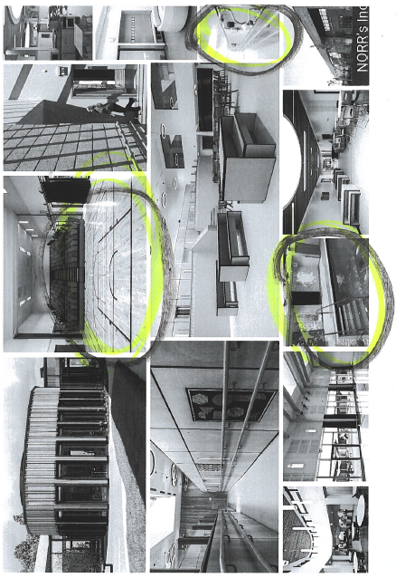

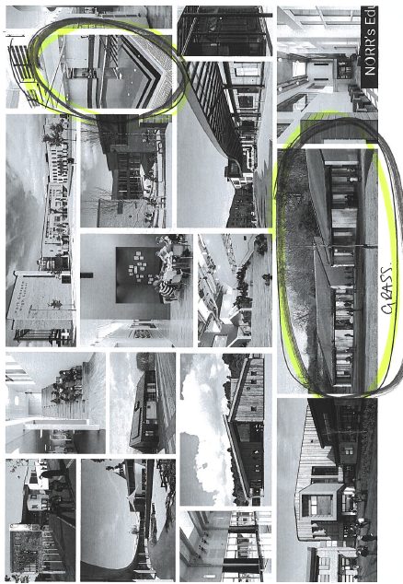
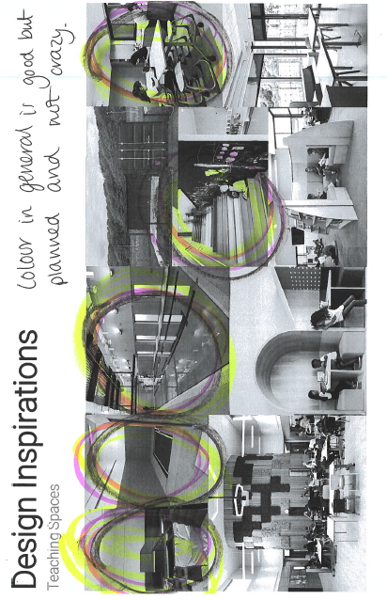

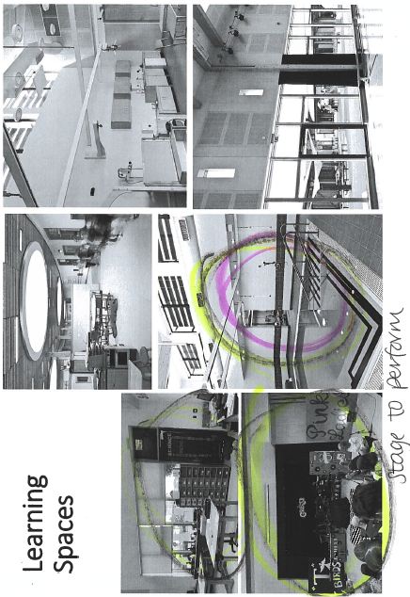
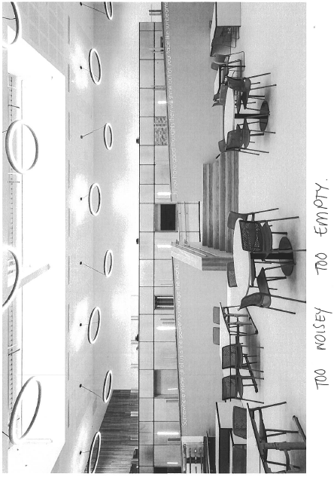

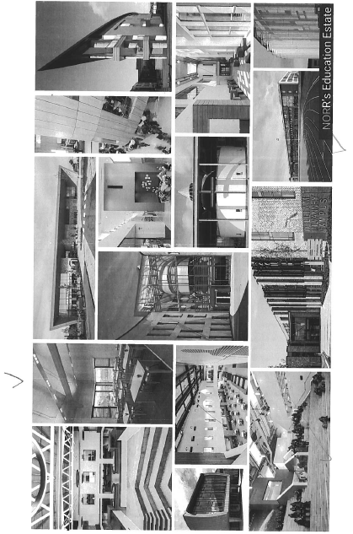
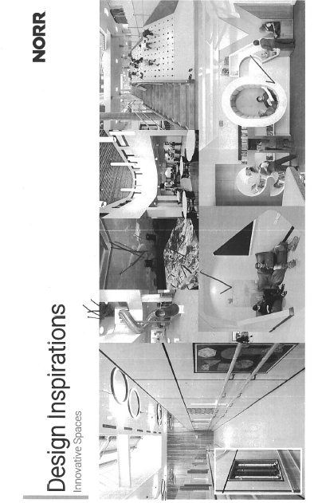

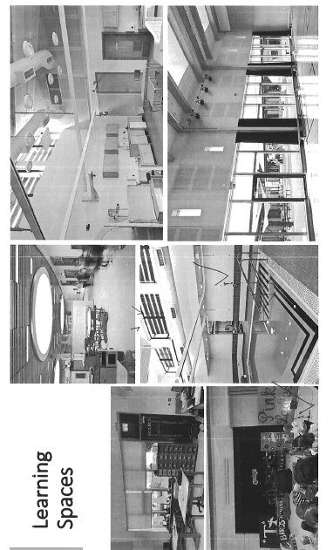
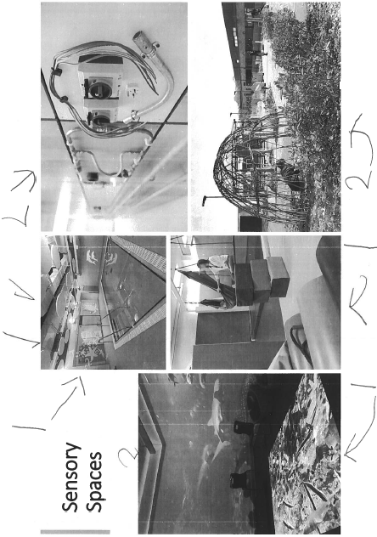

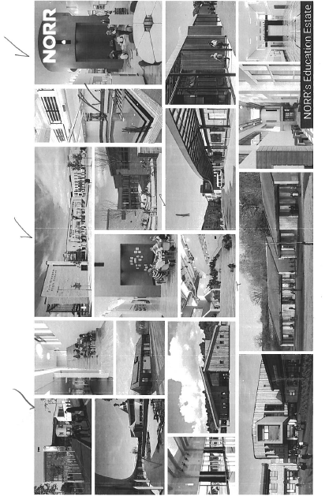
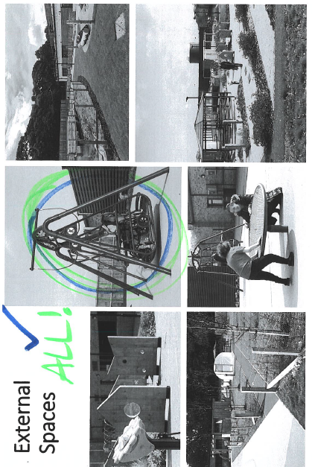

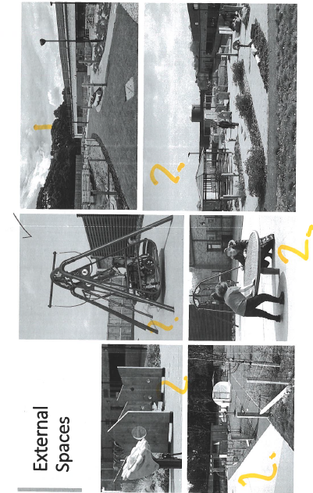
Dingwall Primary Pupil Feedback- St Clement’s Relocation

Timestamp | The things pupils in our class love about our current school: | Things pupils in our class don't like so much about our current school: | After looking at the design inspirations, pupils in our class wanted to note... | Other ideas pupils in our class have for our new school:
18/06/2025 09:43:24 | The different libraries, having the nursery close by, there is a lot of outdoor space, two floors, the red area as a different space to do activities, there is different spaces to play outside, wallbars, lots of light with big windows, blinds in the class. | Too small, colors are dull, didnt like the use of projectors onto a the class whiteboard in the classes, the classroom doors feel unsafe, football takes up most of the outdoor space, corridors are too narrow, toilets are dated and old, not enough car park spaces, lights are dim, walls are old and chipped, plastic areas on roofs, cloakrooms are too small, not enough plugs in classrooms, no elevators for people with disabilities, no ramps for wheelchair access, bike shed is too small | having our own pool, outdoor astro, break out spaces for specific subjects, technology room for Chromebook use, baking areas, indoor slide got a lot of attention, indoor play areas, art designs on the walls for inspiration, stairs for reading, music room, outdoor equipment for practicing different techniques (sports) | Different types of chairs for pupils, windows that stop classroom getting too warm, different coloured blinds, bigger whiteboards for the teacher
18/06/2025 09:55:18 | Large grass area. Library. Nurture Room. Sensory Room. Two levels. Gym Hall & Wall Bars. | No playground equipment. Classroom too close together. Too warm. Small classrooms. Sit on floor in assembly. No comfy/ lounge areas. Canteen too small and loud. Don’t like long tables in canteen. Old building. | Loved: Indoor and outdoor slides. Pool. Comfy seating areas/ built in areas. Astro. Canteen round tables. Comfy chairs. Different levels. Stairs with climbing wall. Colourful stairs/ walls/ chairs/ tables. Big spaces. Wood. Lots of windows and doors. Playground equipment with lots to do. Didn’t like no classroom doors. | Lifts/ elevators. Role play outside – mini houses/ sheds. Climbing area inside. Trampolines. Swings. Treehouses. Art areas. Wet break play area indoors. Soft play.
18/06/2025 13:58:30 | P4/5G -  Big playing field  Gardens and lots of nature  Near to woods and hills  Sandpit  Big windpws in classrooms with nice views (mostly)  Buddy benches  Book trolleys  Big classrooms  Gaelic Medium department  Proper PE teacher | Canteen - too noisy and chaotic, long queues  Can't use the obstacle trails in playground  Fob doors  Separate playing areas for upper and lower school  Having a timetable for football - not enough pitches  Dark corridors  Shared cloakrooms too squashed  Only one basketball court | We loved:  A large slide in the school  A swimming pool with diving board  Lots of big low windows and glass - bring the outside in  Lots of natural materials eg wood on building  Lots of green outdoor spaces where we can do our own gardening and build dens | Clean nice bathrooms  Better cloakroom areas  Changinf room to change into gym kit for PE  Lovely big library  Games Hall  Bigger PE Hall  Sensory room  Interactive outdoor spaces eg chalk drawing on walls/music instruments etc  Lots of garden spaces each with a differecnt use eg mud kitchens/quiet garden/climbing treed garden etc  Bigger classrooms but not open plan  Classroom have doors that open into a garden area  Skylights and low windowns with nice views  Climbing wall on side of building  Basketball courts  Lots of football pitches but also space for other games  Bigger, calmer, quieter canteen, more serving hatches to reduce queues  Elevators and stairs  Big sandpit  Picnic bencehes and tables  Outdoor obstacle trails  Technology Lab  Art Room  Music Room  Good sound proofing throught the school  Lots of Time Out and calm areas  After School Club space and clubs  Lots of litter bins
19/06/2025 09:31:27 | Big classrooms. TV screen. Deaf Base. Sensory Room. | Too many S/W facing windows, broken blinds. Not enough designated areas in playground, Not enough opening windows. Carpets in classrooms. Not enough electric sockets. | Slide. Hill/ mound in playground with den underneath. Running track. Astroand built in seats.. Reading pods. More colour. | Fixed football goals. Lift.
19/06/2025 12:32:18 | - When we had climbing frames in the playground  - The canteen  - The wall bars in the gym hall  - The food at lunchtime  - Our teachers  - Space outside the classroom to work | - The cloakrooms are too small  - The bathrooms smell and there sometimes isn't soap  - There are flies in the lights  - The ceiling has bits coming off it  - There are holes in the walls  - We don't have a proper library  - There's not enough to do in the playground  - The desks are wobbly  - Nothing matches | - A swimming pool!  - It was so colourful  - Slides and climbing frames in the playground look fun  - The willow dome - "we could play in it and hide"  - The different reading nooks and spaces in the library  - How the stairs were really interesting - spaces to sit at the side of the stairs  - It was all clean and bright  - Round tables in the dining room look nice. | - Two gym halls with lots of wall bars  - Bigger gym hall(s)  - More footballs  - Classrooms with more space  - Better sinks in the classrooms  - More colour on the walls  - Proper soap in the bathrooms  - A big library where it's quiet with lots of books and comfy places to read  - More space in the cloakroom  - A garden where we could grow things  - Somewhere to be undercover in the playground if it rains  - Slides and things to play on in the playground  - More places to sit with our friends in the playground  - A library shed in the playground (I PROMISE I didn't prompt this!!)
19/06/2025 14:05:46 | The teachers, the canteen, the size of classrooms, the playing field and sand pit, the gym hall, the support staff and the view from some classrooms. | Lack of play equipment, the library, only one gym hall, heat in classrooms during warmer weather conditions, the state of some equipment (class whiteboards, chairs etc) and more sturdy toilet doors. | They would like a slide, more play equipment, garden areas outside each classroom, a swimming pool, a rock climbing wall, colourful stairs, welcoming and comfortable library areas, an IT area/room, greenhouses, play areas, bigger canteens and art work. | Large classrooms (and a large teacher cupboard in each room please!), a quiet area for resting/naps, facilities for more after school clubs, easy access throughout the school, bigger reception area, an outdoor classroom.
20/06/2025 09:26:34 | Different sized classrooms with slanted ceilings  Sandpit with long jump  Garden areas  Views of Cats Back  Wooded P1 Garden area  Mudsheds  Flip bars  Shed bit near P1 area  Bike shelter  Classroom Cupboards  Nuture Room  P.E. Change rooms  Outdoor shelters | Drinking Taps  Fobbed doors  Bathrooms  More ventilation in the classrooms (windows don't open)  Radiators are too hot  Canteen  Gates, it looks like a prison  No playground  Change the flooring and layout of the gym  CARPARK  No quiet seat area in playground  Grass on the pitches (gets too muddy in the winter) | Interal Slide  New playground equipment  More trees  Astro for the pitch  Nooks built into the wall and quiet areas  Lifts (for pupils and staff with disabilities)  Bigger gym  Skylights  Changing rooms  Bigger canteen  Library/quiet zone | Outdoor classroom  Cooking space (so teachers can cook with pupils)  A room to stay inside for break and lunch  Art room  Soundproof room/rage room  Music room  Quiet work space  Garden  Sensory room  Resource room  Bigger classroom  Aircon/ceiling fans  Science room  Assembly hall/stage/performance space  Bigger gym hall  Better equiment for learning  Bowling room  Sports room  Chill out space  Swings and slides  Dedicated library  Computer lab  Shaded areas  Bike shed  Basketball/netball courts  Ice rink  Boxing area
20/06/2025 10:12:47 | - Good sized gym hall and cupboard  - The classrooms are a decent size  - Good sized pitch  - Canteen is big  - Good, organised corridors | - The playground is on a slope and there's holes in the grass. The ground is uneven. | - Lots of glass  - Up to date desgin  - Park equipment in playground - slides, climbing frame etc. | - Better toilets for P6/7 that can be kept cleaner.  - Upper/lower canteen spaces.  - Assembly room/theatre/MPH hall.  - Clear lines on field for sports pitches/Astro  - Better cooking facilites - Home Economics room  - Chilled water fountains in school  - Lockers / PE changing rooms  - Garden area with greenhouse
30/06/2025 09:54:27 | Resources in our classroom  That there is the option to play on the grass or concrete in the playground | The building is old and the walls don't look good  The carpark isn't safe - too small and too busy  Classrooms are too small | Sport facilities - swimming pool, astro, running track, gym halls  Different types of tables and seating  Nice library spaces  Different types of spaces for learning  Bright spaces - big windows and lots of light  Bigger rooms | Outdoor spaces for classrooms  Different types of tables for the canteen  Playground equipment - seesaw, slide  Garden spaces  Wood work area  Creative areas - for art, sewing
30/06/2025 10:04:34 | we like the large grass, the woods beside the garden, the books and our library, the big screens in our classroom and areas, the big classrooms, the sandpit, drawing spaces (chalkboard wall, creation spaces) the area outside the classrooms to play in, the trays (water, sand, playdough), our red area, | the bins outside aren't the right size/ shape, uneven surfaces in the playground, our play patio - needs updating, lack of cupboard space to store toys/ resources etc, upstairs - might not be suitable for everyone, our windows - not all of them open, our gym hall isn't big enough. | they loved the indoor slides, swimming pool. they notices the big windows and thought we'd need blinds, they liked the open spaces outside and inside the building, they noticed the large classroom with lots of toys, the huge gym hall for playing and learning, they liked the climbing wall in the corridor, | Polycrub for planting and growing, big car park for cars, areas for jackets and bags (large spaces) big spaces for playing outside and inside, slides instead of steps, shed for storage outside, trees, shaded areas, technology in the building (interactive boards), circular tables for sitting and working at. shared playing areas outside classroom particularly in infants, something to help keep us cool inside in summer, plenty of storage options, somewhere for visitors to work, meeting rooms, large gym hall, GARDEN SCHOOL AREA, fruit trees, community garden area,
30/06/2025 10:21:18 | Canteen , PE, Nurture, Football League | Gym hall is too small, Hand driers don't work in toilets, no soap in toilets, playground has no equipment | Astroturf woukd be good, swimming pool would be amazing, changing rooms and toilet facilities at PE , | Art room with specialist equipment, Music room, Cookery room, IT suites
30/06/2025 13:04:18 | Large canteen space  Colour blocking in the Red Area  Large field space  Red Area library  Pictures painted on the shelter walls.  Resign of the infant toilets. | horrible smell of the drains in the P2 area and the Red Area.  The walls are crumbling.  Lots of things are broken.  Ants crawl about lots of areas.  Upper school area larger than infant area.  Sinks in the middle of the floor.  No spare classrooms/spaces/areas | Bright colour panels used throughout new school buildings.  Slide indoors.  Proper library space with bookshelves.  Colourful playground.  Swimming pool.  spacious and light buildings. | Outdoor playhouse  lifts  plenty parking  gym
30/06/2025 13:25:48 | The teachers, the canteen ladies, Mrs MacAskill, the school is sturdy, the big playground (lots of room), full of memories | Dirty walls that are falling apart with lots of holes. Holes in the corridors. Plastic bags on the roof. Old desks. Some of the classes are too cramp and get too hot. Hard, dirty carpets. | Open spaces, different seats, outdoor spaces, sports facilities | Books and new desks, tents, new resources, more technology, cosy inside

