Proposed Site Location: Beauly Primary School (BE04)

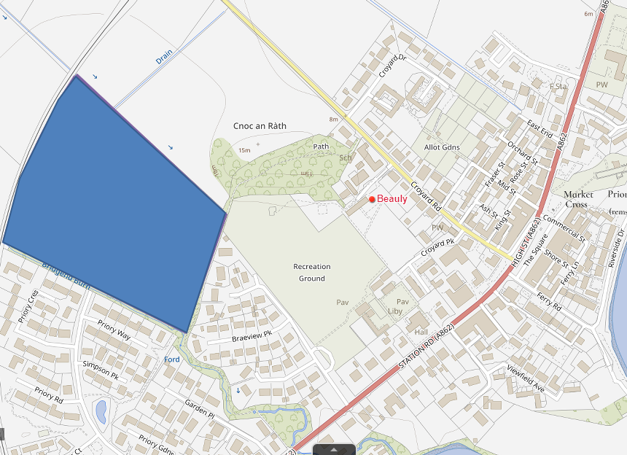
© Crown copyright and database rights 2025, OS AC0000849432

