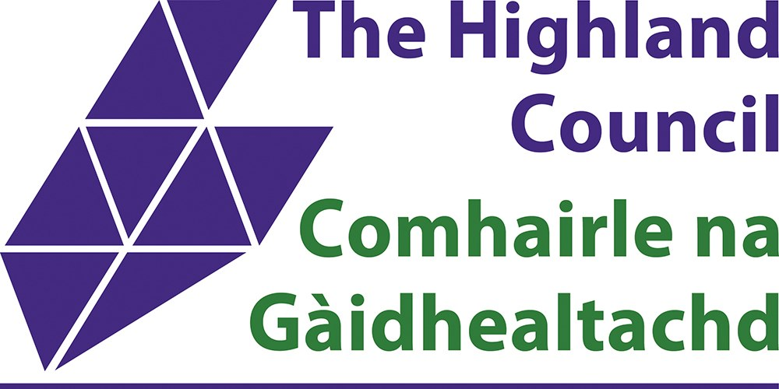

Highland Council Tenant Consultation – Rent Strategy 2026–2031

Have your say
The Highland Council is developing a 5-year Rent Strategy to make sure we can continue to deliver the housing services you rely on, invest in your homes, and build more affordable housing for the future.
We want your views on the proposed rent levels and the priorities for how your rent is spent.

Why is a Rent Strategy Needed?
- The cost of maintaining and improving homes has gone up in recent years due to inflation, higher interest rates, and new legal compliance standards, such as more frequent electrical inspections.
- There are over 8,700 people on the housing register with 30% of applicants being existing tenants and their families. There were 1,270 homeless presentations last year – demand for Council housing is growing and this strategy is aimed at meeting some of this demand. By investing in building new Council homes we are ensuring future generations have the access to secure, warm homes.
- In feedback from last year’s rent consultation you said we needed to invest in existing homes (like kitchens, bathrooms, windows, insulation) and build more homes to meet local needs. This strategy will help us meet these priorities.
- 43p of every £1 of rent currently goes to paying off debt – we need to reduce this so more of your rent goes into services and improvements.

What will this mean to me?
By having a 5-year rent strategy we can ensure that a balance is maintained between investing in our current stock with significant funds going towards upgrading and improving existing homes and building new homes to help those in need.
It can also give some certainty and stability for landlord long term financial planning, however, it must be noted that the budget will be scrutinised each year and tenants will have the opportunity to provide their feedback.
For further background information on this strategy, you can read the report presented to the Housing & Property committee on 5 November 2025 which can be found on the Council website, Item 8 Establishing a Financial Strategy for the Housing Revenue Account – Rent Strategy 2026-2031 - Housing and Property Committee | The Highland Council
You can also watch the discussion on this report - https://highland.public-i.tv/core/portal/webcast_interactive/943040/start_time/3462000?force_language_code=en_GB

Where your rent money is spent:
Since April 2025 the following upgrades have been completed and logged onto the housing system.
- Kitchens 139
- Bathrooms 109
- Heating up grades 504
- Windows 321
- Doors 418
- Roofs 167
- Rewire 34
- Energy efficiency measures
  - Solar 591
  - External insulation 73
  - Cavity wall insultation 140

Loan Charges
What are these and why do tenants have to pay these? Highland Council have to borrow money in part to fund building new council houses and carry out upgrades and improvements to existing homes.
In order to reduce the liability, the Council must look to reduce the amount of tenant rent money that goes to servicing these loans. The only way this can be done is to increase rents over a period of time.
As the loan ratio reduces this will mean that more of your rent money will be spent on the things you prioritise such as upgrades and cyclical maintenance.

Current rents:
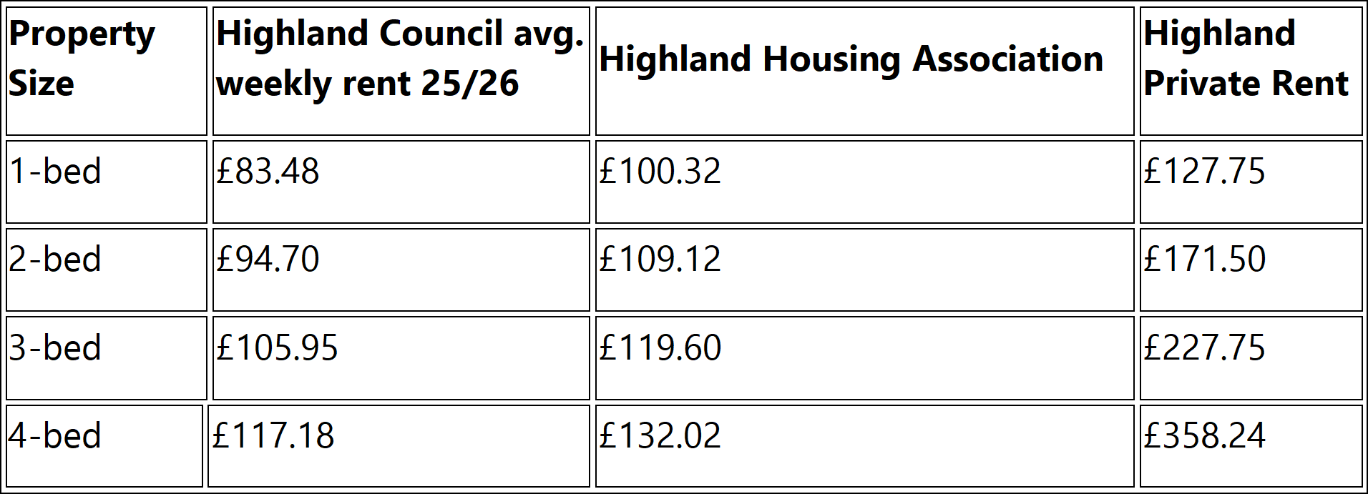
Highland Council Average rents are among the lowest in Scotland. However, we recognise that there are additional living costs unique to Highland that impact on household budgets. Details of support available to tenants struggling can be found at the end of this document.
Over 59% of tenants receive housing benefit or Universal Credit, which helps cover some or all of their rent.

What Are the Rent Options?
We’re asking for your views on three possible rent increases. The options this year have been proposed to allow for more investment in current stock, the new build programme and to address other areas tenants indicated were priorities for them in last year's consultation.
Improvements and upgrades to homes are based on a Capital Programme that looks at homes in the greatest need and where we can achieve economies of scale, that is, the cost savings that occur with the efficiency of carrying out larger projects, for example, streets where there are many houses all in need of improvements.
These options would apply for each year of the 5 years covered by this strategy e.g 8% every year for the next 5 years. This will be reviewed each year to ensure that we can continue to meet our commitments.
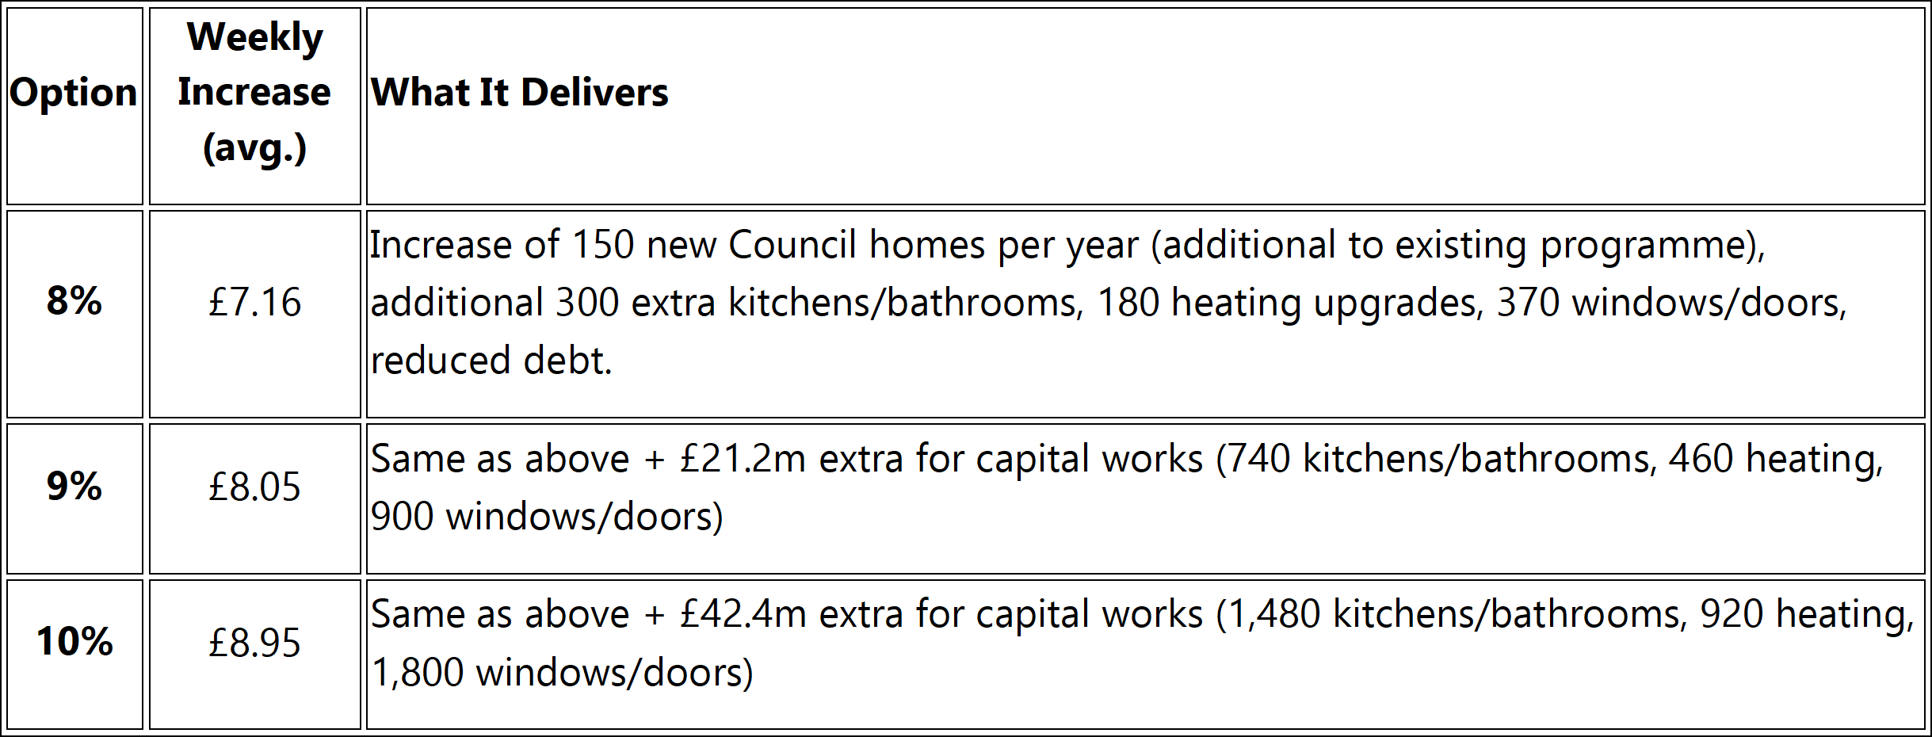

What will this look like?
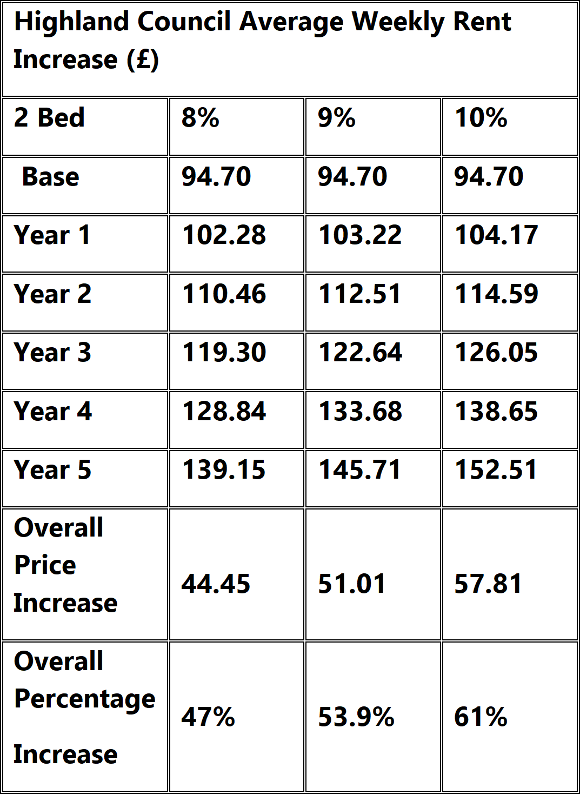

How Will Tenants Benefit from this Strategy?
- Better homes: More investment in repairs, energy efficiency, and upgrades.
- More homes: Doubling the number of new Council homes built each year.
- Lower energy bills: Through insulation and heating improvements.
- Stronger services: Ensuring your rent covers core services like repairs and housing support.
- Long-term stability: A 5-year plan helps with budgeting and gives clarity on where your rent goes.

We Want Your Views
We’re asking tenants to tell us:
- Do you agree with the principles behind the Rent Strategy?
  - Build more Council homes
  - Invest in existing homes
  - Make your home more affordable with improved energy efficiency
  - Reduce debt costs
  - Ensure financial sustainability
- Does a 5-year rent plan help you plan your household budget?
- Which rent option do you think is fair and affordable?
- We are particularly interested to hear from Sheltered tenants paying an additional service charge as part of their rent. Do you think this offers value for money?
- What should we prioritise – new homes, repairs, energy efficiency, estate improvements?
- Are there any priorities that you don’t think should be paid with your rent money?
Consultation runs from 17 November to 5 January 2026.
Feedback received from tenants will be used to prepare a report for the Council’s Housing and Property Committee to decide and agree the increase to your rent.
In addition to completing this survey, we urge you to contact your Local Councillor if you wish to discuss the rent consultation with them. Details can be found here: Councillors | The Highland Council
You can also find details of members on the Housing & Property Committee - Committee members | Housing and Property Committee | The Highland Council
We will write to you at least four weeks in advance to notify you of the new rent and service charges coming into effect for 2026-27.

Are you struggling to pay your rent?
If you are having difficulties paying your rent, we can help you. In the first instance please contact your housing officer.
The Welfare Support Team can advise you on your current circumstances and help you to maximise your income contact Telephone: 0800 090 1004 Email: welfare.support@highland.gov.uk

Have Your Say
Our plans, and how we spend the budget, will have an impact on your home and your community.
We want to hear what you think. Please complete the survey by Monday 5 January 2026.
After previous successful digital consultations, we have decided to continue using this method. To take part in the consultation, all you need to do is select one of the following ways to respond:
- Online: by following the Survey Monkey Link below
  - https://www.surveymonkey.com/r/RC2627document
  - By email: tenant.participation@highland.gov.uk
OR
- By phone: Call 07557 744413 before Monday 22 December to complete the survey with an officer over the phone or to request a hard copy of the rent consultation document. (This number will only be answered between 9am – 5pm Monday to Friday. If the line is busy, please leave your details and we will get back to you.)

As a thank you for taking the time to complete our rent consultation you will be entered into our prize draw to win a £50 shopping voucher! Don’t delay, give us your views today!

