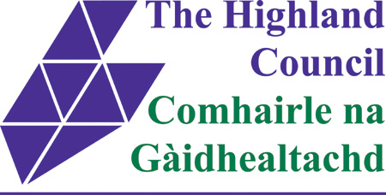
Homelessness etc (Scotland) Act 2003 Section 11

Notice by Creditors of Service of
- Calling-up Notice/Notice of Default; or
- Application to Court for a Warrant to Exercise Remedies on Default; or
- Proceedings to Eject Proprietor.

Under the duties placed on creditors by the above legislation please complete and send this form, by post or email, to the address at the bottom of the form. The form should be sent at the point proceedings are raised in Court.

Address of Property

Post Code
Name of debtor/proprietor

Date Standard Security

Date of calling up notice/notice default or raising of proceedings

Court in which proceedings have been raised

Creditor Details
Name
Address

Post Code
Telephone Number

Email Address

Creditor’s Legal Representatives
Name
Address

Post Code
Telephone Number

In your opinion are any members of this household  vulnerable | Yes | No | Don’t know

Please send this form to The Highland Council, Community Services, Town House, Inverness IV1 1JJ or email it to housing.legalsupport@highland.gov.uk

