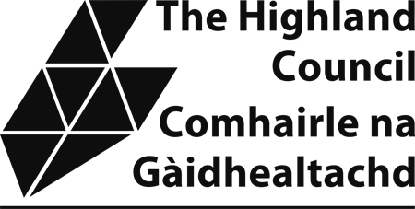

Civic Government (Scotland) Act 1982

Request to be included in the Council’s `Opt in’

List for Notification of Processions

Please complete this application form, ensuring that it is dated and signed and return to the relevant address below.

Name:  Address:  Postcode:  Phone Number:  e-mail address: | Representing  (If organisation)

Area(s) of interest:

Date: Signed:

Inverness, Nairn, Badenoch & Strathspey Area  Michael Elsey,  Licensing Service,  Town House,  Inverness,  IV1 1JJ.  Tel: (01463) 785098  e-mail: michael.elsey@highland.gov.uk | Ross, Skye and Lochaber Area  Angela Mair,  Licensing Service,  Council Offices  High Street  Dingwall IV15 9QN  Tel: (01349) 868493  e-mail: angela.mair@highland.gov.uk | Caithness, Sutherland and Easter Ross Area  Geraldine Sutherland  Licensing Service,  Caithness House  Market Place  Wick  KW1 4AB  Tel: (01955) 608214  e-mail: geraldine.sutherland@highland.gov.uk

