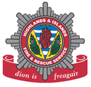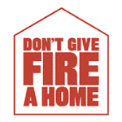

Worksheet: Fire Action Plan activity

Name _________________________________

Think about how you would get out of your house quickly and safely if your smoke alarm sounds. Make an Action Plan of up to five key points to tell the rest of your family what you could do to get out quickly and safely.

1.

2.

3.

4.

5.

Now make a checklist to put on your fridge at home so all your family know what to do.

