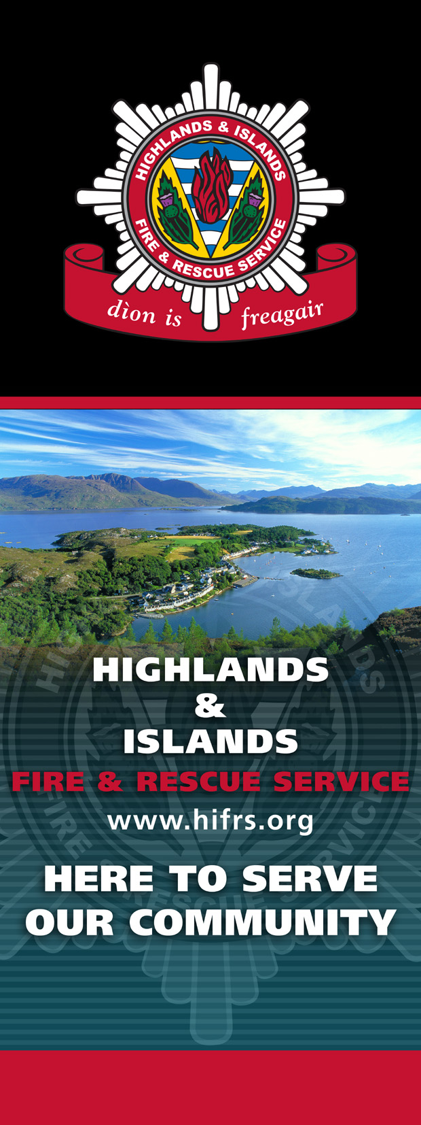

As part of our commitment to your safety at home, we are offering a FREE Home Fire Safety Check. This service is carried out by Community firefighters from your area.
- Visits will be by appointment only
- All appointments will be pre-arranged with you
- The firefighters calling will always be in uniform, use an agreed password and show an ID card
- DO NOT let anyone into your home without identification

The total time to complete a Home Fire Safety Check will vary with each situation but normally would last around 30 – 45 minutes.
This safety check will look at all areas of accident and fire risk within your home. We will advise you on the installation and maintenance of smoke alarms and also give advice and information on how to stay safe from fire including kitchen hazards, safe disposal of smoking materials, candles, heaters, electric blankets and dangers from harmful substances.

In addition, we will help you to make an escape plan to help prepare, you should a fire occur in your home.
To request your FREE Home Fire Safety Check, please call us on 08000 12 13 12 or online at http://www.hifrs.org/

