For Official Use:
Application fee: | No Fee |  | 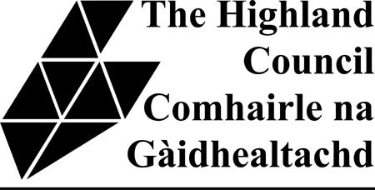
Received by:

HIGHLAND LICENSING BOARD
Licensing (Scotland) Act 2005, section 87
Completion of Refresher Training (Personal Licence)
Notice to Licensing Board
Please use this form to notify your Local Licensing Board that you have completed the “refresher” training required under section 87 of the Licensing (Scotland) Act 2005. You must complete your training and notify your Licensing Board otherwise your Personal Licence will be revoked automatically.
Guidance Note: Personal Licences are issued for a period of 10 years. However, in terms of Section 87 of the Licensing (Scotland) Act 2005, there is a legal requirement for personal licence holders to undertake refresher training within five years of the date of issue of their personal licence and, thereafter, produce evidence of this training to the Board which issued their personal licence not later than three months after the expiry of the period of five years from when the personal licence was issued eg. for those personal licences which were issued with effect from 1 September 2009, refresher training will require to be completed by 31 August 2014 with notification to the relevant Board by 30 November 2014. Further advice can be found at www.scplh.info
Please note that Personal Licences with an issue date prior to 1 September, 2009 are classed as having been issued on 1 September 2009 as that is when the Licensing (Scotland) Act 2005 came into “effect”.

Name (as it appears on your Personal Licence):
Current address: House / Flat Number (or) House name
Street
City / Town / Village
County / Region
Postcode Tel No. Mobile No.
Date of Birth:
Personal Licence Number (this can be found on your personal licence)
Date of Personal Licence Expiry Date of refresher training

SUBMISSION OF NOTIFICATION:
Please attach a physical or scanned copy of your SCPLH(R) Certificate to this form and send to your undernoted Local Licensing Office or email to: licensing@highland.gov.uk

Please note that there is no requirement to return your principal Personal Licence to the Licensing Board, unless there has been any change in your name and/or address.

Inverness, Nairn, Badenoch & Strathspey Area at
Town House
High Street
Inverness
IV1 1JJ
Tel: (01463) 785087
Caithness, Sutherland & Easter Ross Area at
Council Offices  Government Buildings  Girnigoe Street  Wick, KW1 4HW  Tel: (01955) 609508 | Council Offices  Drummuie  Golspie  KW10 6TA  Tel: (01408) 635205
Ross, Skye & Lochaber Area at
Council Offices  High Street  Dingwall, IV15 9QN  Tel: (01349) 868541 | Council Offices  Tigh na Sgire  Park Lane  Portree, IV51 9GP  Tel: (01478) 613826 | Council Offices  Lochaber House  High Street  Fort William, PH33 6EL  Tel: (01397) 707233

If you wish any additional guidance or advice, please contact your Licensing Standards Officer in your area:-
LICENSING AREA | LICENSING STANDARDS OFFICER | CONTACT DETAILS
Inverness, Nairn, Badenoch & Strathspey | Ian Cox | Tel: (01463) 785089  E-mail: ian.cox@highland.gov.uk
Caithness, Sutherland & Easter Ross | David Inglis | Tel: (01955) 609507  E-mail: david.inglis@highland.gov.uk
Ross, Skye & Lochaber | Elizabeth Treasurer | Tel: (01397) 707200  E-mail: elizabeth.treasurer@highland.gov.uk

