Dingwall Conservation Area Regeneration Scheme

GUIDANCE NOTES

Shop Front Grants
Building Restoration Grants

Funded by:
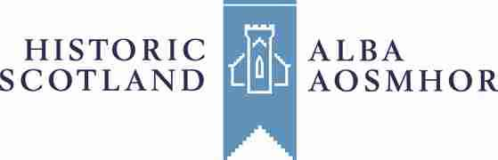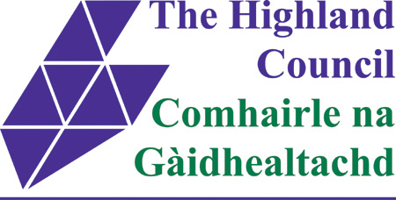

Introduction

The Dingwall Conservation Area Regeneration Scheme (CARS) aims to aid regeneration in the Dingwall Conservation Area through the restoration of historic properties along the High Street. Funding has been provided by Highland LEADER 2007-2013, Historic Scotland and the Highland Council for the creation of two grant programmes, one for the reinstatement of historic shop fronts and the second for the conservation of other exterior features on traditional buildings.

Grant Guidance Notes

Eligible Activities and Standards of Work

General

Only properties within the CARS boundary are eligible for grant assistance. Buildings and shop fronts must contribute towards the historic character of the conservation area to be eligible. Only external and some structural works are grant eligible.

All work should retain as much of the existing original or historic fabric as possible by minimising intervention. Approved works to the existing fabric should adopt the traditional materials, craft skills and construction techniques found in the original building. This list indicates the general standards and broad criteria that apply to works carried out with CARS grant funding. In all cases detailed proposals should be discussed with the CARS Project Officer before an application for grant is made.

Roofs

Eligible: The comprehensive refurbishment of traditional natural slate roofs is grant eligible. Eligible works may include slating, timber, ridge, skew and chimney work, leadwork and works to traditional dormers and rooflights.

Standards of Work:
Slate: Existing original or historic slates should be retained and reused. Where replacement slate is necessary, this should be matched to the existing slate in colour, size, thickness material and laying pattern.

Roof Timbers: Existing historic roof timbers should be conserved. Where new timbers are necessary they should match the original profile. The eradication of rot or insect infestation to timbers should avoid unnecessary treatment and should be based on a careful and knowledgeable assessment of the outbreak or infestation including, activity, extent and location of the problem. Works should eliminate the source of moisture and should seek to solve timber problems by construction methods.

Ridges, Skews and Chimneys: Historic skews and ridges should be retained and repaired and any necessary new materials should match the historic pattern. Chimney heads should not be lowered and historic chimney cans should be retained.

Leadwork: Leadwork should be laid in accordance with the recommendations of the lead sheet association.

Dormers and Rooflights: Existing traditional rooflights and dormers should be retained and repaired.

Windows

Eligible: The conservation of original or historic timber windows is grant eligible. Replacement windows may be eligible for grant only where the existing windows are beyond repair or are inappropriate. Double glazed windows are only eligible in certain circumstances.

Standards of Work:
Existing original or historic windows should be conserved and retained. Works may include replacement of rotted timber sections, draught proofing, repair of sash cords, mastic and putty. Original or historic elements such as ironmongery should be retained. Where new windows are necessary the design and materials should be constructed to an appropriate traditional pattern and glazing bars/astragals should be an integral part of the sash construction.

Doors

Eligible: The conservation of original or historic traditional exterior timber doors is grant eligible. The replacement of inappropriate modern doors with doors which match the historic design and material for the building may be grant eligible.

Standards of Work: A minimal intervention approach to the restoration of historic doors and their frames should be taken. Historic features such as fanlights and traditional ironmongery should be retained.

Rainwater Goods

Eligible: The conservation of historic cast iron rainwater goods as well as the replacement of plastic pipes and gutters with cast iron are grant eligible works.

Standards of Work: Existing cast iron rainwater goods and their fixings should be retained and repaired where possible. Where new sections or fittings are needed these should match the existing traditional or historic design in material and profile.

Stonework

Eligible: Where the existing pointing is failing or causing damage to the stonework its repair or replacement with a traditional lime mortar appropriate to the building is grant eligible. Rendering or harling will normally only be eligible where a render or harl is traditional to the building and any proposed rendering/harling works will have to be discussed on a case by case basis. Stonework repairs are grant eligible where a minimum intervention approach is taken.

Standards of Work:
Pointing: The removal of existing cement pointing should only be carried out where its removal will be less damaging than leaving the pointing in situ. Mortars used in re-pointing should match traditional existing mortars, including the aggregate, colour and texture. Mortars should be lime based and the strength of the mortar should reflect the strength of the stonework.

Rendering/Harling: Renders and harls should usually only be reapplied where they already exist as a traditional finish.

Stone Reinstatement: A minimum intervention approach should be taken with all stone restoration and all works should follow the guidelines found in Historic Scotland’s Advisory Standards of Repair.

Structural

Eligible: Some structural works may be eligible where there is a proven ongoing defect.

Standard of Work: In all cases the most conservative solution of structural repair should be adopted.

Professional Fees

Eligible: Professional fees up to a value of 10% of the eligible works costs may be eligible for grant. For grants in excess of £25,000 a suitably qualified professional advisor must be appointed to manage and oversee the works.

Standard of Work: The professional advisor must be suitably qualified in building conservation and details of architects and surveyors experienced in the repair of historic buildings can be obtained from the Royal Incorporation of Architects in Scotland (RIAS) and the Royal Institution of Chartered Surveyors in Scotland (RICS). In certain circumstances other suitably qualified professionals may be acceptable for a specialised scheme requiring their particular expertise.

Shop Fronts

Eligible: The conservation and reinstatement of traditional shop front features such as fascia boards, windows, doors and stallrisers are grant eligible works. Reinstatement must be based on physical or documentary evidence of a shop’s previous form.

Standards of Work: There are a variety of traditional shopfronts on the High Street, so specific eligible works to historic shops shall be discussed on a case by case basis. The publication Traditional Shopfronts: A Short Guide for Shop Owners by Historic Scotland contains a guide to the elements of a shop front and explains important architectural features.

Non-Eligible
The following works are not grant eligible:
- Retrospective applications - Grant cannot be awarded for works that have already been undertaken
- Interior Works
- Normal routine maintenance and decoration
- Unsympathetic alterations, modern techniques and materials
- The installation of services, drainage or other earth works
- New buildings and extensions
- Demolitions

Application Guidance Notes

Small Grants/Large Grants

The CARS grant intervention rate is currently set at 80% of the eligible works for both shopfront and building restoration works. This rate will be revised periodically and may go down in the future.

Approved small grants of up to £25,000 shall be awarded to property owners/occupants according to the conditions of grant set out in appendix A. Large grants of over £25,000 will require additional conditions including a standard security over the property.

Making Your Application

The application process for all grants; small, large, shopfront or building restoration will follow the same procedure. The initial application form can be found at www.highland.gov.uk under Grants and Discretionary Funding, Dingwall Conservation Area Regeneration Scheme [Select ‘G’ from the A-Z of Council Services (left-hand side of screen); select ‘Grants’; select ‘Highland Council Grant and Discretionary Funding’ and finally ‘Dingwall Conservation Area Regeneration Scheme’]. This should be submitted along with three quotes for the proposed work. After an initial assessment, a second form will be provided which will allow the application to go for approval. A letter will be sent to applicants notifying them of the outcome of the application with any specific grant conditions attached.
Please submit applications well before any work is due to start as grants will not be considered retrospectively. Work must not start before the grant application has been made and a decision issued.
Use the application form found at www.highland.gov.uk, and include three independent quotations for the work. A full specification of the work will also be required if this does not form part of the quotation.
Detailed drawings must be submitted of any architectural features or joinery being replaced or renewed. You can also support your application with appropriate photographs if this helps to clarify the extent or nature of work.
Where the total works costs will be more than £25,000 the contract for the works will need to be openly advertised. The procedure for this can be discussed with the CARS Officer during the application stage.
A letter confirming that the applicant is the owner of the property where the proposed works will take place will need to be submitted. Where the applicant is not the owner of the building, a letter from the owner giving consent for the works will be required.
In submitting this application for grant under the Dingwall CARS you are confirming acceptance of the conditions of grant, as detailed in appendix A overleaf and you are agreeing to be bound by those conditions.
Special conditions may also be applied relating directly to methods, materials, detailing or techniques when needed.

Please ensure that the builder/contractor is fully aware of the specialised requirements of the grants scheme and of any conditions attached to your offer. Grants will not be paid if the work does not meet the required standard.

Statutory Consents
Grant eligible works may require Listed Building Consent, Planning Permission and/or Building Warrant. These requirements are separate from the grant application process and it is the responsibility of the applicant to ensure that all statutory consents are in place prior to work being commenced on site. Applicants are strongly advised to contact the local Highland Council Planning Office to check whether the works require any consent.

Application Checklist
Application Form www.highland.gov.uk
Three Quotes
Specification of Works
Letter of ownership or owner’s consent for works
Planning permissions

Contact and Further Reading

Contact

For further information or to submit an application, please contact:

CARS Officer
Council Offices
High Street
Dingwall
IV15 9QN

Tel: 01349 868485
dingwall.cars@highland.gov.uk

Further Reading

Historic Environment Grants: Advisory Standards of Repair, Historic Scotland Sets out the basic standards of repair to be used in historic building repair grant schemes. Copies are available from the Historic Scotland website or the CARS Office.

Traditional Shopfronts: A Short Guide for Shop Owners, Historic Scotland, Hard copies are available from the CARS Office or can be downloaded from Historic Scotland’s website.

Inform Guides, Historic Scotland – A range of guides on traditional building skills, including slate roof repair, lime mortar pointing, repair of ironwork etc. Copies are available to download from the Historic Scotland website.

Map of CARS Boundary

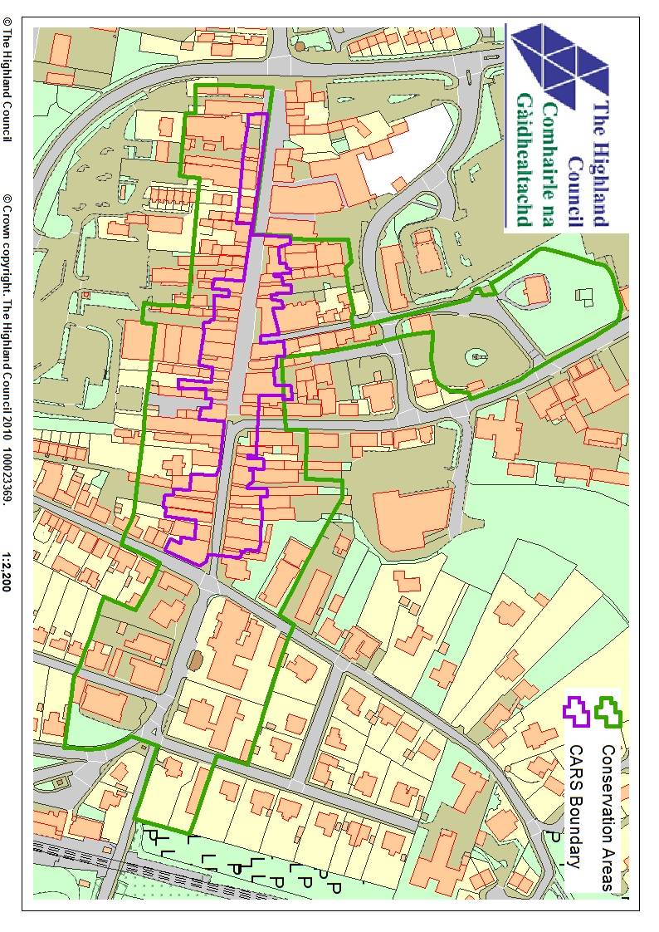

Funded By:

This Project is being part financed by the Scottish Government and the European Community Highland LEADER 2007-2013 Programme, Historic Scotland’s Conservation Area Regeneration Scheme and the Highland Council.

v.02 July 2012
Appendix A

Conditions of Grant
Grants are discretionary and subject to the availability of funds. The inclusion of a property within the Dingwall CARS does not necessarily indicate that a grant will be awarded. All grants are subject to the following general conditions:
1 No grant related work has started before approval of the grant, in writing, has been received from The Council.
2 The offer must be accepted, in writing, within one month, and the work completed, within one year of the date of offer of grant unless an extension of time has been agreed, in writing, by the Council.
3 Reasonable access to the property must be given to representatives of the Council or the Scottish Executive before during and on completion of the works.
4 Work must be carried out to the satisfaction of the Council in accordance with the approved plans and specification. Any variations must be agreed, in writing, with the Council before any works are undertaken.
5 Payment will only be made on the satisfactory completion of the work and following submission of all relevant paid, receipted original invoices.
6 Grants will be adjusted downwards if the final eligible costs are less than those indicated in the original quotations.
7 The property shall, on completion of the grant aided works, be adequately maintained consistent with the character and architectural detailing of the property.
8 The Council reserves the right to reclaim the grant, or a proportion thereof, within a period of ten years if the grant-aided works to the building are inadequately maintained. Inadequate maintenance at any time in the future may also be taken into account should further heritage property grants become available through the Council or the Scottish Executive.
9 The applicant shall advise the Council in writing of any intended sale or other disposal of the property or termination of a leasehold interest where this occurs within three years of the payment of grant.
10 The Council reserves the right to require repayment of the grant, or a proportion thereof, if the property is sold or the lease terminated within three years of payment of grant.
11 When the application is on behalf of a Company or Community Group grants are awarded on the basis that it falls within the objects of the applicant’s constitution and that the named signatory has the power to accept the grant subject to these conditions and the power to repay the grant if required.
12 Following completion of the grant aided works the property is to be adequately insured in respect of all reasonable and relevant risks to enable repayment of the grant in the case of total loss, or reinstatement of the building in the case of partial loss.
13 The signing of the application form by the named contact/applicant, the receipt of a formal offer letter from the Council and the acceptance of that offer by the applicant, form the basis of a binding contract between the applicant and The Council.
14 The Council reserves the right to withhold all, or part of the grant, if any of the above standard conditions or any special conditions are not complied with.
Special conditions may also be applied relating directly to methods, materials, detailing or techniques when needed. These might include the requirement to approve a sample area of pointing before the main work proceeds or the specification of mortar to be used or the approval of joinery cross-sections.

