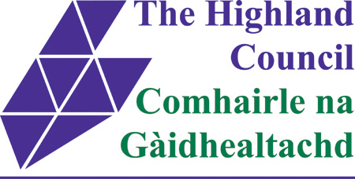

PLUS ONE SCHEME

CERTIFICATE OF ELIGIBILITY
AUTHORISATION
(by GP or other medical professional)

Name of Applicant
……………………………………………………..……………....

Address of Applicant
……………………………………………………..……………….

The above named person has applied for a Plus One Card to enable his / her carer / attendant to gain free entry at certain culture and leisure activities across Highland on the grounds that he / she meets criteria.

Could you please confirm if the above named person falls into any of the following categories?
( ) A permanent resident in the Highland Council area

And one of the following:
( ) Sensory impairment
( ) Physical impairment or frailty
( ) Learning disability
( ) Mental health problems
( ) Other (please determine)

Signature …….…………..………………………………….
Printed name ……….……………….…………………………...
Title …………………………………………………….
Address ……………….……………………………............
Date …………………….……………………………....

