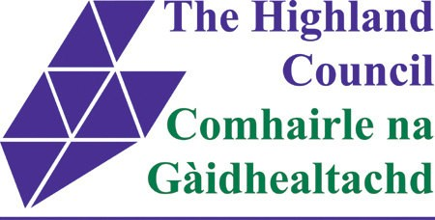

RIVER NESS FLOOD ALLEVIATION SCHEME AND STREETSCAPE

The Highland Council (Huntly Street, Inverness) Restricted Parking Zone Order 2012 Amendment Order 2014
The Highland Council (Inverness Permit Parking) Order 1999 (Various Roads, Inverness) Amendment Order 2014
The Highland Regional Council (Inverness – Riverside West) (General Traffic) Order 1984 (Balnain Street, Friars Place, Greig Street, Huntly Street, Inverness) Amendment Order 2014

STATEMENT OF REASONS
- Introduction

The River Ness Flood Alleviation Scheme will involve the construction of flood walls and embankments to defend neighbouring streets and properties from the threat of high river levels and tides. It is proposed that improvements are carried out on various streets as a result of the Flood Scheme. In February 2013, the City of Inverness Area Committee approved amendments to Traffic Orders affecting Huntly Street and neighbouring streets. These Orders resulted in a reduction of parking spaces on Huntly Street and Friars Place from 101 (mixed Pay & Display/Free/Permit) to 39 during the day. Of the 39 spaces, 26 were Permit Parking on Huntly Street; 7 Disabled and 6 Permit on Friars Place. Following further consultation with the public, further amendments were required to these Orders to reintroduce more parking.

- The Scheme's Objectives

Huntly Street
When the proposed Orders come into effect, on-street parking between Celt Street and Greig Street would be increased by 11 no. short-stay (max 2 hours), “pay and display” spaces. These would be restricted between 8am and 6pm, Monday to Saturday. Outwith these periods, parking would be unrestricted overnight and during Sundays. The parking restrictions in the loading bays located outside Balnain House and House of Fraser (proposed in earlier Traffic Orders associated with this scheme) would be altered to allow free unrestricted parking for cars after 6pm Monday to Saturday. The above alterations would result in an additional 20 parking spaces (in total) being available outwith restricted hours.
The total provision of car parking spaces on Friars Place / Huntly Street would therefore be increased from 39 to 50 (during the day) with 59 spaces available at night.
Balnain Street / Greig Street Parking - 6 spaces on Greig Street currently classed as free/unrestricted would be re-determined as Permit Parking (8am – 6pm, Monday - Saturday). On Balnain Street, 1 Permit Parking space will be removed as “No Parking at any time” is introduced between the junction of Balnain Street / Huntly Street and No. 24.

Traffic Direction - When the Orders come into effect, traffic will flow in a southerly direction along Huntly Street (as per current situation), with 2-way traffic being re-introduced on Balnain Street and Greig Street. At the Ness Bridge end of Huntly Street, the left-hand turn will be banned.
- Programme and Next Steps

Formal consultation on these draft Orders will be open for a period of 28 days. Any relevant representations to these Orders will be discussed with the Project Team. A report explaining the process and remaining representations will then be presented to the City of Inverness Area Committee for consideration.

