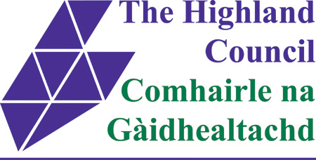

THE HIGHLAND COUNCIL

THE HIGHLAND COUNCIL (INVERNESS PERMIT PARKING) ORDER 1999 (VARIOUS ROADS, INVERNESS) AMENDMENT ORDER 2014

The Highland Council in exercise of their powers under Sections 45 and 46 of the Road Traffic Regulation Act 1984 as amended (which Act as so amended is hereinafter referred to as “the 1984 Act”), and of all the other enabling powers and after consultation with the Chief Constable in accordance with Part III of Schedule 9 to the 1984 Act hereby make the following order:-

- This Order may be cited as “The Highland Council (Inverness Permit Parking) Order 1999 (Various Roads, Inverness) Amendment Order 2014” and shall come into operation on *******

- The Interpretation Act 1978 shall apply for the interpretation of this Order and of all other orders revoked by this Order as it applies for the Interpretation of an Act of Parliament.

- All provisions contained in any Order Enactment or others in so far as the same repeat or are inconsistent with the provisions of this Order and the true intent and meaning hereof shall cease to have effect and are hereby revoked.

- In this Order “the Principal Order” means ‘The Highland Council (Inverness Permit Parking) Order 1999 as amended”.

- The restrictions imposed by this Order shall be in addition to and not in derogation of any restriction or requirement imposed by any regulations made under the 1984 Act or by or under any enactment.

- Without prejudice to the validity of anything done or to any liability incurred in respect of any act or omission before the coming into operation of this Order, the Principal Order shall have effect subject to the following variations, insertions, amendments and substitutions:

  - The following Schedules shall be amended as detailed in the Schedule annexed hereto.
Schedule 5
Schedule 14

Sealed with the Common Seal of The Highland Council and subscribed for them and on their behalf by ***** their Legal Manager Conveyancing and Commercial and Proper Officer at Inverness on *******
This is the Schedule referred to in the foregoing The Highland Council (Inverness Permit Parking) Order 1999 (Various Roads, Inverness) Amendment Order 2014

SCHEDULE

Schedule 5 On Street Parking Places – Permit Parking (8am to 6pm) (Mon to Sat)

The following shall be added to Schedule 5
Greig Street (Southeast side)

From a point of 10 metres or thereby from the southwest kerbline of Huntly Street southwestwards for a distance of 26 metres

Schedule 14 On Street Parking Places - Permit Parking, ‘AREA B’ (Applies to valid resident permit holders from Balnain Street, Celt Street, Friars Place, Huntly Street and Queen Street) At Any Time

The following shall be deleted from Schedule 14
Balnain Street (Northwest side)

From a point of 37 metres or thereby northeast from the northeast kerbline of King Street for a distance of 6 metres or thereby

