Agenda

1. Welcome and introductions
2. Notes from Meeting on 19 December 2014
3. **Childrens Services**
   1. Early Years – Sam Brogan
   2. Staffing update (school nurses/health visitors) – Wendy Allman
   3. Merkinch Family Centre and Primary School – Wendy Allman
4. **Adults Services**
   1. Updates - Donellen Mackenzie
      1. Home care
      2. Delayed discharge
      3. Staffing
      4. Care homes
      5. Review work
   2. Adult social care initiatives – Joanne MacDonald
   3. District Change & Improvement plan – Donellen Mackenzie
   4. Defibrillator mapping – Robert Farquhar
   5. Revised District Partnership Guidance
   6. Resilience Planning – Mo Bates & Shona Horn, SSE
   7. Handyperson Scheme – Jay Muirhead, Signpost
5. Public views/suggestions
6. Date of next meeting – Friday 19th June 2015 (10 – 12 p.m.)

Members of the public are welcome to attend and observe this meeting

For further information contact Charles Stephen on 01463 785010

**INVERNESS WEST DISTRICT PARTNERSHIP**

Friday 20th March 2015

Merkinch Community Centre, Inverness

10 a.m. – 12.30 p.m.

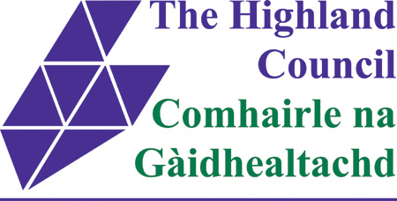

[NHS Highland Logo](http://www.nhshighland.scot.nhs.uk/)