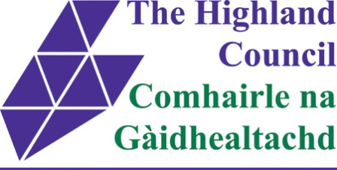
INVERNESS EAST DISTRICT PARTNERSHIP
Wednesday, 24th June 2015
Ross Room, Hilton Community Centre, Inverness
10 a.m. – 12 noon
Agenda

1. Attendance & Apologies

2. Action Note from previous meeting 18th March 2015 – Matters Arising

3. True Partnership Working - Engagement at Community, Family and Individual Level

- Self-Directed Support
- Transition Pathway
- Work in Progress

Margaret Kinsella, District Manager - Care & Learning, Highland Council

&

Gavin Sell, Adult Services Manager, NHS Highland

4. A.O.C.B.

Next Meeting – Thursday 17th September 2015

