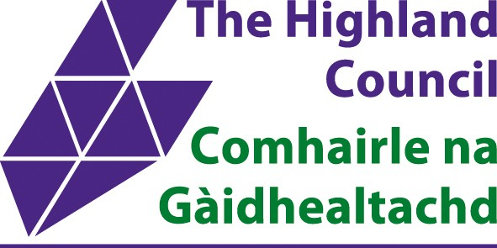
Reasonable Adjustment Passport Form

What is a Reasonable Adjustment Passport?
A reasonable adjustment passport (RAP) is a record of adjustments agreed between a worker who has a disability or health condition and their manager. The passport acts as a 'live' document about agreed changes in the workplace.

Employee Name: |  | Job Title:
Manager Name: |  | Job Title:
Date: |  | Review date:

Reasonable adjustments details

The nature of my condition is:
My disability/health condition can have the following impact on me at work:
The following reasonable adjustments have been agreed between me and my manager (include date(s) of implementation):
I have requested/been provided with the following advice:
(From whom and when for example ie occupational health or GP)

I need to make my manager aware of the following First Aid requirements: please also attach Personal Emergency Evacuation Plan (PEEP) requirements:

My condition at work
Please complete if you have a fluctuating condition:

On a good day, I believe that my disability/health condition has the following impact on me at work.
When things are not so good, the following symptoms are indications that I’m not well.
When things are not so good, I might need the following further reasonable adjustments:

Adjustments declined

Are there any adjustments that cannot be accommodated and if so why?:
(Line Manager to contact HR)

Emergency contacts
Below is a section for optional emergency contact details. You are under no obligation to provide these details.

If I’m not well or there are any urgent concerns about my wellbeing, I’m willing for my manager to contact any of the following emergency contacts.

Name:
Telephone numbers: | Home:
Telephone numbers: | Mobile:
Relationship to you:

Name:
Telephone numbers: | Home:
Telephone numbers: | Mobile:
Relationship to you:

If you decide to complete this section please ensure that this information reflects the details you may have already provided on Myview.

Passport sign off
As the employee, I agree that this is an accurate reflection of the meeting and agree to retain an up to date copy of this passport a copy of which will be retained by my manager. Permission will always be sought from me before the content is shared. However, I understand that in certain circumstances the passport may be subject to disclosure by my manager (e.g employment tribunal).

I agree that it is my responsibility to ensure that any new manager, or anyone I think would need to know about my condition and the adjustments, are informed about the passport by me.

Employee signature: |  | Date:
Manager signature: |  | Date:

Review

The passport and agreed reasonable adjustments should be reviewed six months after the adjustments have been put in place to ensure they are removing any identified workplace barriers. Where adjustments have not been put in place or have not proved to be useful, this meeting would ensure adjustments can be actioned or new adjustments can be discussed and agreed.

Further reviews will be at the employee’s request, or if there is any change to an employee’s job role which might create additional barriers, to ensure the adjustments are still appropriate and effective in eliminating workplace barriers.

The employee has the right to be accompanied by their trade union representative or any other representative of their choice at the original meeting and any subsequent review meetings.

I believe there have been the following changes in my condition/impairment which will require the following additions/amendments to the agreed adjustments:
(please attach any supporting information if applicable)
Review date | Manager’s signature | Employee’s signature

Notes:
This passport is a live record of adjustments agreed between you and your manager to support you at work because of a health condition or disability. It’s for you to keep and pass onto anyone you think needs to know about your condition and any impact it may have on you (we won’t do this automatically).

The purpose of this passport is to:

make sure that there is a clear record of what has been agreed;
reduce the need to re-assess adjustments every time you change jobs, are re-located or are assigned a new manager;
provide you and your manager, with the basis for future conversations about adjustments

The passport should be reviewed for example if there is a change to your condition and amended where appropriate. Remember that your manager may need to get additional advice from, Occupational Health, Access to Work, and/or HR, before any adjustments or changes can be agreed and implemented.

If you change your job or you have a new manager, you should provide a copy of this to them so that they understand what adjustments have been made for you, this will not be done automatically. If you’re in the same role and your health condition remains the same, new managers should accept the adjustments outlined in the passport. If, in the event you refuse to share your passport with your new manager, or do not make him/her aware of its existence then then a new passport will be offered where appropriate.

If your health condition changes, you have moved to a new role, location, desk etc., or there are any other changes to your job which mean that the adjustment may no longer be appropriate; then the adjustments may be reviewed straight away.

Passports are not stored or recorded centrally, therefore it is your responsibility to keep it safe and supply it when necessary. Your manager should also keep a copy for their own records which may be held electronically and must remain secure.

