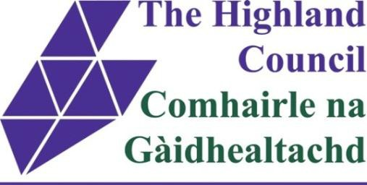
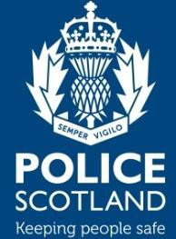
Your Logo

INTRODUCTION OF COLD CALL CONTROL ZONE (CCCZ)

You recently received a consultation pack asking if you would be interested in a Cold Call Control Zone (CCCZ) in your area. As a result of this, YOUR COMMUNITY GROUP has decided to introduce a CCCZ covering INSERT STREET NAMES HERE.

This means that signage will be introduced around these streets and you will be provided with information on how to deal with an unwanted doorstep trader. While it is not illegal for a trader to enter the CCCZ, the signs should act as a visible deterrent and the information provided should help you feel better equipped to deal with them.

Please find the enclosed Residents Pack. It should contain:
- A double-sided door sticker which warns anyone calling at your doorstep that you do not buy goods/services at the door on one side, and gives information on who to report any unwanted doorstep traders to on the other.

Please peel off the backing and display this sticker with the warning facing out in the window of your door or at the front of your property. The details of who to contact should be facing you on the inside.

- A booklet entitled Buying on the Doorstep which gives information on how to protect yourself and others from rogue doorstep traders.
- Information on the Nominated Neighbour Scheme, a Police Scotland initiative which is supported by Trading Standards.
- A checklist for noting down details of any unwanted doorstep trader for example when they called and what they were selling.

By choosing to introduce a CCCZ, you and your neighbours have decided that you do not want rogue doorstep traders in your area. Please report any doorstep trading activity to:

Highland Council Trading Standards on 01463 644570
or

Police Scotland’s Non-Emergency number on 101

Criminals will be pursued and legitimate traders, where identified, will be offered advice about doorstep calling and the residents’ wishes in this area, not to be cold called.

Thank you for supporting this initiative.

YOUR COMMUNITY GROUP

Trading Standards, Chief Executive's Office,
The Highland Council, 38 Harbour Road, INVERNESS, IV11UF.
Tel: (01463) 644570 E-mail: trading.standards@highland.gov.uk Website: www.highland.gov.uk

