What Happens Next?
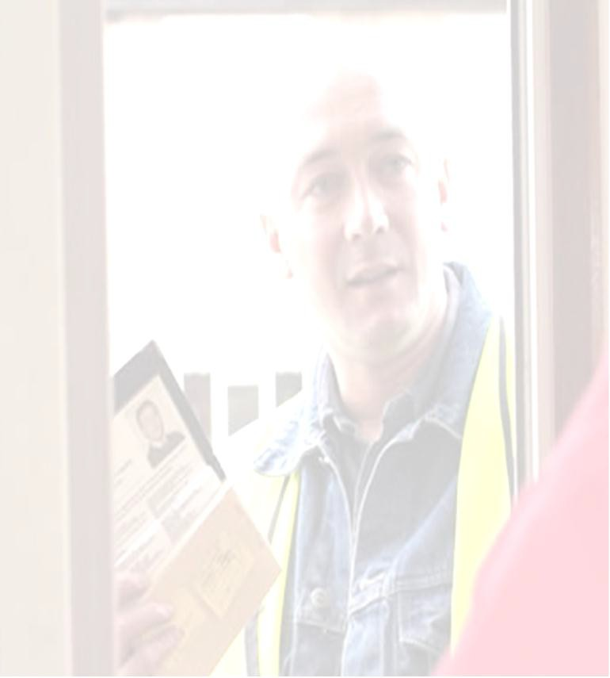
If the majority of residents are in favour of creating a Cold Call Control Zone then you will be provided with an information pack by Trading Standards detailing basic measures to protect you from doorstep crime.
Door stickers and notices have proved to be a useful way of deterring traders in the past. Each household within the Zone will be provided with notices to display on their door and windows.
On the outward facing side is a clear message that doorstep traders are not welcomed and on the inward side is a simple crime prevention message and a contact number for help or to report an incident.
There will also be display signs on lamp posts indicating the Cold Call Control Zone.
There will be an open evening in INSERT VENUE HERE on INSERT DATE HERE to receive your pack.

If you require further information please contact:
YOUR DETAILS HERE
Highland Council Trading Standards:- 01463 644570
YOUR COMMUNITY GROUP in conjunction with Highland Council Trading Standards, Police Scotland and your local Ward Councillors are actively looking towards establishing a Cold Call Control Zone in INSERT STREET NAMES.
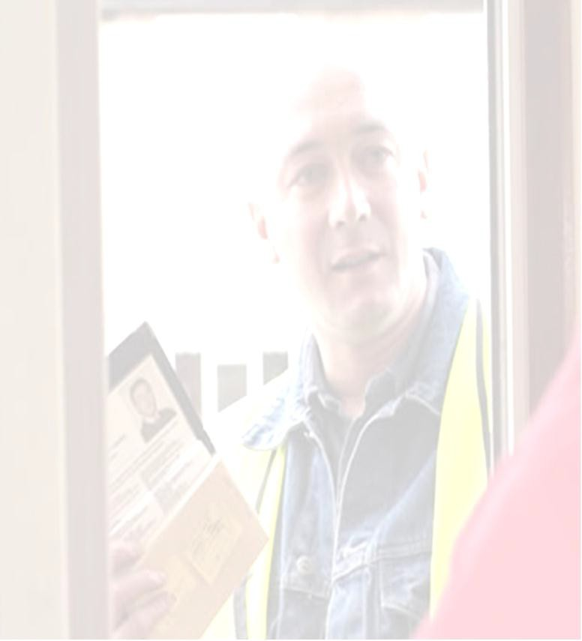
Quite simply, a Cold Call Control Zone is about local residents having the confidence to say “NO” to uninvited traders, that they are not welcome in this community and that their trading practices will be investigated if they cold call residents within the Zone.
“Cold calling” refers to uninvited traders calling at your home. “Doorstep Traders” includes sellers and buyers such as double glazing, roofing repairs, paths/driveway work antique buyers etc. This does not include local roundsmen e.g. newspapers, Church or Community Organisations.
To assist with this work we would be grateful if you could take a few minutes of your time to fill in the Questionnaire inside. When completed, please pop it in the stamped addressed envelope provided. Please help us to help you by returning the questionnaire by INSERT DEADLINE HERE

Thank you

- In the past 12 months (as far as you can remember) were you visited by any doorstep traders?
Yes ☐ No ☐
- If you have had traders cold calling was it for…..Tick as many boxes as appropriate.
Home Improvements eg Double Glazing ☐ Kitchens ☐ Building repairs eg Wall insulation, roofing, guttering and Fascias ☐ Driveways ☐ general property repairs ☐ Gardening Services ☐ Clothing Collections ☐ home security ☐ Church/Community Organisations ☐
Other please specify

- In the past 2 years have you had an unsatisfactory experience dealing with doorstep traders or with the products or services that they sold you?
Yes ☐ No ☐
Please give a bit of detail – (All information will be treated in a confidential manner)

- Please state how you feel about the following
statement ” I feel confident and secure that I would
be able to deal effectively with an unwanted and persistent doorstep trader”
Strongly agree ☐ Agree ☐ Disagree ☐
Strongly Disagree ☐ Neither ☐
- Would you support a Cold Call Control Zone in your street?
Yes ☐ No ☐
- Would you like to actively assist in the setting up and running of a Cold Call Control Zone in this street?
Yes ☐ No ☐
If yes Please give your name address and a contact number

- If you feel unable to support a Cold Call Control Zone but the majority of neighbours did support it, would you oppose or object to the erection of signs indicating the area as such a Zone?
Yes ☐ No ☐

