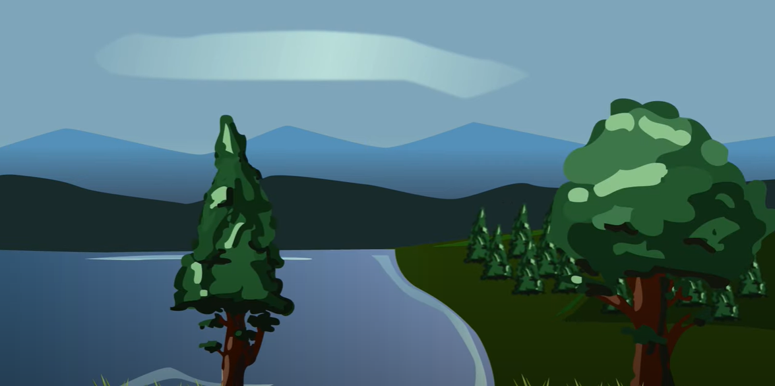
Nature Restoration Fund
Maoin Ath-shlànachadh Nàdair

Expression of Interest
Cur an cèill ùidh

Application Form

Please refer to the ‘Guidance Notes’ to complete the application form.
This fund is for capital projects only.
Supporting documentation must be submitted with the application (see section 7.2).
Projects must not start or commit expenditure before receiving and accepting the offer of grant letter.

SECTION 1: PROJECT SUMMARY
1.1 | Project reference number
1.2 | Organisation name
1.3 | Project title
1.4 | Project costs | Total cost of project |  | £
1.4 | Project costs | Match funding |  | £
1.4 | Project costs | Grant requested |  | £
1.5 | Start date
1.6 | End date

1.7 Which of the following programme themes will the project meet?

You must meet at least ONE essential theme:  - Habitat and species restoration: Management for enhancement and connectivity  - Freshwater restoration, including restoration of natural flows in rural catchments  - Coastal and marine initiatives which promote restoration, recovery, enhancement or resilience  - Control of invasive non-native species (INNS) impacting on nature  - Urban: Enhancing and connecting nature across, and between, towns and cities. | Yes / No  Yes / No  Yes / No  Yes / No  Yes / No
You must also meet at least ONE of the following criteria:  - Deliver positive effects for biodiversity and enhance local ecosystems;  - Address the climate emergency and its impacts through mitigation and adaptation and by promoting nature-based solutions. | Yes / No  Yes / No

SECTION 2: CONTACT DETAILS

2.1 | Main contact name
 | Contact number
 | Alternative contact number
2.2 | Position
2.3 | Address  Postcode
2.4 | Email address
2.5 | Website address

SECTION 3: ORGANISATION DETAILS

3.1 | Organisation Status | Please indicate (x) | Organisation number
 | Company limited by guarantee
 | Constituted group
 | Public body
 | Charity
 | SCIO
 | Private
 | Other (please specify)

3.2 | Are you applying on behalf of a partnership and is your organisation the lead applicant? If yes, please provide partnership agreement with the application. | Yes / No

3.3 | Is the organisation VAT registered?  You are declaring your organisation’s VAT status with HMRC. If this changes at any time during the project, you must notify the NRF Team as this may affect the offer of grant. |  | Yes / No
3.4 | If the organisation is VAT registered, please quote number.
3.5 | Is the VAT related to the project being reclaimed from HMRC? Provide relevant details in the box below, i.e. details of exemptions |  | Whole | Partial | None
Notes:

3.6 | Project delivery team
Name |  | Job title/area of work

3.7 Privacy Notice
Please confirm you have read and understood the NRF Privacy Notice: Yes / No https://www.highland.gov.uk/privacynoticenrf

3.8 Artificial Intelligence Assistance Declaration
Have you used any form of AI assistance in the preparation of this application: Yes / No
For guidance on the appropriate use of AI in funding applications, please refer to Use of AI in Funding Applications Guidance https://www.highland.gov.uk/AIguidance

SECTION 4: PROJECT DETAILS
Please refer to the Guidance Notes to complete this section. It provides important information, definitions, and examples to ensure you answer each section correctly.

4.1 | Project location - include postcode Please also confirm whether the project location is within a designated area i.e SSSI, SAC, LNR and provide details of any advice sought in 4.4.
4.2 Do you own the land/is there a lease agreement in place or do you have landowner consents? Please provide evidence - this must be in place before you start the project.

4.3 | Does the project require planning permission or statutory regulatory consents? | Yes / No
If YES, please detail below – consents must be in place before you start the project. Please provide evidence.
Type |  | Date granted

4.4 Have you had support/advice from other organisations in developing the project?

Organisation | Please indicate (x) | Details
NatureScot
Highland Council
Cairngorms National Park
Other (please detail)

4.5 | The project
- Please summarise the project. Explain how it will achieve the Funds’ themes as noted in 1.7.

- Explain how the project benefits biodiversity, specifically in the location stated in 4.1. How will this improve, enhance and deliver positive effects for local ecosystems in this area?

- List the main activities to deliver the project including timescales – this will be the project delivery plan. Projects must start before 31st March 2026 and be completed by 31st October 2026.
Activity name | Achieve by (date)

- Please quantify your anticipated project outputs below. This information will be used to support the monitoring and evaluation of your project’s progress and impact
Project Outputs | Target
Number of trees planted
Area of wildflower planted (hectares)
Length of hedgerows planted (meters)
Area or length of Invasive Non-Native Species removed (hectares)
Total area of wetland/pond creation (hectares)
Total area of NRF project (hectares)

- Environmental impact. Explain how the project specifically addresses/supports climate change/net zero ambitions and how it mitigates any negative impacts through nature-based solutions/enhancements.

- Equalities impact. Explain how the project ensures that no one is disadvantaged or prevented from benefitting from the project

- Do you have a Fair Work First Policy Statement. Yes / No All applicants must provide a signed statement detailing how your organisation is committed to advancing the Fair Work First Policy including the ‘Real Living Wage’ and ‘Effective Voice’ criteria (see guidance note).
- Do you have Living Wage Accreditation and/or are you planning to be certified?
Please give details.
- How will the project be supported or maintained after NRF funding and what will be the legacy/lasting benefits?

- Please outline how the project fits with local plans and strategies (eg Highland Nature: Biodiversity Action Plan 2021 – 2026, Local Place Plans).

SECTION 5: BUDGET
This can be provided in a separate excel spreadsheet if preferred. Delete the example below before completing this section. If the NRF project is part of a bigger project, list what the funding specifically will be spent on. Please provide a copy of the overall project budget to show how the NRF element contributes towards this.
5.1 Main project expenditure

Budget Heading | Details/items | Amount
Equipment | Shovels | £50
 | Tools | £200
Materials | Tree saplings | £1000
 | Wildflower seed | £1500
Labour | Landscaping and tree planting | £500
 | Digger hire | £2000
TOTAL PROJECT COST |  | £
Is VAT included in these costs? |  | Yes / No

5.2 | Reasonableness of costs – please explain how you have obtained these costs whilst developing the project?
SECTION 6 – MATCH FUNDING

6.1 | Please give details of confirmed match funding:  Match funding must be confirmed before you start the project and evidence provided.
Name of funder |  | Date awarded | Amount £
Total match funding |  |  | £
NRF requested |  |  | £
Total project cost |  |  | £

6.2 Will the project involve “in kind” support?
This should not form part of the overall budget or counted as confirmed match funding for the project.
Yes / No. If yes, please detail:

6.3 Please explain why public funding is required to deliver the project.

SECTION 7 – SIGNATURE

I declare that the information contained in this application is correct to the best of my knowledge. I have read the guidance notes and understand and accept the terms and conditions noted within them.
The data you have provided in the application (and claim) forms are subject to the provisions of the Freedom of Information (Scotland) Act 2002, the Data Protection Act 1998 and the Environmental Information (Scotland) Regulations 2004.

7.1 | Main applicant, chairperson or equivalent – the person signing this application has the authority within the organisation to apply for grant funding
 | Signature: | Print: | Date

7.2 Supporting documents checklist.  You must enclose the following documents (where applicable) with the application. If they are not available, please state why |  | Y / N / NA
Submit with initial application:
1 | Signed Fair Work First Policy
2 | Bank statement – latest statement
3 | Financial accounts – latest available accounts
Required before offer of grant confirmed:
4 | Constitution or articles and memorandum
5 | Committee Members or Directors List
6 | Permissions – planning, consents, licences
7 | Policies – eg. health and safety, environmental, equal opportunities
8 | Confirmation of match funding letters
9 | Copy of valid insurance policy
10 | Evidence of land ownership or lease
11 | Partnership agreement
Reason for missing documentation:

For assistance completing this form please contact: NRF@highland.gov.uk

For further information, please visit https://www.highland.gov.uk/naturerestorationfund

