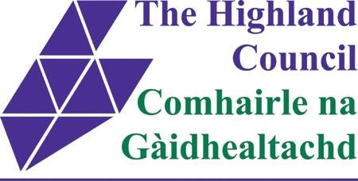

Application For Applying for Ward Discretionary from the Highland Council – Under £1,000

Applicant organisation:
Project title:
Project location (inc. postcode):
Contact name:
Applicant Address (inc. postcode):

Email address:

Contact telephone:
Council Ward: (check guidance for link)

Does the main contact have any communication needs? E.g. textphone, sign language, large print?

Yes |  | No

What type of organisation are you? (Please tick all that apply)

Third Sector (voluntary or community) organisation |  | Community Council
Registered Charity  If yes – Registration number  ……………………………………. |  | Company Limited by Guarantee If yes – Company Number  ……………………………….
Other - please specify………………………………………….

Start date of project:

End date of project:

Project summary – please provide a brief outline of your project and the outcomes it will deliver.
example:
- Aims of the project and how you are going to do it
- Help with running costs or for a specific project or activity?
- Who will benefit?
- How your project or activity will help the Council to meet its Public Sector Equality Duty

Please note that the Council will be unable to provide any resources not specified on this form or supporting information.

Please provide a breakdown of how much your activities / project will cost, listing the items requested from Ward Discretionary Funding

Amount (£)

Total Project Cost
Total Requested Amount

How will the project be funded? (What other organisations have you applied to?) | Amount (£) | Confirmed
Total Requested Funding
Total Match Funding
Total Project Costs

Your Bank Details:

Name of Bank:
Account Name:
Account Number:
Sort Code:

Checklist And Declaration - To ensure that the Highland Council can consider your application, please tick boxes to show what you have enclosed. Please ensure that you have enclosed the following information:

Externally verified Statement of Accounts as presented to your latest AGM

OR

For new organisations which have been established less than 12 months, please
give an estimate of first year’s income and expenditure

AND

A copy of your organisation’s last month’s bank statements (for very new organisations a single bank statement will be sufficient)

AND

A copy of your organisation’s constitution

Declaration: We confirm that we are allowed to submit this application on behalf of:
Name Of Organisation: ……………………………………………………………………

We undertake to ensure that all the necessary enclosures are included, that the information is, to the best of our knowledge, accurate and that this application complies with the Highland Council’s Conditions of Award. The data you have provided in the application and claim forms will be recorded on an electronic data base and are subject to the provisions of the Freedom of Information Act (Scotland) Act 2002, the Data Protection Act 1998.

Please provide 2 signatures. Signatory 1 should be the Chairperson of the Organisation and signatory 2 should be the person who has filled out the form. If these two people are the same, signatory 2 should be another member of your organisation’s committee.

Signatory 1: Signatory 2:

Print Name: ………………………………………… .…………………………………………

Signature: ………………………………………… …………………………………………..

Date: ………………………………………… ……………………………………………

Please confirm you have read and understood the Privacy Notice: Yes ☐ No ☐ Please confirm you have read and understood the Funding Terms and Conditions:
Yes ☐ No ☐
Completed forms should be emailed to: Policy6@highland.gov.uk:

