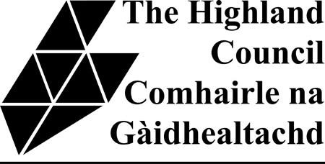
PUBLIC ENTERTAINMENT LICENCE 1

TEMPORARY STRUCTURE SUMMARY TABLE

Reference | Description of temporary structure | Details of Supplier | Location | Structure Name (if applicable) | Max wind speed permissible mph | Capacity (If applicable) | Design Concept Statement Attached
Example INV 01 | Marquee | North of Scotland | Main arena | Dance Tent |  | 6000 | Yes. Dated 1/10/07
Revised September 2012

PUBLIC ENTERTAINMENT LICENCE 1

TEMPORARY STRUCTURE SUMMARY TABLE

Reference | Description of  temporary structure | Details of  Supplier | Location | Structure Name  (if applicable) | Max wind speed  permissible mph | Capacity  (If applicable) | Design Concept  Statement Attached
Revised September 2012

