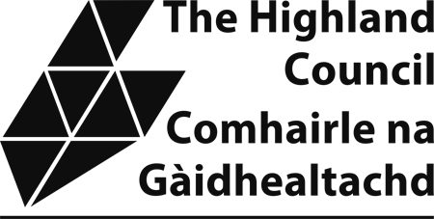

Sample Taxi Driver’s Knowledge Test

The attached sample knowledge test provides applicants with an example of the format and types of questions which will be asked in the actual test. Please note that the sample test is not updated so there may be premises which have now relocated etc. However, the purpose of the sample test is to allow applicants an opportunity to familiarize themselves with the format that the test will take.
Applicants require to complete Section 1 and one of the local area sections. The local section chosen would normally be the one in which the applicant resides or intends to operate in.

CAITHNESS AREA

1. By which street or road and location (if street has no name use road designation, eg. A9) are the following:

(a) The Pentland Hotel -

(b) Thurso Police Station -

(c) Wick Tourist Information Centre -

(d) MacKays Hotel -

(e) Sinclair Bay Hotel -

(f) Wick Swimming Pool -

(g) Portland Arms Hotel -

(h) Wick Heritage Centre -

(i) Dunbar Hospital -

(j) Thurso Library -

(10)

2. Describe the route you would take from:

(a) Thurso Station to Traill Hall, Castletown

(5)

(b) Girnigoe Street to Wick High School

(5)
(c) Scrabster Harbour (Ferry Terminal) to Robert Dick Place

(5)

3. In which villages or towns, on which roads or streets (use road designations if street has no name, eg A9), within those villages are the following located:

(a) Pulteneytown Distillery -

(b) Thurso Town Hall -

(c) Wick General Hospital -

(d) Laurandy Centre -

(e) The Last House -

(f) The Cian Gunn Museum -

(g) The Lamplighter Restaurant -

(h) Norfrost -

(i) Thurso Bus Station -

(j) Mountpleasant Primary School -

(10)
4. Name five campsites or Youth Hostels/Backpackers Accommodation in the Caithness Area:

(a)

(b)

(c)

(d)

(e)

(5)

5. Name five recreational grounds and state on which road/street they are located in the Caithness Area:

(a)

(b)

(c)

(d)

(e)
(5)
[ END OF SECTION ]

