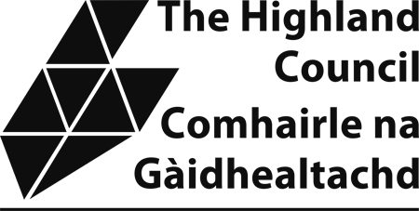

Sample Taxi Driver’s Knowledge Test

The attached sample knowledge test provides applicants with an example of the format and types of questions which will be asked in the actual test. Please note that the sample test is not updated so there may be premises which have now relocated etc. However, the purpose of the sample test is to allow applicants an opportunity to familiarize themselves with the format that the test will take.
Applicants require to complete Section 1 and one of the local area sections. The local section chosen would normally be the one in which the applicant resides or intends to operate in.

NAIRN AREA

1. On which street or road are the following:

(a) Nairn Museum -

(b) Rosebank Primary School -

(c) Westerlea Hotel -

(d) Nairn Academy -

(e) North of Scotland Marquees -

(f) The Lion Hotel -

(g) Nairn Swimming Pool -

(h) Havelock House Hotel -

(i) MacGregor & Co. Solicitors -

(j) Nairn Old Parish Church - (10)

2. Describe the route you would take from:

(a) Blair Road to Queen Street:

(5)

(b) Park Street to Tulloch Drive:

(4)

(c) Seafield Gardens to Balmakeith Drive:

(6)
3. On which streets or roads are the following hotels, guest houses or restaurants:

(a) Golf View Hotel -

(b) Brackla Hotel -

(c) Greenlawns -

(d) The Braighe -

(e) Lovat Lodge Hotel -

(f) Newton Hotel –

(g) Sunny Brae Hotel -

(h) Al Raj Indian Restaurant-

(i) The Classroom -

(j) Latino
(10)

4. Name 5 campsites/caravan sites or Youth Hostels/Backpackers
accommodation in the Nairn Area.

(a)

(b)

(c)

(d)

(e) (5)

5. Name five Recreation Grounds and state on which road/street or area they are located:

1.

2.

3.

4.

5.
(5)

