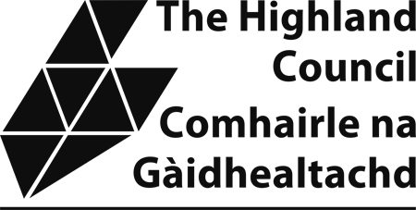

Sample Taxi Driver’s Knowledge Test

The attached sample knowledge test provides applicants with an example of the format and types of questions which will be asked in the actual test. Please note that the sample test is not updated so there may be premises which have now relocated etc. However, the purpose of the sample test is to allow applicants an opportunity to familiarize themselves with the format that the test will take.
Applicants require to complete Section 1 and one of the local area sections. The local section chosen would normally be the one in which the applicant resides or intends to operate in.

LOCHABER AREA

1. On what street or road are the following:

(a) Station Bar -

(b) Ben Nevis Woolen Mill -

(c) Tourist Information Centre -

(d) Lochy Bar -

(e) MacDonald Bros Florist -

(f) Motorway Cars -

(g) Nevis Radio -

(h) Fort William Sports and Social Club -

(i) Budget Rent a Car -

(j) Fort William Railway Station -

(10)

2. Describe the shortest route you would take from:

(a) Middle Street to Perth Place

(5)

(b) Main Taxi Rank to Telford Road

(5)
(c) Treig Road to Glenmallie Road

(5)
(d) Caledonian Road to Lochiel Crescent

3. On which street or roads are the following:

(a) Croit Anna Hotel –

(b) Allt Nan Ros Hotel -

(c) Moorings Hotel -

(d) Milton Hotel -

(e) Innseagan Apartments –

(f) Anoach Mor Hotel –

(g) Lochiel Outward Bound Centre -

(h) Lochan Cottage Guest House -

(i) Guisachan Guest House –

(j) An Crann Restaurant -

(10)

4. Name five campsites or Youth Hostels/ Backpackers Accommodation in the Lochaber Area:

(a)

(b)

(c)

(d)

(e)

(5)

5. Name five recreational grounds and state on which street or road they are located:

(a)

(b)

(c)

(d)

(e)
(5)

