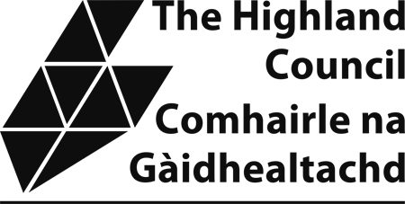

Sample Taxi Driver’s Knowledge Test

The attached sample knowledge test provides applicants with an example of the format and types of questions which will be asked in the actual test. Please note that the sample test is not updated so there may be premises which have now relocated etc. However, the purpose of the sample test is to allow applicants an opportunity to familiarize themselves with the format that the test will take.
Applicants require to complete Section 1 and one of the local area sections. The local section chosen would normally be the one in which the applicant resides or intends to operate in.

SKYE & LOCHALSH AREA

1. Where are the following places/attractions:

(a) The Airstrip on the Isle of Skye -

(b) Aros -

(c) The Clan Donald Centre -

(d) The Swimming Pool on the Isle of Skye -

(e) The Serpentarium -

(f) The Five Sisters -

(g) The only Distillery in Skye & Lochalsh -

(h) The largest Swimming Pool in Lochalsh -

(i) The Airstrip in Lochalsh -

(j) Eilean Donan Castle -

(10)

2. Describe the shortest route naming at least 5 settlements/townships for the following:

(a) From the place where the ferry from Mallaig lands to the place where the ferry for Harris/North Uist departs

(5)

(b) Plockton to Dunvegan Castle

(5)

3. In which town/village or area are the following:

(a) The Cuillin Hills Hotel -

(b) The Lochalsh Hotel -

(c) The Three Chimneys Restaurant -

(d) Kinloch Lodge Hotel -

(e) Viewfield House Hotel -

(f) Tingle Creek Hotel -

(g) Tongadale Hotel -

(h) Taigh Ailean Hotel -

(i) Kings Arms Hotel -

(j) Rosedale Hotel -

(10)

4. Name five campsites or Youth Hostels/ Backpackers Accommodation in the Skye & Lochalsh Area:

(a)

(b)

(c)

(d)

(e)

(5)

5. Name five recreational grounds and state on which road/street they are located:

(a)

(b)

(c)

(d)

(e)
(5)

6. Where are the following:

- The railway terminus in Lochalsh –

- The ferry to the Isle of Raasay

- The ferry to Harris/North Uist

- The Ferry to Glenelg

- The Ferry to Mallaig.
(5)

