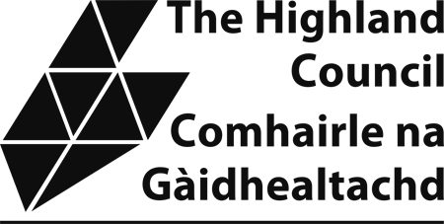

Sample Taxi Driver’s Knowledge Test

The attached sample knowledge test provides applicants with an example of the format and types of questions which will be asked in the actual test. Please note that the sample test is not updated so there may be premises which have now relocated etc. However, the purpose of the sample test is to allow applicants an opportunity to familiarize themselves with the format that the test will take.
Applicants require to complete Section 1 and one of the local area sections. The local section chosen would normally be the one in which the applicant resides or intends to operate in.

SUTHERLAND AREA

1. On which streets or roads are the following:

(a) Ferrycroft Visitor Centre -

(b) Dornoch Library -

(c) Assynt Leisure Centre -

(d) Mitchells Chemists, Dornoch -

(e) Bank of Scotland, Lairg -

(f) Strathy Hall -

(g) Tourism Information Centre, Dornoch -

(h) Brora Health Centre -

(i) Swimming Pool, Bettyhill -

(j) Highland Council Service Point, Helmsdale -
(10)

2. Describe the route you would take from:

(a) Ferrycroft Countryside Centre to Timespan:

(5)

(b) Clynelish Distillery to Shin Falls:

(5)

(d) Carbisdale Castle to Dunrobin Castle:

(5)

- Brora Visitor Centre to Grannies Heilan Hame

(5)

3. On which streets or roads are the following hotels or guest houses located:

(a) Marine Hotel, Brora -

(b) Navidale House Hotel, Helmsdale -

(c) Golf Links Hotel, Golspie -

(d) Nipp Inn, Lairg -

(e) Eagle Hotel, Dornoch -

(f) Culag Hotel, Lochinver -

(g) Lady Ross Hotel, Ardgay -

(h) Bettyhill Hotel, Bettyhill -

(i) Belgrave Arms Hotel, Helmsdale -

(j) Rhiconich Hotel, Rhiconich -
(10)

4. Name 5 campsites or Youth Hostels/Backpackers accommodation in
the Sutherland Area.

(a)

(b)

(c)

(d)

(e) (5)

