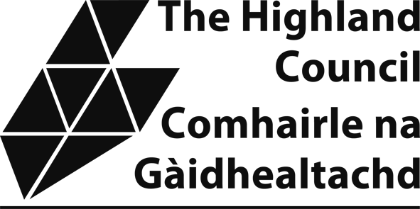

NON-DOMESTIC RATES: APPLICATION FOR DAY NURSERY RELIEF
Explanatory note
From 1 April 2018, certain non-domestic premises used wholly or mainly as a nursery school providing day care of children may be entitled to a 100% rates reduction, referred to as ‘Day Nursery relief’.
An application to the council from, or on behalf of, the ratepayer is required.
Ratepayer/business name:

Email: Telephone:

Property address (including postcode):

Property reference number (on the rates bill):

Is the property used wholly or mainly as a nursery school which provides day care of children? (Y/N))
Was the property so used on 31 March 2018? (or later as applicable)

Signed:

Please be aware that in signing this form you are declaring that the information provided is correct and complete. If you provide information that is wrong incomplete or fail to report a change which may affect your relief you may be prosecuted.

Subsidy Rules under the EU-UK Trade and Cooperation Agreement (TCA)

This relief is capped at a maximum of 325,000 Special Drawing Rights (around
£340,000, although exact amount will fluctuate) over a three-fiscal-year period. This amount is set out in the EU-UK Trade and Cooperation Agreement (TCA).

You must consider whether you have already received support from any public sector body in the current and previous two accounting (fiscal) years.
To ensure that The Highland Council complies with the subsidy regime, it may be required to cap this relief. This may depend on:

- whether or not you have an interest in any business with other properties that are in receipt, or eligible, for one of the existing rate relief schemes;
- the level of other public sector assistance received by the economic actor making the application (NOTE: this may include certain COVID-19 grant support. However, not all grants are considered to be capped in this way. The Council will determine this from your completed Subsidy and Aid Information Form)
Have you (i.e. your business/es) received public sector assistance over the last 3 years* that in total would exceed £300,000, or would you expect to exceed that threshold if this relief were granted to you? (*current and previous two accounting years of your business/es)
Yes ☐ No ☐
IF YES, complete the accompanying Subsidy and Aid Information Form.

DECLARATION
I declare that the information provided on this form is true, complete and correct. I understand that if I give information that is wrong, incomplete or fail to report a change, which may affect my relief, I may be prosecuted.
A privacy notice explaining how The Highland Council manages your information for the purpose of collecting non domestic rates and administering rates reliefs is detailed here: www.highland.gov.uk/privacy-Non_domestic_rates_payments
Please tick this box to confirm that you have read the privacy notice. ☐

Company Name and stamp (if applicable): | Applicant’s Full Name: Print:  Sign:
Position held:
Date:

IMPORTANT: Before posting this form to Non Domestic Rates, The Highland Council, PO Box 5650, Inverness, IV3 5YX, please check the following:
- Have you included all requested documentation?
- Have you read, fully understood and signed the declaration above?

If you need assistance or additional information please contact the Non Domestic Rates Team by telephoning 01463 702984 or by emailing nondomesticrates@highland.gov.uk. Please do NOT send personal data to this email address

